Optimizing Preventive Maintenance Strategy at The Ottawa Hospital through the Application of Alternative Equipment Maintenance
M. Sangargir1,2, J. Brose2
¹ Ottawa-Carleton Institute for Biomedical Engineering (OCIBME), Ottawa, Canada
² Department of Biomedical Engineering, The Ottawa Hospital, Ottawa, Canada

INTRODUCTION
With the goal of improving Preventive Maintenance (PM) practices, The Ottawa Hospital (TOH) has launched the Alternative Equipment Management (AEM) project. AEM introduces a systematic approach for scenarios where there is a need to deviate from manufacturer-recommended maintenance recommendations, aligning practices with the hospital's specific needs. This evaluation focuses on safety prioritization, integration of World Health Organization (WHO) guidelines, and establishing a dedicated AEM committee.
While the original manufacturers tailor specific activities and frequencies for PM on each device, the AEM project acknowledges instances where deviations from these recommendations may be crucial to addressing the hospital's particular needs and enhancing patient safety. This project explores how AEM optimizes resources and allocates priorities in cases where failures are less preventable or predictable. The AEM project, designed for effective preventive maintenance prioritization, emphasizes enabling highly trained technologists to assign time to the most critical tasks.

method
The AEM procedure at TOH is designed using the AAMI AEM Guide [1] and is outlined in Figure 1. The procedure begins with an AEM Eligibility Assessment, evaluating predefined criteria to ensure that only eligible medical devices undergo the AEM methodology. Following WHO’s risk-based PM management guidelines [2], the AEM committee calculates the Equipment Management Number (EM#). This numerical indicator determines the necessity of PM and establishes the WHO-recommended maintenance frequency.
The safety verification process is essential in assessing the likelihood of preventable or predictable failures in medical devices. Utilizing AAMI-suggested failure codes [3] and data derived from the TOH Computerized Maintenance Management System (CMMS), the AEM committee analyzes the annual probabilities of PM-related failures over the accepted time window of past data. This analysis identifies trends, offering insights for potential PM frequency or activity adjustments. The AEM program emphasizes scheduled follow-up reviews to validate ongoing safety within the next years of this decision.
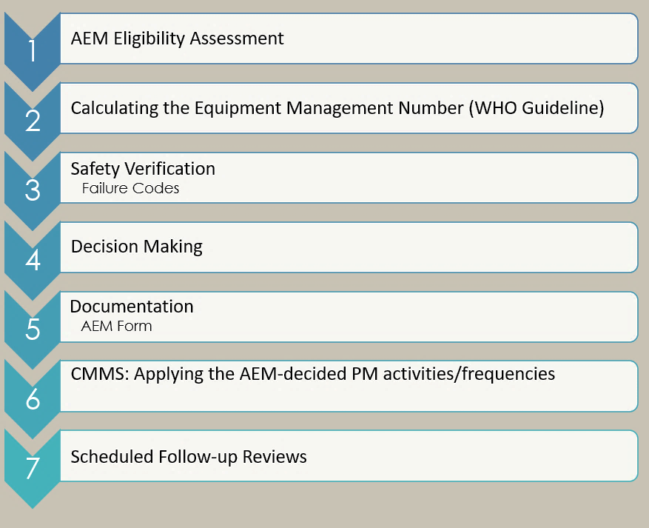
Fig. 1 AEM steps

CONCLUSIONS
The primary objective of AEM is to achieve a harmonious balance where patient safety is prioritized and resources are utilized effectively to ensure the reliability and functionality of medical devices. Following the establishment of the AEM Standard Operating Procedure (SOP), the formation of the AEM committee, and the development of an automated form that calculates the EM#, probabilities, and trends, TOH will implement the AEM project on eligible cases soon.

REFERENCES
- AAMI: AEM, Alternative PM for Patient Safety, 2018.
- World Health Organization: Medical Equipment Maintenance Program Overview, 2011.
- AAMI White Paper: Optimizing the CMMS Failure Code Field, 2020.

