Influence of Body Posture and Electrode Placement on the Measurement of Electrocardiogram Using Textile Electrodes
Delaram Sadatamin^{1,2}, Ivana Culjak², Saba Sadatamin^{1,3}, Bryan Piper^{1,2}, Baptiste Garnier², Azadeh Yadollahi^{1,2}
¹ Institute of Biomedical Engineering, University of Toronto, Toronto, Canada
²KITE-Toronto Rehabilitation Institute, University Health Network, Toronto, Canada
³Wilfred and Joyce Posluns Centre for Image-Guided Innovation and Therapeutic Intervention,Hospital for Sick Children, Toronto,Canada

Abstract— Wearable technology has become popular in recent years due to its convenient ability to be integrated into our everyday lives. These tools can collect a wide range of data and help us to observe and manage various aspects of our health more closely. Smart clothing is a wearable that can track physiological signals, such as electrocardiogram (ECG) conveniently, remotely, and continuously. The quality of the captured ECG signal depends on various factors such as body posture and electrode placement. This study's main objective is to investigate these factors' influence on the ECG signal quality.
Three healthy adults participated in the study. ECG signal was captured with both gold standard gel electrodes and dry textile electrodes simultaneously. The heart rate (HR) values from both gel and textile electrodes were calculated in different body postures and with different electrode placements. Statistical analysis was done to see how accurately the textile captured ECG in comparison with the gold standard in different body postures and with different electrode placements. Furthermore, the absolute error between gel and textile measurements was calculated in different body postures and electrode placements to see which combinations give more accurate HR compared to the gold standard.
The early results indicate that electrode placement and body posture interact to affect HR measurement accuracy. Future work to gather more data is being done to achieve additional statistical power to draw definitive conclusions regarding the influence of electrode placement and body posture on ECG accuracy.

Keywords— Smart Textiles, ECG Monitoring, Heart Rate, Electrode Placement, Body Posture

Introduction
Wearable technology, including integrated electronic devices into accessories or clothing, facilitates remote tracking of health-related metrics [1]. Remote monitoring has been shown to significantly extend the management of advanced cardiovascular disease and improve quality of life [2]. These wearable devices vary in design and shape, yet they all share a common objective: to monitor health conveniently and unobtrusively. One format of wearable technologies that is getting more attention is the use of smart clothing which can integrate sensors into the garments to record physiological signals [3], [4], [5], [6], [7], [8]. Although it is still in its infancy, smart clothing could improve the accessibility of remote monitoring at home and address factors such as comfort in the design, affordability, washability, and biocompatibility [9]. ECG is one of the most frequently used tests in medical settings providing extensive information about cardiac health [10]. Smart clothing can monitor ECG without the need for traditional clinical methods [11]. Previous studies show that factors such as body posture [12] and electrode placement [13] may affect the quality of the ECG signal.
We have designed a novel smart T-shirt embedding textile-based dry electrodes to study the influence of body posture and electrode placement on the textile ECG signal measurements.

Methods
This study investigated whether body posture and electrode placement affect the quality of the ECG signal and measurement accuracy. Participants were asked to lie down in four body postures (supine, left, right, and prone) with the textile electrodes placed on the chest, on the sides, and at the back. Their ECG signals were captured with both the smart T-shirt and the gold-standard monitoring device. The R-peaks were detected and the resulting heart rate (HR) from both textile and gel electrodes were compared to determine the best body posture-electrode placement combination for optimal ECG monitoring.
Fig 1 shows the 21-minute protocol over time. It starts with a 5-minute interval lying supine, transitions to the left side for 5 minutes, returns to supine for 30 seconds, moves to the right side for 5 minutes, has another 30-second supine interval, and ends with 5 minutes lying prone. The protocol was repeated three times, each with a different electrode placement: on the chest, on the sides, and at the back (as shown in Fig 1).
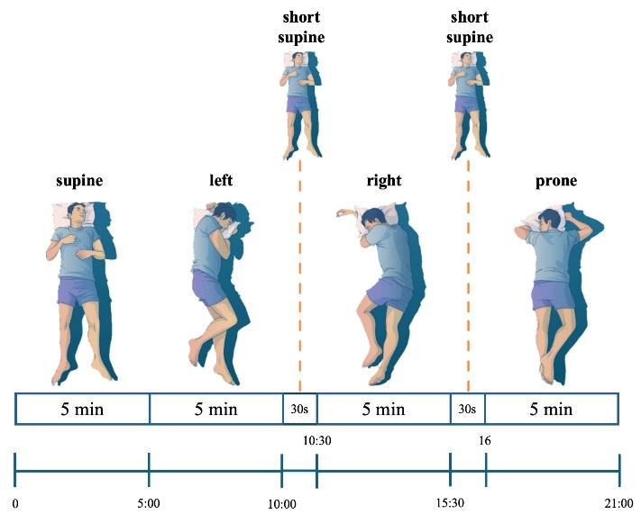
Fig. 1 Study protocol: 5-minute supine, 5-minute left, short supine,
5-minute right, short supine, 5-minute prone.

To capture the ECG signal with the smart T-shirt, we used 5.5x3.5 cm patches of conductive knitted fabric as electrodes, which were metalized with silver. This fabric consists of 22% elastomer, making it stretchable in two directions [14]. We also integrated the MAXREFDES106 (Analog Devices) chest-patch health platform into our system [15]. This platform includes an ECG analog front end, the MAX20356 (Analog Devices) power-management integrated circuit, the MAX32666 (Analog Devices) host microcontroller unit featuring onboard Bluetooth 5, and 256 MB flash storage. To capture the ECG signal according to the gold standard, we used the Compumedics device [16] placing gel electrodes in a wrist-to-wrist configuration. For both devices, the ECG sample rate was 512 Hz.

Data Analysis
The smart T-shirt collected a 3-channel ECG that was gathered from the chest patch for analysis and comparison against the gel ECG. The recorded textile and gel ECG were processed using Python 3.10.1 to detect R peaks and estimate textile and gel HR.
For preprocessing, we implemented a multi-faceted filtering approach to ensure signal integrity and clarity. A low-pass filter with a 40 Hz cutoff was employed to remove high-frequency noise, predominantly arising from muscle tremors and electronic interference. Baseline correction was applied to counteract low-frequency drifts caused by factors such as respiration and body movements. Additionally, a notch filter at 60 Hz was utilized to specifically target and eliminate power line interference. To mitigate the impact of noise from position change, we conducted separate processing for each of the four distinct blocks corresponding to the four different body postures. Fig 2 shows the transition phases and Fig 3 shows a zoomed-in section of both signals captured at the same time with the R-peaks detected.

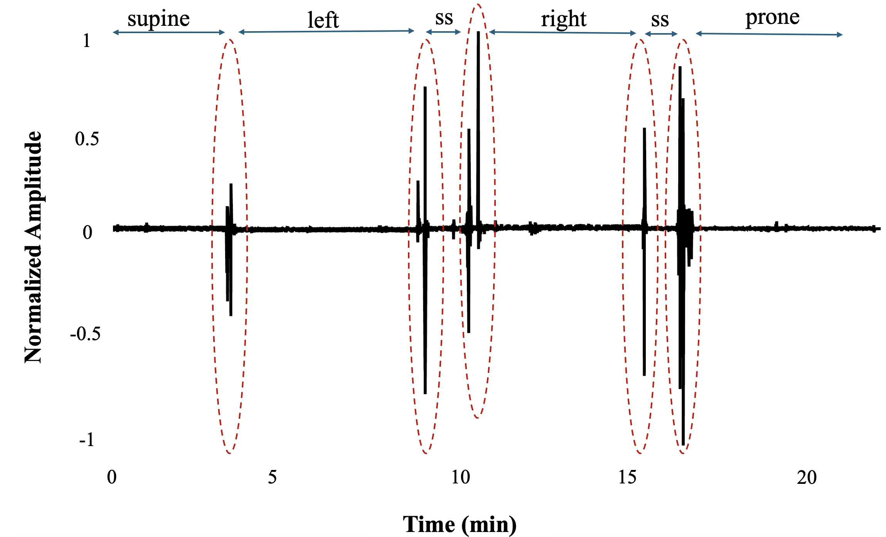
Fig. 2 ECG signal representation: Protocol steps and transition phases in a single data collection with the electrodes placed on the front of the smart T-shirt. SS is short supine.

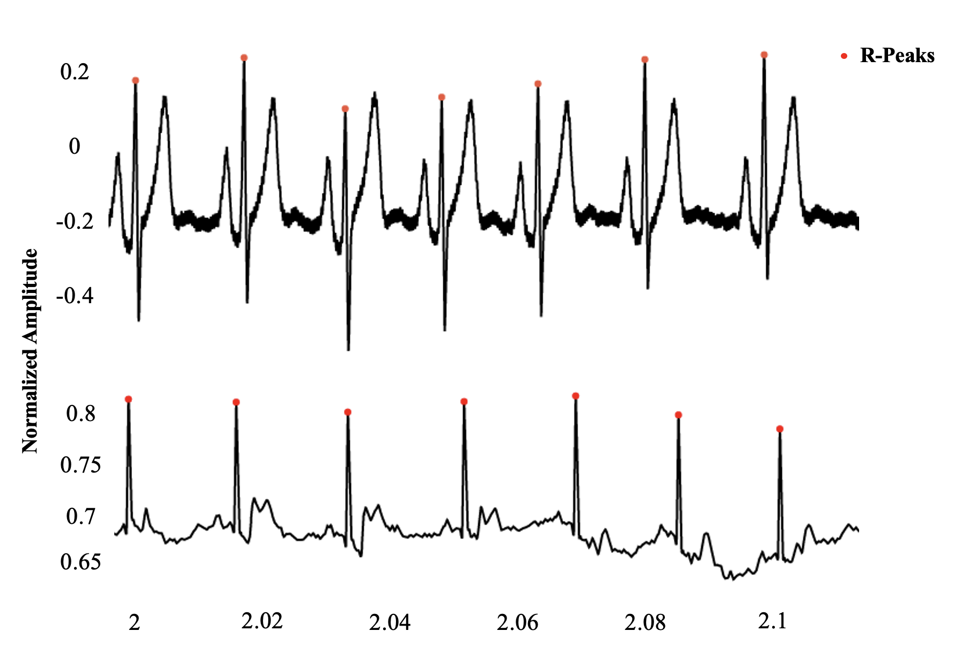
Fig. 3 Six seconds of gel (top) and textile (bottom) ECG signals with the R-peaks detected using the sliding window technique.

For consistency, the parts with persistent noise related to transition phases were marked and excluded from further analysis for both systems, and a fixed timeframe of 3.5 minutes was decided for every posture-placement combination analysis. Processing started with data segmentation where we divided the continuous ECG signal into smaller 30-second sliding windows with 70% overlap [17]. After adjusting the ECG values within the range of -1 and +1 (min-max normalization), the R-peaks were extracted using Neurokit2 [13], and the HR values were calculated within each window by measuring the time intervals between successive R-peaks and converting this to beats per minute
(bpm) for both systems.

Furthermore, the HR values extracted from textile measurements were compared with the gel HR from all the 30-second windows. The absolute error was calculated and visualized in the Fig 5 boxplot for different states: front-supine, front-left, front-right, front-prone, side-supine, side-left, side-right, side-prone, back-supine, back-left, back-right, back-prone.

Results
Three healthy adults, 1 female and 2 males, aged 48.6±14.38 years, and BMI of 27.8±1.61 kg/m² participated in this study.
The Bland-Altman method was used, as shown in Fig 4, to evaluate the level of agreement between HR measurements obtained from textile electrodes and those from gel electrodes [18]. Data collected across various body postures (supine, left, right, and prone) and electrode placements (front, side, and back) were analyzed. The mean difference and the limits of agreement, defined as the mean difference ±1.96 times the standard deviation of the differences were calculated to assess the interchangeability of the two electrode types.
The analysis showed varying degrees of agreement between the textile and gel HR measurements, with mean differences ranging from -9.43 to 7.19 bpm. The limits of agreement were notably wide in several combinations, showing variability in the measurement differences. For example, the front-supine combination showed a mean difference of 3.18 bpm with limits of agreement from -10.47 to 16.82 bpm. Similarly, the back-supine demonstrated a mean difference of 3.47 bpm, with limits of agreement from -28.50 to 35.45 bpm. Other combinations, such as the back-prone, showed even larger discrepancies, with a mean difference of -9.43 bpm and limits of agreement ranging from -38.72 to 19.85 bpm.
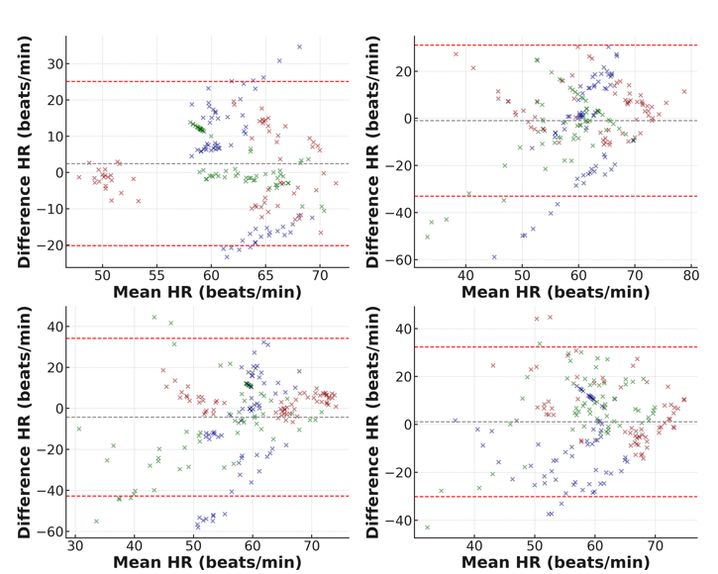
C
A
B
D

Fig. 4 Bland-Altman analysis of HR measurement agreement between gel and textile electrodes across different electrode placements (front, side, back) and different body postures: (A) supine, (B) left, (C) right, (D) prone.
A
The differences seen in the measurements between the textile and gel electrodes across different postures and placements suggest that they may not reliably match up with each other. The wide limits of agreement in all analyzed combinations suggest that the textile electrodes may overestimate, or underestimate HR compared to the gel electrodes in different states.
D
The boxplot in Fig 5 is a visual representation of the variability in the absolute error of HR measurements across different electrode placements and body postures when using gel and textile electrodes.

Fig. 5 Gel and Textile HR (beats per minute) measurements’ absolute differences across different body postures and electrode placements.

Based on the boxplot in Fig 5, the median absolute error in HR measurement varies with both electrode placement and body posture. Errors are generally lower when electrodes are placed at the back, suggesting it may be the most accurate location for HR measurement across different postures. The front placement shows a higher median error and greater variability, especially when in the supine and prone positions. Side placement tends to have a lower median error, but with a wide range indicating inconsistency. Outliers are present in all categories, indicating occasional large errors in HR measurement. The prone position (red box) tends to have a higher error rate compared to other postures, regardless of electrode placement. This suggests that electrode placement and body posture both impact the accuracy of HR measurement.
B

Conclusion
Our study investigated the influence of body posture and electrode placement on the accuracy of HR measurements from textile electrodes in comparison with fixed gel electrodes. The results demonstrate that both electrode placement and body posture affect HR measurement accuracy.
Back placement may offer the most reliable HR measurements and that prone posture is particularly challenging for accurate measurements. The variability and presence of outliers in the boxplot are consistent with the spread of differences in the Bland-Altman plots.
However, our study's limitations, including small sample size and uncontrolled variables like skin conditions and body hair density, necessitate further research with more participants and regulated conditions to validate observed trends and establish guidelines for optimal electrode placement across different body postures. As well, the impact of position order on the outcomes will be investigated in more detail.
conflict of Interest
The authors declare that they have no conflict of interest.
acKNOWLEDGMENT
We gratefully acknowledge the funding provided by TransformHF, which has supported the research efforts of our team.
REFERENCES
[1] G. Appelboom et al., “Smart wearable body sensors for patient self-assessment and monitoring,” Archives of public health, vol. 72, no. 1, pp. 1–9, 2014.
[2] P. Ware, H. J. Ross, J. A. Cafazzo, A. Laporte, and E. Seto, “Implementation and evaluation of a smartphone-based telemonitoring program for patients with heart failure: mixed-methods study protocol,” JMIR Res Protoc, vol. 7, no. 5, p. e9911, 2018.
[3] K. T. Sweeney et al., “Identification of sleep apnea events using discrete wavelet transform of respiration, ecg and accelerometer signals,” in 2013 IEEE International Conference on Body Sensor Networks, IEEE, 2013, pp. 1–6.
[4] A. Kiaghadi, S. Z. Homayounfar, J. Gummeson, T. Andrew, and D. Ganesan, “Phyjama: Physiological sensing via fiber-enhanced pyjamas,” Proc ACM Interact Mob Wearable Ubiquitous Technol, vol. 3, no. 3, pp. 1–29, 2019.
[5] J. Pion‐Massicotte, R. Godbout, P. Savard, and J. Roy, “Development and validation of an algorithm for the study of sleep using a biometric shirt in young healthy adults,” J Sleep Res, vol. 28, no. 2, p. e12667, 2019.
[6] T. Q. Le, C. Cheng, A. Sangasoongsong, W. Wongdhamma, and S. T. S. Bukkapatnam, “Wireless wearable multisensory suite and real-time prediction of obstructive sleep apnea episodes,” IEEE J Transl Eng Health Med, vol. 1, p. 2700109, 2013.
[7] W. Wongdhamma, T. Q. Le, and S. T. S. Bukkapatnam, “Wireless wearable multi-sensory system for monitoring of sleep apnea and other cardiorespiratory disorders,” in 2013 IEEE International Conference on Automation Science and Engineering (CASE), IEEE, 2013, pp. 605–610.
[8] S. Goodrich and W. C. Orr, “An investigation of the validity of the Lifeshirt in comparison to standard polysomnography in the detection of obstructive sleep apnea,” Sleep Med, vol. 10, no. 1, pp. 118–122, 2009.
[9] T. Dias, Electronic textiles: Smart fabrics and wearable technology. Woodhead Publishing, 2015.
[10] L. Neri et al., “Electrocardiogram Monitoring Wearable Devices and Artificial-Intelligence-Enabled Diagnostic Capabilities: A Review,” Sensors, vol. 23, no. 10, p. 4805, 2023.
[11] D. Duncker et al., “Smart wearables for cardiac monitoring—real-world use beyond atrial fibrillation,” Sensors, vol. 21, no. 7, p. 2539, 2021.
[12] M. G. Adams and B. J. Drew, “Body position effects on the ECG: implication for ischemia monitoring,” J Electrocardiol, vol. 30, no. 4, pp. 285–291, 1997.
[13] D. Makowski et al., “NeuroKit2: A Python toolbox for neurophysiological signal processing,” Behav Res Methods, pp. 1–8, 2021.
[14] “Shieldex® Technik-tex P130 + B.” Accessed: Jan. 21, 2024. [Online]. Available: https://www.shieldex.de/en/products/shieldex-technik-tex-p130-b/
[15] “MAXREFDES106.” Accessed: Jan. 21, 2024. [Online]. Available: https://www.analog.com/en/design-center/reference-designs/maxrefdes106.html#rd-overview
[16] “Compumedics.” Accessed: Jan. 21, 2024. [Online]. Available: https://www.compumedics.com.au/en/products/grael-psg/
[17] T. Anbalagan, M. K. Nath, D. Vijayalakshmi, and A. Anbalagan, “Analysis of various techniques for ECG signal in healthcare, past, present, and future,” Biomedical Engineering Advances, vol. 6, p. 100089, 2023, doi: https://doi.org/10.1016/j.bea.2023.100089.
[18] N. Montazeri Ghahjaverstan et al., “Textile-based Wearable to Monitor Heart Activity in Paediatric Population: A Pilot Study,” CJC Pediatric and Congenital Heart Disease, vol. 2, no. 4, pp. 187–195, 2023, doi: https://doi.org/10.1016/j.cjcpc.2023.05.007.

