Electro-fabrication of Molecular Imprinted Polymer Biosensor: Efficient Approach to Achieve Reliable and Reproducible Biosensors
Bahareh Babamiri^{1,2, *}, Mohammadreza Farrokhnia^{1,2}, Mehdi Mohammadi Ashani^{2,3}, Amir Sanati Nezhad¹
¹ Department of Biomedical Engineering, University of Calgary, Calgary, Alberta, Canada
² Fluidome-Biochiptech Company, Calgary, Alberta, Canada
³ Department of Biological Sciences, University of Calgary, 2500 University Drive, Calgary, AB, Canada, T2N 1N4

Abstract
In this investigation, a novel strategy for screening the electrodes has been introduced to improve the reproducibility, reliability, and performance of fabricated molecularly imprinted polymer biosensors. The MIP biosensor was fabricated by the electrodeposition of Prussian blue nanoparticles (PB NPs) as the embedded redox probe, electropolymerization of pyrrole (Py) in the presence of a template molecule, and electro-cleaning of template molecules, which each electrosynthesis step of the MIP biosensors has been monitored by electrochemical approach. The presence of Prussian blue in the structure of the MIP biosensor provides the possibility of monitoring all the fabrication steps of the biosensor through electrochemical methods which leads to screening the electrodes during electrosynthesis of MIP biosensors that can be used as an efficient quality control (QC) approach to achieve reproducible MIP biosensors. According to this strategy, we fabricated reproducible and reliable biosensors for the detection of agmatine as a proof of concept.

Keywords: Molecularly imprinted polymers (MIP), Prussian blue, Quality control (QC).

INTRODUCTION
Continuous and real-time detection of biomolecules such as metabolites, proteins, bacteria, viruses, and nucleic acids can provide useful biological information for early-stage disease diagnosis ^{1–3}. In this regard, the development of sensitive, selective, reliable, and reproducible biosensors for the determination of biomolecules is a crucial approach for medical evaluation and precision medicine ¹. Electrochemical biosensors due to high sensitivity, selectivity, portability, and ease of use have attracted tremendous focus and efforts as a core analytical tool in the design of chemical and biological sensors. Among the different characteristics of electrochemical biosensors, the reproducibility of biosensors is crucial for their accurate, reliable performance, and ensuring the validity of experimental results. However, improvement in stability, reproducibility, sensitivity, cost of materials, and fabrication approach of electrochemical biosensors for the commercialization, mass production, and broad point-of-care applicability of integrated electrochemical biosensors is an obvious demand.
The variations during screen-printed electrode preparation including Variations in ink properties and substrate characteristics, and fabrication processes of electrochemical biosensors can result in differences in the working electrode's surface properties and the developed biosensor's reproducibility.
Using quality control (QC) strategies during the manufacturing of electrochemical biosensors can be considered an efficient approach to creating uniform and reproducible electrode surfaces and reliable biosensors ².
Current biosensors utilize biological recognition elements (capture probes) such as enzymes, antibodies, nucleic acids, and aptamers, which provide selective affinity toward their target biomolecules. Despite their efficacy, these biorecognition elements face inherent challenges, including high costs, limited long-term stability under measurement conditions, and a single-use nature. Considering these limitations, the development of synthetic alternatives is an obvious demand of healthcare authorities for reliable, sensitive, specific, rapid, and continuous detection of target biomolecules. Molecularly imprinted polymers (MIPs) emerge as efficient biomimetic receptors with characteristics such as easy preparation, low cost, scalability, remarkable reusability, and long shelf-life, which hold great promise to provide a new generation of chemical-biological sensors by substituting antibodies used in biosensors ⁴⁻⁶.
MIPs are synthetic receptors prepared by polymerizing functional monomers or a series of functional monomers around target molecules, along with a cross-linker. This process results in the creation of noncovalent detection cavities based on the shape, size, geometries, and functionality of template molecules which is achieved through the subsequent removal of the template molecule ^{7,8}. Despite the notable advantages of MIP biosensors, the advancement of electrochemical MIP biosensors encounters certain challenges, including selecting appropriate monomers and cross-linkers, controlling the thickness of the polymeric layer, template removal, producing reproducible MIP film during MIP fabrication and providing efficient electrodes with high conductivity, active surface area, and acceptable reproducibility.
The electropolymerization of conductive monomers represents an exceptionally attractive technique for the direct, in situ fabrication of molecularly imprinted polymers (MIPs) on the electrode's surface which offers a rapid and straightforward approach to synthesizing MIPs as the recognition element in electrochemical sensors. This method yields electrically conductive polymeric films with controllable thickness, reproducible outcomes, and the capability for real-time monitoring of polymer growth thereby enhancing the precision of MIP-based biosensor development. Also, utilizing embedded redox probes such as Prussian blue (PB) in electrochemical MIP biosensors can provide a useful approach for quality control measures throughout the manufacturing process.
In this regard, we developed an efficient methodology in three steps including electrodeposition redox probe, electropolymerization of pyrrole as a functional monomer, and extraction of the template through the electrochemical oxidation of polypyrrole for the fabrication of MIP biosensors with excellent reproducibility. Each electrosynthesis step of the MIP sensors was monitored using electrochemical approaches. The high controllability of the electrochemical method for the fabrication of MIP biosensors offers the opportunity for screening the electrodes throughout electrodeposition, electropolymerization of conductive monomers, and electro-cleaning of template molecules that can be used as an efficient quality control (QC) approach to achieve reproducible MIP biosensors.

Material and Methodology
The agmatine MIP biosensor was fabricated as follows: In the first step, the carbon/Graphene/poly (3,4-ethylenedioxythiophene) polystyrene sulfonate (PEDOT: PSS) screen-printed electrode ⁹ was washed triple times with DI water and dried with nitrogen. In the next step, Prussian blue (PB) was electrochemically synthesized as the embedded redox probe on the surface of the electrode. PB layers were synthesized through the electro-deposition of 5 mM K₃Fe (CN)₆, and 5 mM FeCl3, to achieve a stable and appropriate redox signal, in the presence of 0.1 M HCl and 0.1 M KCl. This synthesis was performed by a cyclic voltammetry (CV) method within the potential range of -0.2 to 0.6 V at a scan rate of 50 mV s⁻¹ for 60 cycles. Then, the modified electrode was washed twice with deionized water. The MIP film was electrochemically synthesized via electropolymerization using CV at 0 to 1 V potential range with a scan rate of 50 mV s⁻¹ for 10 cycles in PBS solution (pH = 7.4) containing 5 mM agmatine, 37.5 mM pyrrole, and 0.1 M HCl. The template extraction was conducted right after the electropolymerization process by CV scans at -0.2 to 0.8 V with a scan rate of 50 mV s⁻¹ in 0.5 M HCl for 15 cycles through over-oxidation of PPy. After removing the template, the MIP electrode was rinsed extensively with ultra-pure water several times and gently dried with a nitrogen stream. To assess the electrochemical behavior of the modified electrode surfaces during the synthesis steps, cyclic voltammetry (CV) analyses were conducted in a PBS solution containing 0.1 M KCl. The square wave voltammetry (SWV)-based detection of agmatine was performed on the agmatine MIP biosensor in a 0.01 M PBS solution at pH 7.4. SWV testing conditions include an anodic direction range of -0.8 to 0.8 V, a frequency of 10 Hz, an amplitude of 100 mV, and an E step of 10 mV, with a total measurement duration of 25 s.

results and discussions
As mentioned, the development of reliable and repeatable electrochemical MIP-based biosensors requires uniform electrodes in terms of both surface morphology and conductivity and precise control over the fabrication process of the MIP film, as well as the extraction of target molecules to synthesize uniform polymer films. Incorporating Prussian Blue Nanoparticles (PB NPs) as the embedded redox probe offers a valuable opportunity to select reproducible electrodes in terms of their surface properties and conductivity. In this strategy, the peak current intensity threshold of electrodeposited PB NPs on the electrode's surface was specified for each step of the fabrication of the MIP-based biosensor. During the electro-fabrication of MIP biosensors, electrodes that did not meet this threshold were systematically eliminated. Furthermore, evaluating the pattern of variations in the current intensity of the PB NPs during the electropolymerization of the pyrrole and extracting the target molecule is an effective method for monitoring the electrodes.

Figure 1A illustrates the PB nanoparticles' growth process on the electrode's surface. One redox peak appeared at a formal potential (E◦) of 0.15 V. The redox peak gradually grew, and the peak potential remained relatively constant with the increase in the scan number. The obtained result indicated that the PB nanoparticles had formed on the surface of the electrode successfully. After activation and stabilization, the redox signals throughout 60 continuous cyclic voltammetry (CV) scans in the blank PBS electrolyte (0.01 M, pH 7.0) containing 0.1 M KCl were recorded, demonstrating the acceptable stability of the redox probe and the effective presence of PB on the modified electrode (Figure 1B). As mentioned, the electropolymerization method was applied to fabricate a uniform MIP film of Polypyrrole (Ppy) on the modified electrode's surface. Figure 1C illustrates CV curves during the electropolymerization process of pyrrole on the surface of the electrodeposited electrode with PB as the embedded redox probe that shows the obvious oxidation peaks of PB at about + 0.15 V. Throughout the electropolymerization of pyrrole, due to the formation of an insulating Ppy layer which hindered the electron transfer, the current intensity of PB decreased with the increasing number of cycles and almost disappeared at the 10th cycle confirming the formation of imprinted polymer film on the surface of the electrode.
With increasing the scan number during the electropolymerization of pyrrole, the thickness of the imprinted Ppy film is increased, so the access of template molecules to the recognition sites due to high mass transfer resistance will be difficult. It can lead to the detachment of the fabricated MIP film, reflecting the lower sensitivity of the designed MIP biosensor. So, fewer scan cycles contribute to the development of efficient MIP biosensors with high sensitivity and wide linear concentration range. The complementary cavities to agmatine were obtained upon the extraction of template molecules through over-oxidation of Ppy. These cavities acted as channels for electron transfer, resulting in an increase in the current intensity of PB with an increasing number of cycles. The intensity almost reached a near-steady state after 15 cycles, indicating the successful removal of most template agmatine from the MIP structure (Figure 1D). As shown, the presence of Prussian blue as an internal embedded redox probe enables monitoring and screening of the biosensor preparation during the synthesis steps which offers an efficient approach to selecting reliable and reproducible MIP biosensors.
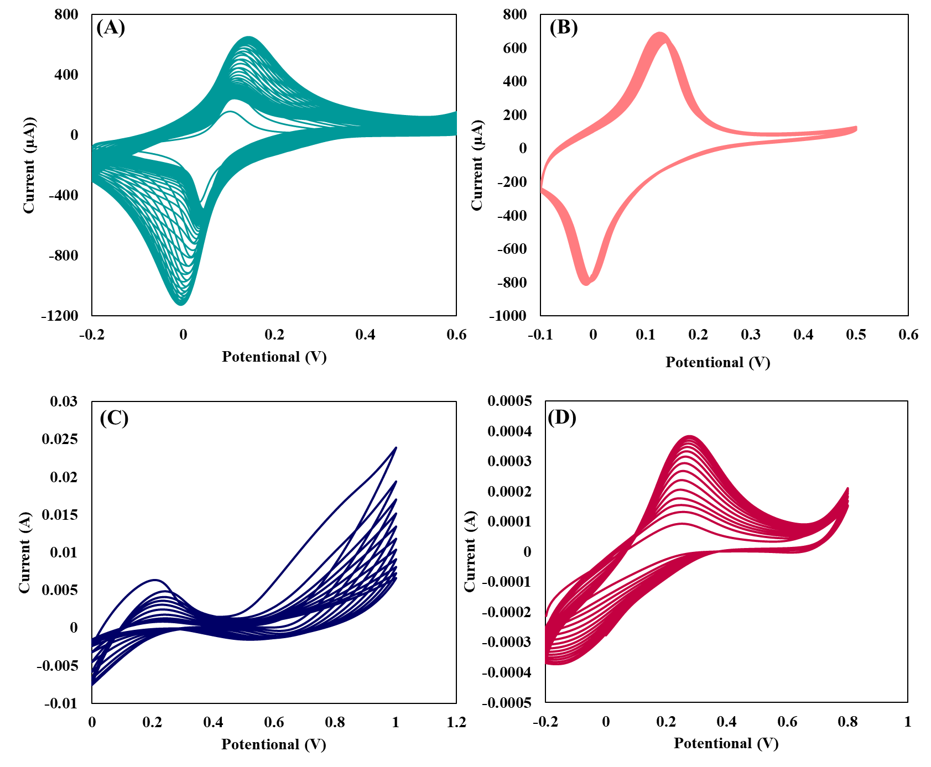

Figure 1. (A) Cyclic voltammograms representing the electrodeposition of the PB NPs, (B) The stability of the PB signal under 60 consecutive cyclic potential scans in 0.01 M, pH 7.0) containing 0.1 M KCl, (C) Cyclic voltammograms representing the MIP formation on the surface of the PB electrode, (D) Measured CV voltammograms during the removal of agmatine from the formed Ppy matrix in HCl 0.1 M with a scan rate of 50 mV s⁻¹.
Hence, an efficient approach for the evaluation of electrodes can be established through precise monitoring of the changes in the current intensity of the PB NPs during the biosensor’s synthesis procedure. This systematic approach comprehensively assesses electrode performance during synthesis, enhancing biosensor fabrication's reliability and reproducibility.
As shown in Figure 2, we chose 12 electrodes and assessed the current intensities in PBS following the electrodeposition of PB NPs. Among them, 7 electrodes exhibited similar and comparable current intensity and were consequently chosen for subsequent steps. Following the electropolymerization of pyrrole and extraction of the template molecule, the current intensity was measured, revealing that three electrodes displayed similar intensity. In the final phase, three carefully selected electrodes were employed for the measurement of agmatine.
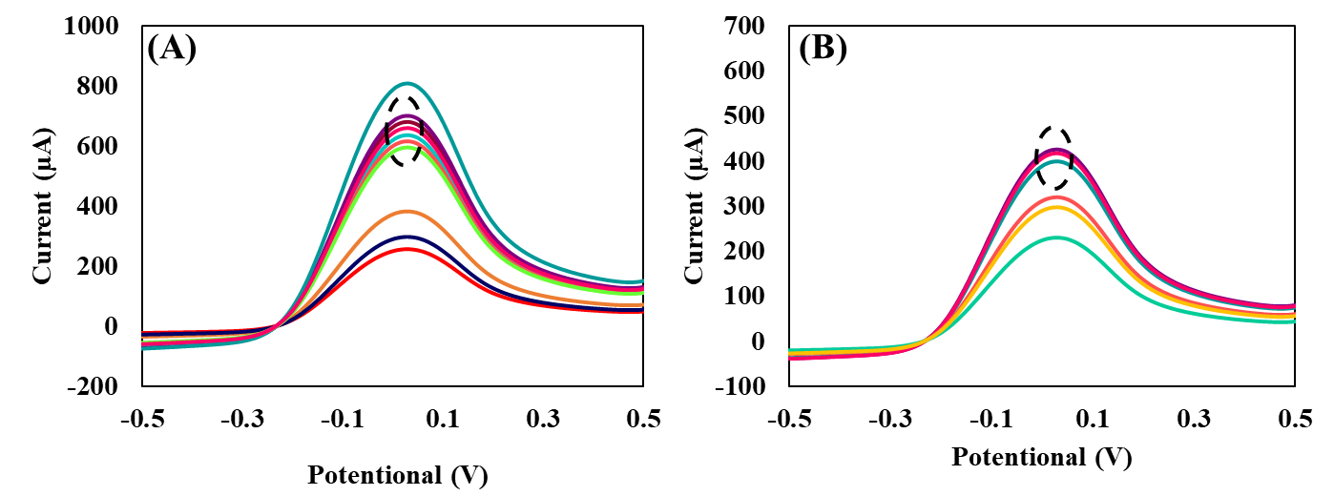

Figure 2. (A) SWV voltammograms of 12 different electrodes after electrodeposition of PB NPs measured in 0.01 M PBS (pH 7.4), (B) SWV voltammograms of 7 different electrodes after extraction of template molecule measured in 0.01 M PBS (pH 7.4).

As mentioned, we employed a quality control approach to select electrodes exhibiting the same current intensities of PB NPs and consistent behavior during electrodeposition, electropolymerization, and electro-cleaning steps. As illustrated in Figure 3, selected electrodes show the same analytical performance and are successfully applied for the detection of agmatine in the concentration range of 1 nM–100 µM in 0.01 M PBS. The determined LOD was found to be 0.1 nM at a signal-to-noise ratio of 3, based on the standard deviation of the MIP biosensor response and the slope. Also, as can be seen, a good agreement between the slope of calibration curves and the correlation coefficient of these electrodes was obtained which shows the high efficiency of the introduced quality control approach. This accurate process resulted in the production of reproducible biosensors. Furthermore, the reproducibility of five different MIP biosensors, which were fabricated by the same procedure, was assessed by measuring the electrochemical signal change upon the addition of 1 µM of agmatine. The calculated Relative Standard Deviation (RSD) for the five independent assays was 3.41%, confirming the satisfactory reproducibility of the proposed MIP biosensor.
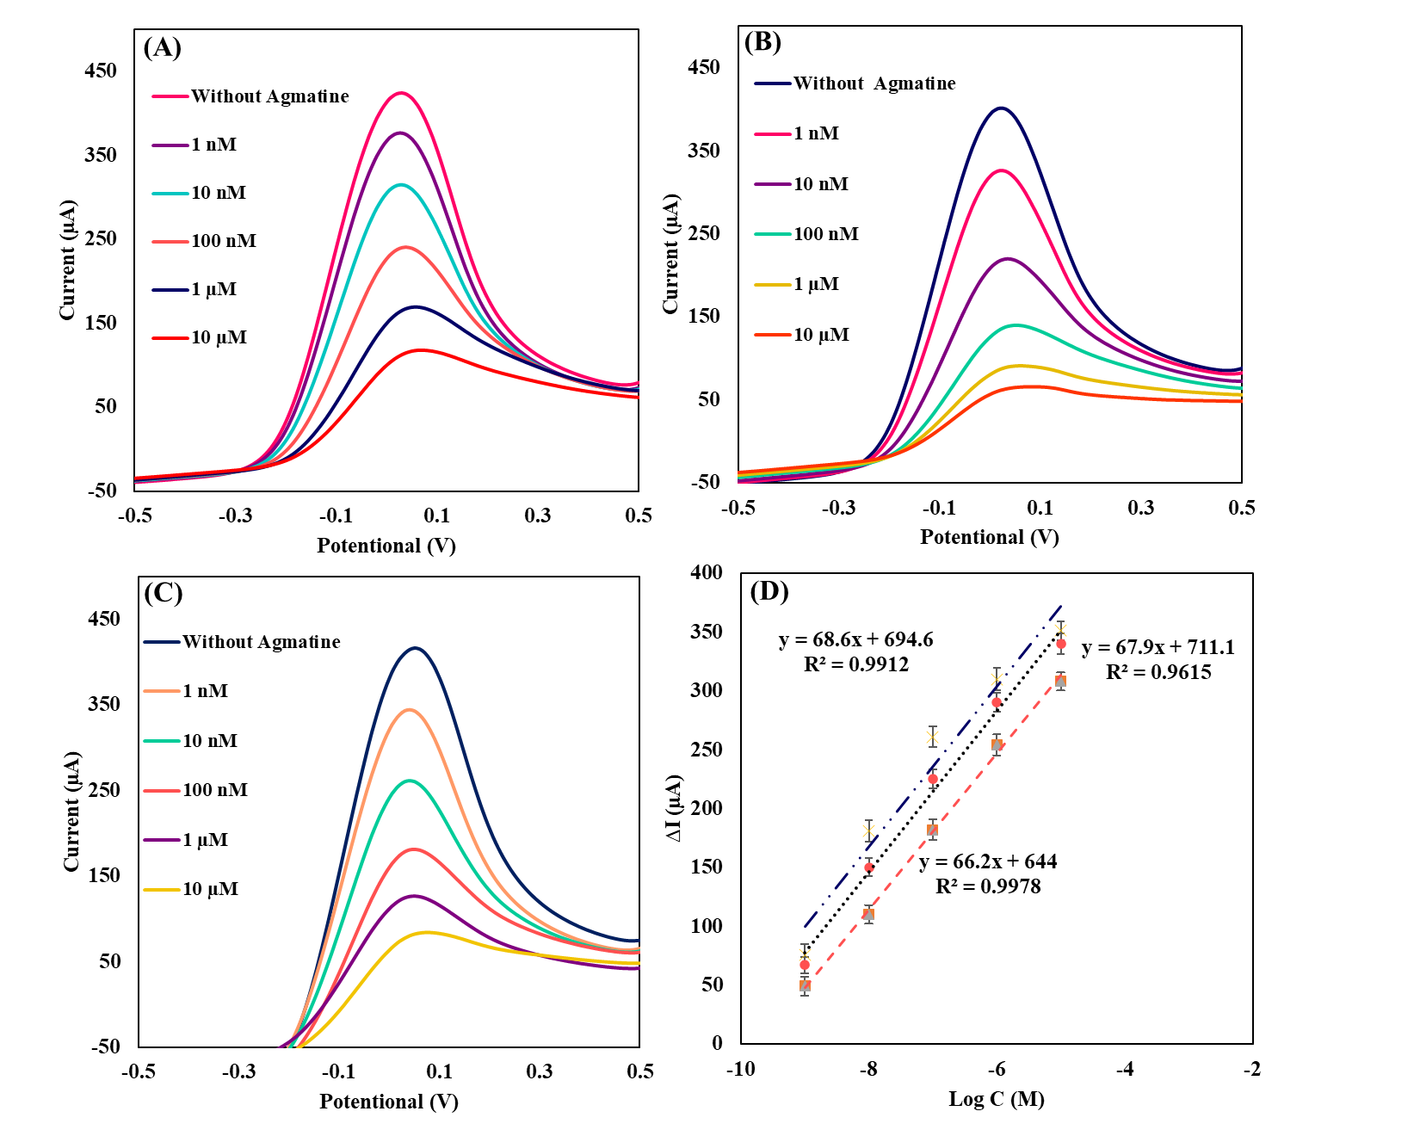

Figure 3. The electrochemical performance of three different MIP electrodes after QC for rebinding agmatine: (A, B, C) SWV voltammograms of three different MIP electrodes measured in 0.01 M PBS (pH 7.4) with different concentrations of agmatine, (D) the corresponding linear calibration curve of three different MIP electrodes (ΔI stands for the SW peak height).

Conclusions
In this study, we have successfully introduced an efficient quality control approach to achieving MIP-based biosensors with high reproducibility by investigating the results that are produced automatically during the electro-fabrication process. The incorporation of Prussian Blue Nanoparticles (PB NPs) as the embedded redox probe in the structure of developed MIP biosensors provides a valuable strategy for selecting reproducible electrodes in terms of their surface properties, thickness of MIP film, and conductivity. This strategy can open new avenues to fabricate reliable and reproducible MIP-based biosensors and scalable production for point-of-care applications.

ACKNOWLEDGMENTS
The authors acknowledge Natural Sciences and Engineering Research of Canada (NSERC), Canadian Institutes of Health Research (CIHR), University of Calgary, Mitacs, Alberta Innovates, and CMC Microsystem for supporting this research.

Conflict of Interest
The authors declare no conflict of interest.
REFERENCES

1. J. Wang, “Electrochemical Biosensors: Towards Point-of-Care Cancer Diagnostics” Biosens. Bioelectron. vol 21, pp. 1887–1892. 2006.
2. J. Baranwal, B. Barse, G. Gatto, G. Broncova, and A. Kumar, “Electrochemical Sensors and Their Applications: A Review” Chemosensors, vol 10, pp. 2-22, 2022.
3. D. H. Lee, W. Y. Lee, and J. Kim, “Introducing Nanoscale Electrochemistry in Small-Molecule Detection for Tackling Existing Limitations of Affinity-Based Label-Free Biosensing Applications” J. Am. Chem. Soc. vol 145, pp. 17767–17778, 2023.
4. K. R. Rogers, “Principles of Affinity-Based Biosensors” Mol. Biotechnol. vol 14, pp. 109-129, 2000.
5. L. Uzun, and A. P, F. Turner, “Molecularly Imprinted Polymer Sensors: Realising Their Potential” Biosens. Bioelectron. Vol 76, pp. 131–144, 2016.
(6) 6. G. Dykstra, B. Reynolds, R. Smith, K. Zhou, and Y. Liu, “Electropolymerized Molecularly Imprinted Polymer Synthesis Guided by an Integrated Data-Driven Framework for Cortisol Detection” ACS Appl. Mater. Interfaces vol 14, pp. 25972–25983, 2022.
(7) 7. A. Raziq, A. Kidakova, R. Boroznjak, J. Reut, A. Öpik, and V. Syritski. “Development of a Portable MIP-Based Electrochemical Sensor for Detection of SARS-CoV-2 Antigen” Biosens. Bioelectron. vol 178, pp. 113029, 2021.
(8) 8. B. Yang, H. Gong, C. Chen, X. Chen, and C. Cai, “A Virus Resonance Light Scattering Sensor Based on Mussel-Inspired Molecularly Imprinted Polymers for Highly Sensitive and High Selective Detection of Hepatitis A Virus” Biosens. Bioelectron. vol 87, pp. 679–685, 2017.
9. R. Salahandish, F. Haghayegh, S. Khetani, M. Hassani, and A.S. Nezhad, “Immuno-Affinity Potent Strip with Pre-Embedded Intermixed PEDOT:PSS Conductive Polymers and Graphene Nanosheets for Bio-Ready Electrochemical Biosensing of Central Nervous System Injury Biomarkers” ACS Appl. Mater. Interfaces vol 14, pp. 28651–28662, 2022.
(10

Author: Bahareh Babamiri
Email: Bahareh.babamiri1@ucalgary.ca
University of Calgary

