Innovative Strategy for Quality Control of Preparing Molecularly Imprinted Polymer Biosensor for Glial Fibrillary Acidic Protein Detection
Mohammadreza Farrokhnia^{1,2,} ∗, Bahareh Babamiri^{1,2}, Mehdi Mohammadi Ashani^{2,3}, Amir Sanati Nezhad1
¹ Department of Biomedical Engineering, University of Calgary, Calgary, Alberta, Canada
² Fluidome-Biochiptech Company, Calgary, Alberta, Canada
³ Department of Biological Sciences, University of Calgary, Calgary, Alberta, Canada

Abstract
The reproducibility of biosensors is an important parameter for the commercialization and mass production of biosensors in different applications which is the main challenge of most research in this field. To address this challenge, in this paper, a novel strategy for screening the electrodes has been introduced to improve the reliability and performance of fabricated molecularly imprinted polymer biosensors. In this strategy, we just use the non-interfering quality controls during the fabrication procedures. By using the electro-fabrication approach for each step of preparation and analyzing their results, we could make the perfect decision about the screening of electrodes. According to this strategy, we could prepare reproducible biosensors for the detection of glial fibrillary acidic protein (GFAP). As the bare screen-printed electrodes suffer from a lack of reproducibility because of variable resistance, capacitance, or electroactive area, the percent of preparing the repetitive and good performance GFAP biosensors to bare electrodes is about 36 % (13 of 36). The impedance electrochemical results showed the efficient performance of this novel approach for preparing high-quality MIP biosensors.

Keywords: Quality Control, Molecularly Imprinted Polymer Biosensor, Glial Fibrillary Acidic Protein (GFAP), reproducibility, Electro-fabrication.

INTRODUCTION
In recent years, biosensors have emerged as pivotal tools in medical diagnostics, offering sensitive and selective detection of biomolecules with broad applications in disease diagnosis and monitoring. Molecularly imprinted polymer (MIP) biosensors, in particular, have gotten attention due to their ability to mimic natural recognition processes, providing a molecularly selective platform for target analyte detection [1].
The rapid advancement in biosensor technology has forced the development of screen-printed ink electrodes. These electrodes are known for being economical, stable, and simple to fabrication. However, the realization of their full potential hinges upon the establishment of robust quality control strategies to ensure reproducibility and reliability in biosensing performance[2].
Variations in ink properties, substrate characteristics, and fabrication methods and conditions can lead to disparities in electrochemical performance, impacting the accuracy and precision of prepared MIP biosensors. Furthermore, a primary impediment to the commercialization of this technology lies in the inherent randomness of the production process. This unpredictability poses a significant challenge in scaling up the manufacturing process to meet the requirements of mass production. This necessitates the development of an efficient quality control strategy tailored to address these challenges and enhance the overall reliability of such prepared biosensors.
Notably, the electro-fabrication procedure, a critical step in biosensor development, demands stringent quality control measures to ensure the reproducibility and reliability of the fabricated electrodes. The electro-fabrication process is governed by several key parameters essential for the optimal development of molecularly imprinted polymer (MIP) biosensors. These parameters encompass (i) the applied potential, characterized by either voltage or current; (ii) the potential scan rate, including periodic potential pulses employed during deposition cycles; and (iii) the limitation of electrical density on the electrode surface. The successful electro-fabrication of MIP biosensors hinges upon a meticulous series of optimizations that intricately control the surface morphology, density, and film thickness [3, 4]. This strategic tuning is essential to modulate the capacity for charge transfer through the electrode, thereby influencing the biosensor's overall performance. Consequently, the electro-fabrication process serves as a critical determinant, necessitating precise adjustments to achieve the desired characteristics and functionality of the MIP biosensor [5]. The process of MIP biosensor fabrication involves complex steps, including the electrodeposition of redox solution, electropolymerization of MIP solution, and washing step for removing the target from MIP film. The screening of electrodes during this electro-fabrication procedure is paramount to identify and eliminate defects or irregularities that may compromise the biosensor's overall performance[6].
In this context, this article proposes a comprehensive strategy for the quality control of carbon screen-printed disposable electrodes. By combining innovative manufacturing techniques with rigorous quality assessment protocols, our approach aims to not only identify and rectify potential inconsistencies but also to advance the broader field of electrochemical sensing. Through this endeavor, we aim to provide a foundation for researchers and practitioners to produce electrodes with enhanced performance and reliability.
Our study addresses this crucial aspect by proposing an efficient strategy for quality control during the electro-fabrication process. By implementing advanced screening techniques, such as impedance spectroscopy and cyclic voltammetry, we aim to identify and rectify electrode irregularities, ensuring consistent and high-quality MIP layer deposition. To prove our approach, we developed an MIP biosensor to detect Glial Fibrillary Acidic Protein. GFAP has emerged as a potential biomarker for various neurodegenerative disorders, including Alzheimer's disease and traumatic brain injuries. The precise and timely detection of GFAP holds great promise for advancing our understanding of these conditions and improving patient outcomes. This meticulous approach contributes to the reliability and reproducibility of the biosensor.

MateriAl and Methodology
3.1 Preparation process of GFAP MIP biosensors
The fabrication process of the GFAP MIP biosensor is shown in Figure 1. In the first step, the carbon/Graphene/poly (3,4-ethylenedioxythiophene) polystyrene sulfonate (PEDOT:PSS) screen-printed electrode [7] was washed triple times with DI water and dried with nitrogen. In the next step, Prussian blue (PB) was electrochemically synthesized as the embedded redox probe on the surface of the screen-printed electrode. To achieve a stable and reliable redox signal, PB layers were synthesized through the electro-deposition by putting 200 µl droplet of redox probe consisting of 3 mM K₃Fe(CN)₆, and 3 mM FeCl₃, in the presence of 0.1 M HCl and 0.1 M KCl. This synthesis was performed by a cyclic voltammetry (CV) method within the potential range of -0.2 to 0.6 V at a scan rate of 50 mV.s⁻¹ for 60 cycles. Then, the modified electrode was washed triple times with DI water. The molecularly imprinted polymer platform for GFAP as the target molecule was electrochemically synthesized via electropolymerization using CV at 0 to 1 V potential range with a scan rate of 50 mV.s⁻¹ for 10 cycles by placing 150 µl droplet of MIP solution (pH = 7.4) containing 25 µg.ml⁻¹ GFAP, 60 µg.ml⁻¹ pyrrole, 30 µg.ml⁻¹ 3-Aminophenylboronic acid (APBA), and 0.1 M HCl in PBS. The target molecules extraction was conducted right after the electropolymerization process by putting the prepared electrode in the washing solution consistent with 10%(w/v) of Sodium dodecyl sulfate (SDS) and 5%(v/v) of Acetic acid in DI water and shaking for 1 hour with 100 rpm to produce the complementary cavities to GFAP in terms of shape, size, and functionality. After removing the target molecules, the MIP electrode was rinsed extensively with ultra-pure water triple times to remove GFAP residues from the Polypyrrole (Ppy) film and gently dried with a nitrogen stream.

3.2. Electrochemical measurements
At the end of the preparation MIP biosensor, a 150 µl PBS droplet was placed on the prepared electrode to measure the impedance of each electrode via the Electrochemical impedance spectroscopy (EIS) method. This measure can be used for calculating the impedance difference in real sample testing. The EIS test was conducted in the frequency range of 20 kHz to 1 Hz with an amplitude of 10 mV and an open circuit potential (Eocp) of 0.17 V.
Figure 1: The preparation process of GFAP MIP biosensor by considering the different quality controls for mass production.

results and Discussions
4.1. Physical characterization of GFAP MIP Biosensor
To investigate the morphology of the electropolymerized MIP film, Field Emission Scanning Electron Microscopy (FESEM) was utilized. Moreover, the surface topography of the GFAP MIP biosensor was characterized by taking atomic force microscope (AFM) images to investigate the homogeneity and surface roughness of the MIP surfaces (Figure 2).
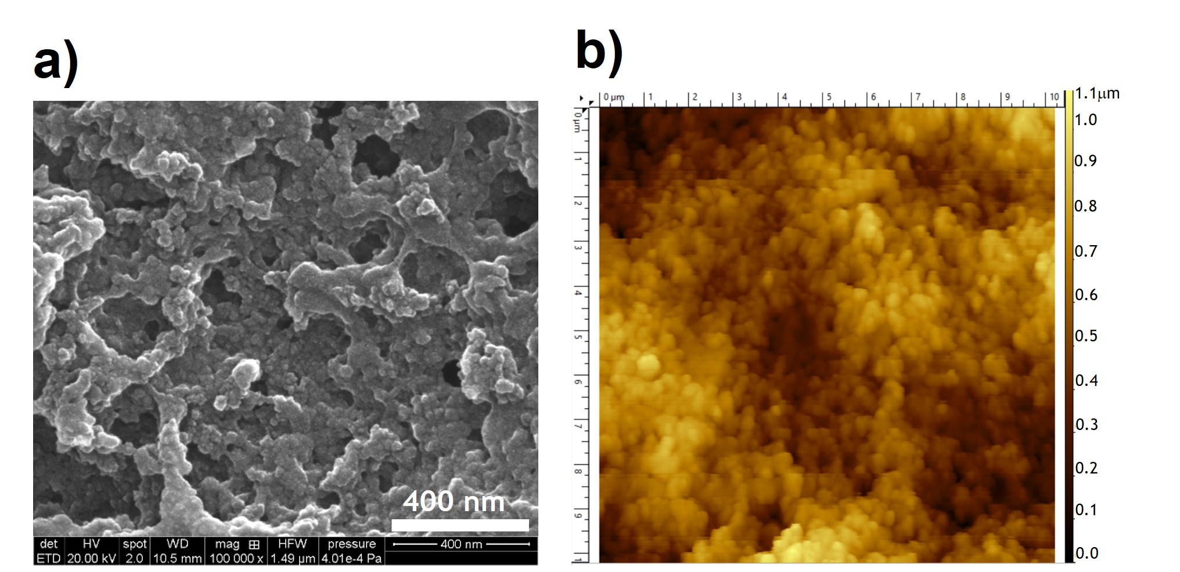
Figure 2: (a) FESEM image of GFAP MIP biosensor (Mag: 100k), (b) AFM image of the topography of GFAP MIP biosensor (10µm × 10µm).

4.2 New strategy for quality controls of MIP biosensor mass production
The inherent variability in the manufacturing process and also challenges to preparing a reliable and stable MIP biosensor for biomolecule recognition[1] have underscored the need for developing a simple and controllable MIP fabrication technology and stringent quality control measures. Several strategies have been proposed to enhance the quality control of fabricated biosensors. These include the use of advanced characterization techniques, optimization of electrode printing parameters, and the implementation of standardized protocols for electrode evaluation[8]. While these approaches have contributed to improvements, a comprehensive and efficient strategy remains elusive. Building upon the shortcomings of existing methods, our proposed strategy integrates novel manufacturing techniques with meticulous quality assessment protocols. By focusing on key parameters influencing electrode performance, we established a systematic and efficient approach to quality control that addresses current challenges and paves the way for advancements in electrochemical sensing applications.
In this strategy, we did not carry out destructive and extra steps. We just investigated the results that are produced automatically during the electro-fabrication process. The manufacturing protocol for MIP biosensors by considering this new strategy is shown in Figure 3. In this Figure, the flowchart of mass-production MIP-based biosensors with attention to four non-destructive quality control steps including QC1: Physical, QC2: Electrodeposition step, QC3: Electropolymerization step and QC4: Washing step is depicted. In each step, the threshold is determined technically based on the MIP biosensor design, materials used in the platform structure and comparing the results of electrodes group.

4.3 Investigation of the innovative quality control for GFAP MIP biosensor as the case study
In this strategy, the current intensity peak threshold was specified for each step of the fabrication of the MIP-based biosensor. For investigating this manufacturing protocol, we started with 36 bare screen-printed electrodes received from Memtronik Company for fabricating the GFAP MIP biosensor as the case study. After passing all the electrodes from QC1: physical quality control, the main quality control after electrodeposition of the redox probe was conducted based on the obtained threshold of 52 μA. In this Step, nineteen electrodes passed the electrodeposition step quality control (QC2). In Figure 4(a), the electrochemical results related to this step are illustrated. The minimum ipa belongs to the first cycle of the Pb nanoparticles electrodeposition step and the maximum ipa relates to the last cycle (#60). During the electrodeposition of Pb nanoparticles on the surface of electrode, the current intensity of peaks increases up to a maximum one at the end of the process considered as the quality control parameter.
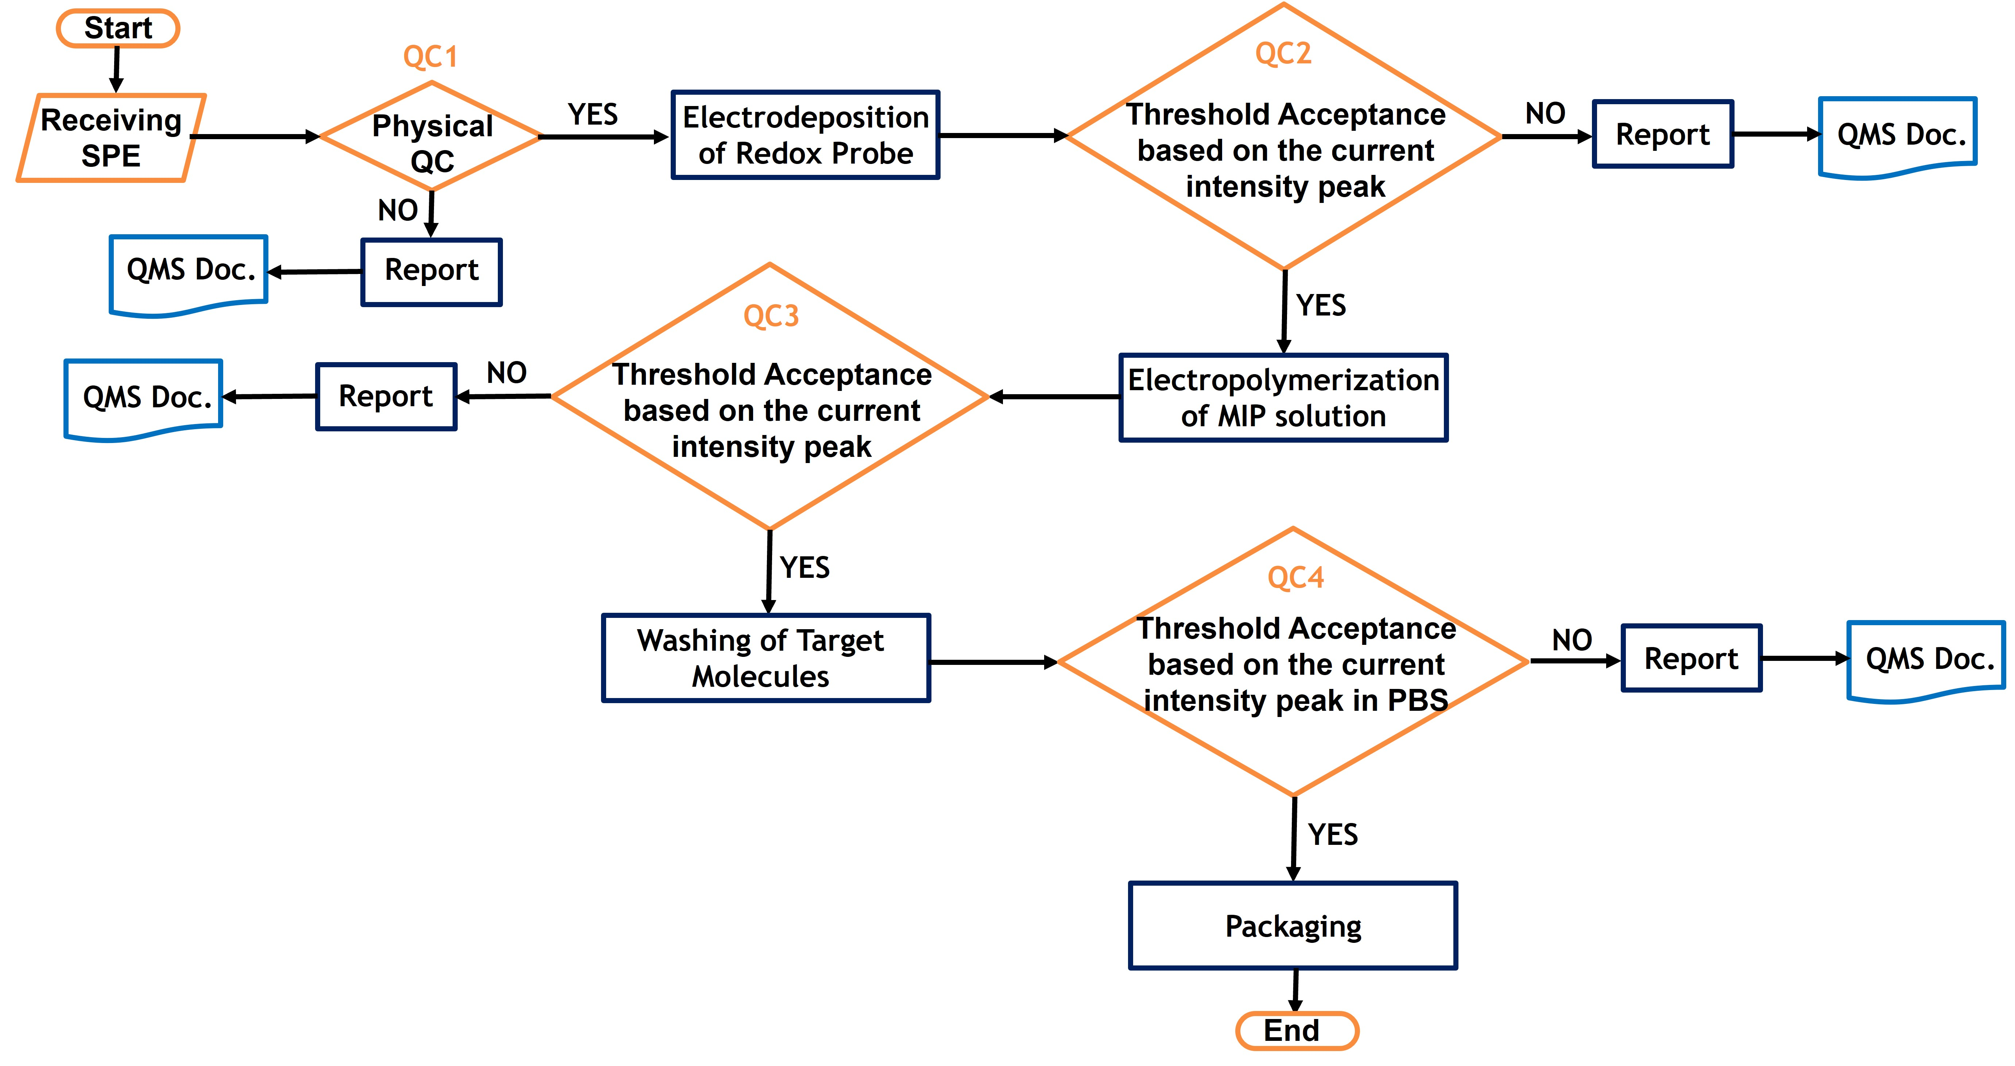
Figure 3: Flowchart of mass-production MIP-based biosensor with attention to four non-destructive quality control steps (QC1-QC4).

Figure 4(b) shows the cathodic peak results of different cycles of the electropolymerization step of GFAP MIP solution. According to the results, sixteen electrodes passed this quality control step (QC3) with the obtained threshold of 40 μA. By enhancing the layers of GFAP MIP film on the prepared electrode, the conductivity of the surface of electrode decreases after 10 cycles of electropolymerization as mentioned in Figure 4(b) for the first and the last scan number. The last scan number was considered for passing the electrode to the next step (Min ipa). Also, this method of quality control is not destructive, and it does not add extra steps to the electro-fabrication process. The results obtained from this approach are so useful to produce GFAP MIP-based biosensors.
The last main step of the quality control strategy is illustrated in Figure 5. After washing the electrode as described in the previous section, the EIS electrochemical measurement was carried out by placing the droplet of PBS on the surface of the electrode. Obtaining this result is essential for calculating the impedance difference for real sample testing. By removing the outlier data with attention to the confirmed range of 1200 Ω to 2800 Ω, thirteen electrodes passed this quality control step (QC4). This biosensor surface resistance range was determined for this GFAP MIP biosensor by comparing all biosensor’s results The sub-figure of Figure 5 shows that about 36 % of electrodes passed this quality control strategy to prepare reliable and reproducible GFAP MIP biosensors. By improving the quality of bare electrodes, it has the potential to enhance the percentage of passed electrodes to more than 65 %.
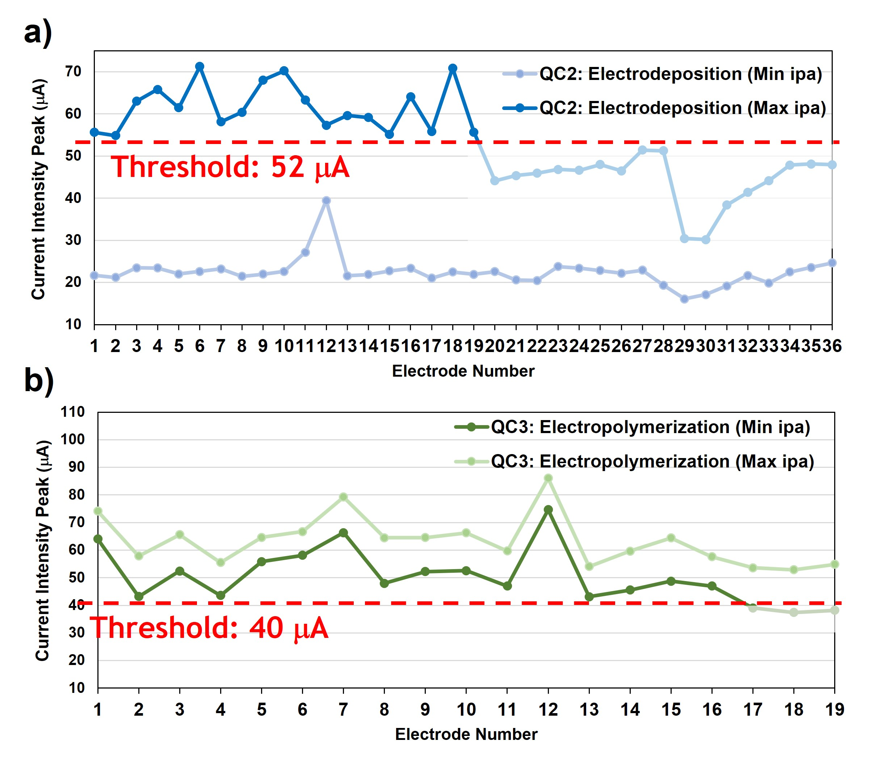
Figure 4: The anodic current peak of cyclic voltammetry results for (a) electrodeposition of redox probe (QC2 Threshold) and (b) electropolymerization of MIP solution (QC3 Threshold).

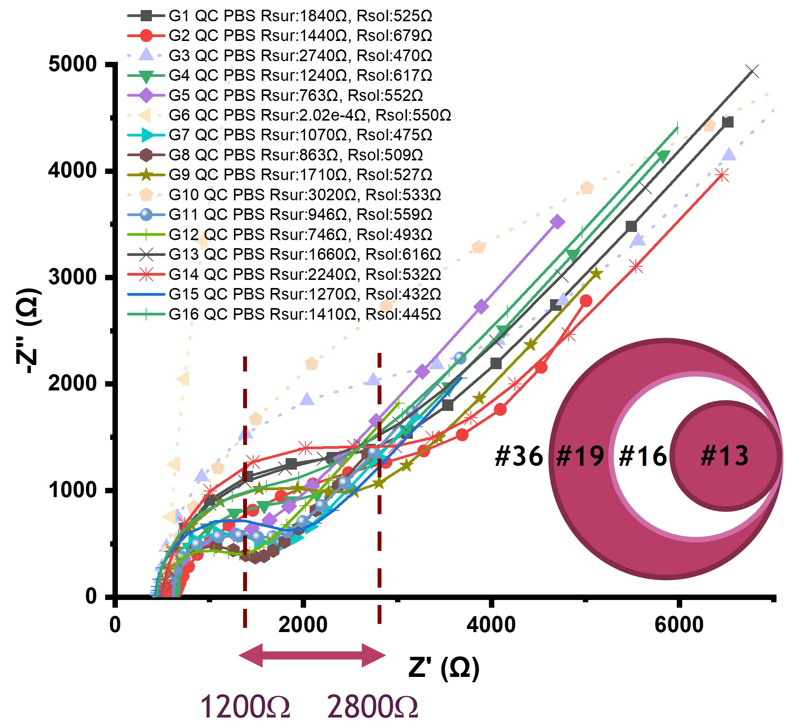
Figure 5: The EIS electrochemical results of washing step quality control (QC4) by placing the droplet of PBS (Rsur: Biosensor Surface Resistance, Rsol: Solution Resistance).

ConclusionS
In this paper, a pioneering strategy for screening electrodes during the electro-fabrication process, enhancing the reliability and performance of MIP biosensors was introduced. This approach incorporates non-destructive quality controls at key fabrication stages, facilitating efficient decision-making in electrode screening. The electro-fabrication process, guided by this quality control strategy, successfully yielded reproducible biosensors for GFAP detection. The strategy’s effectiveness is underscored by achieving a notable 36% success rate in preparing repetitive and high-performance GFAP MIP biosensors, a significant improvement compared to inherent variability observed in bare screen-printed electrodes.
ACKNOWLEDGMENTS
The authors acknowledge Natural Sciences and Engineering Research of Canada (NSERC), Canadian Institutes of Health Research (CIHR), University of Calgary, Innovate Calgary, Mitacs, Alberta Innovates, and CMC Microsystem for supporting this research.

REFERENCES
1. Li, Y., et al., Recent advances in molecularly imprinted polymer-based electrochemical sensors. Biosensors and Bioelectronics, 2024: p. 116018.
2. Harris, A.R., et al., Efficient strategy for quality control of screen-printed carbon ink disposable sensor electrodes based on simultaneous evaluation of resistance, capacitance and Faradaic current by Fourier transform AC voltammetry. Journal of Solid State Electrochemistry, 2008. 12(10): p. 1301-1315.
3. Kan, X., et al., Molecularly imprinted polymers based electrochemical sensor for bovine hemoglobin recognition. Sensors and Actuators B: Chemical, 2012. 168: p. 395-401.
4. Ribeiro, J., et al., Electrochemical detection of cardiac biomarker myoglobin using polyphenol as imprinted polymer receptor. Analytica Chimica Acta, 2017. 981: p. 41-52.
5. Park, R., et al., Recent advances of point-of-care devices integrated with molecularly imprinted polymers-based biosensors: From biomolecule sensing design to intraoral fluid testing. Biosensors, 2022. 12(3): p. 136.
6. Marimuthu, M., et al., Chapter 20 - Commercialization and safety aspects of biosensing technologies, in Health and Environmental Applications of Biosensing Technologies, M. Veerapandian, J. Joseph, and M. Marimuthu, Editors. 2024, Elsevier. p. 425-438.
7. Salahandish, R., et al., Immuno-affinity potent strip with pre-embedded intermixed PEDOT: PSS conductive polymers and graphene nanosheets for bio-ready electrochemical biosensing of central nervous system injury biomarkers. ACS Applied Materials & Interfaces, 2022. 14(25): p. 28651-28662.
8. du Plooy, J., et al., Advances in paper-based electrochemical immunosensors: Review of fabrication strategies and biomedical applications. Royal Society Open Science, 2023. 10(11): p. 230940.

∗ Email: Mohammadreza.farrokh@ucalgary.ca

