Reducing Risk to Patient Safety with Custom Modification to Manufacturer’s Design
Kamallesh Canjimavadivel1
¹ Sinai Health/Department of Biomedical Engineering, Toronto, Canada

Abstract— This paper explores the experimental process of improving the design of an adapter to reduce patient safety risk. The built-in tether that secures the adapter to the multi-function cable for a defibrillator did not meet the clinical needs. As a consequence the adapter gets discarded and leaves the defibrillator in a state not ready to be used in an emergency situation. Three solutions were considered to minimize the risk. The final solution is a combination of two solutions which involves a set screw being added to the lock tab which prevents the tab from being pressed. This, in-turn, limits the ability to remove the adapter. A label was also added to add a visual that would prevent the removal of the adapter. The proposed solution was met with positive feedback from the clinical staff and was implemented across two units, ICU and ER. Since the implementation there have not been any complaints of missing adapters. This process opens up the opportunity to improve the design of other accessories as needed.
Keywords— Defibrillator, Adapter, Patient Safety, Multi-function Cable (MFC)

INTRODUCTION
Medical devices are designed to be the best in their class. Manufacturers integrate unique features into their products and accessories to increase their appeal and provide ease of use. In some cases, the intended function by design does not meet the needs of the end users in the clinical environment.
Mount Sinai hospital recently rolled out a new fleet of defibrillators with a change in manufacturer of the previous fleet. The defibrillators are capable of being used with various types of single use pads or reusable paddles connected to a multi-function cable (MFC). The defibrillators at our site use an adapter that connects onto the standard MFC and allows use of specialized CPR pads that have a green connector.

Overview

Problem Statement
The current security measures that are built into the design are not adequate to prevent the adapter from being separated from the MFC. Two issues arise when an adapter is missing. Firstly, there is a patient safety issue as the defibrillator will not be ready for use in the event of an emergency. The second issue is the associated cost with replacement, the adapter costs $500.

Background
When the new defibrillator fleet was rolled out, all devices were outfitted with accessories and adapters. Over time it was found that various units needed replacement of the adapter. Initially this was considered as a teaching point during the early adoption phase of the rollout of a new fleet. Staff needed time to become familiar with the new devices and all of its components. This opportunity was used to reinforce the idea to staff that the pads could be removed from the adapter and the adapter does not need to be removed from the MFC. However, there were continuous reports of missing adapters. Further investigation revealed the adapters were getting thrown out with the pads as they are discarded after use.

Assessment
The design of the adapter includes a locking tab (Figure 1) that clicks into place when correctly seated on the MFC. There is also an attached tether (Figure 2), made from a nylon plastic type material that is intended to go around the MFC end before the adapter clicks into place. In the event the adapter needs to be disconnected from the MFC, the tether will keep it attached to the cable. To remove the adapter, the tab needs to be depressed and then the adapter can be disconnected from the MFC and can hang from the tether until it needs to be reconnected.

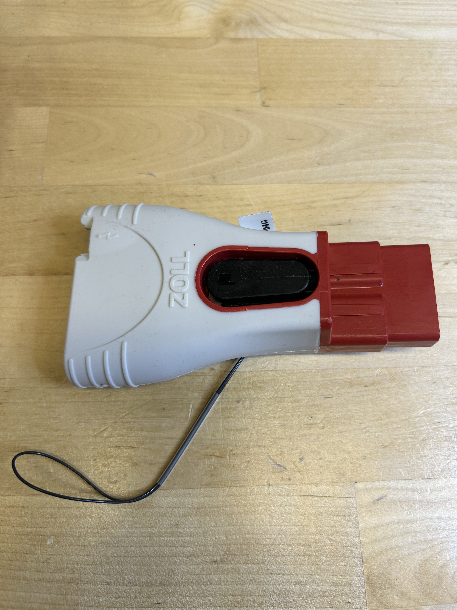

Figure 1: Top view of adapter with lock tab

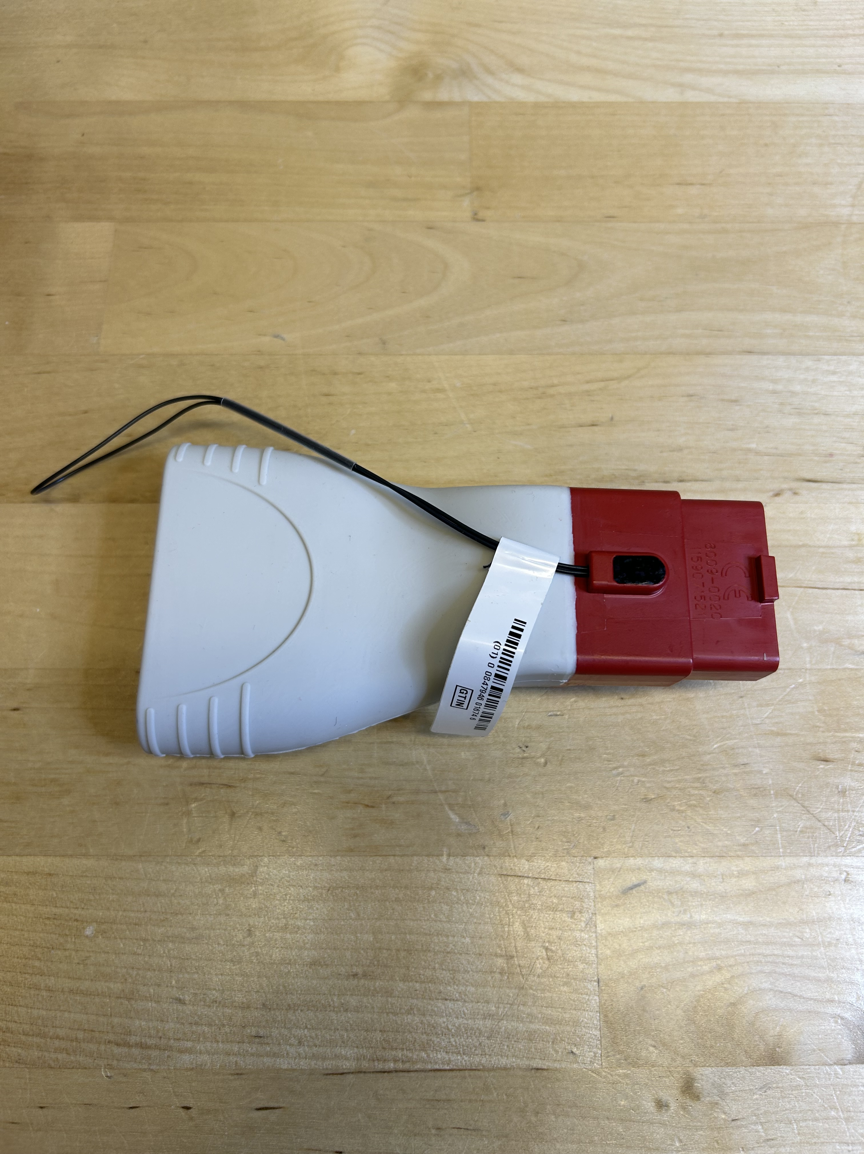

Figure 2: Bottom view of adapter with nylon plastic tether

On a majority of the adapters the tether was ripped and as a consequence the adapter was no longer secured to the MFC. The built-in design feature to keep the adapter attached to the MFC was no longer viable and an alternative solution was required. Multiple solutions were considered.

Solution Evaluation

Solution I
One solution that was considered and trialed was simply adding labels to the adapters. Two labels were added: one stating “Do not discard” and another “Do not remove”. These labels were printed on a yellow label and attached to the adapter directly. The intention was to have a visually appealing label that would stand out and provide additional information. This idea was to supplement the initial education information of removing the disposable pads from the adapter after use.

Solution II
Another solution that was considered was to install a steel wire tether to replace the nylon plastic tether. This process would involve drilling a hole into the adapter to allow the wire to be fed through and crimping the wire through a clamp after it is secured around the MFC. The entire process requires multiple tools and components nut can be implemented relatively quickly. After installation the wire tether would provide the same function as the nylon plastic tether but with higher durability that will not rip or break.

Solution III
A third solution considered was to add a set screw that goes through the button on the adapter. This process involves drilling a hole into the locking tab and installing a set screw. Once screwed in the set screw would prevent the tab from being pressed. This in turn would keep the tab locked in at all times, preventing the adapter from being disconnected entirely. The process to implement would be very quick.

Analysis
The initial solution was the first solution. However, this method did not yield the results that were expected as adapters continued to be discarded. The final solution that was implemented was to use a combination of the first and third solution. A set screw was installed in the lock tab (Figure 3) and a label was put over the lock tab with the message “DO NOT REMOVE” (Figure 4). The set screw requires a 3/32” size hex key to remove and the label was printed on a red label. The simplicity of the solution allows for easy implementation and can be reversed in the adapter needed to be remove intentionally. The clinical staff would not be able to remove the adapter without the correct tools or causing damage. The solution was proposed to the clinical team for feedback and they felt this solution would meet their needs. It took about 10 minutes to install the screw on the adapter. The solution was implemented in two clinical areas, ICU and ER. Since then there have not been any calls regarding missing adapters.

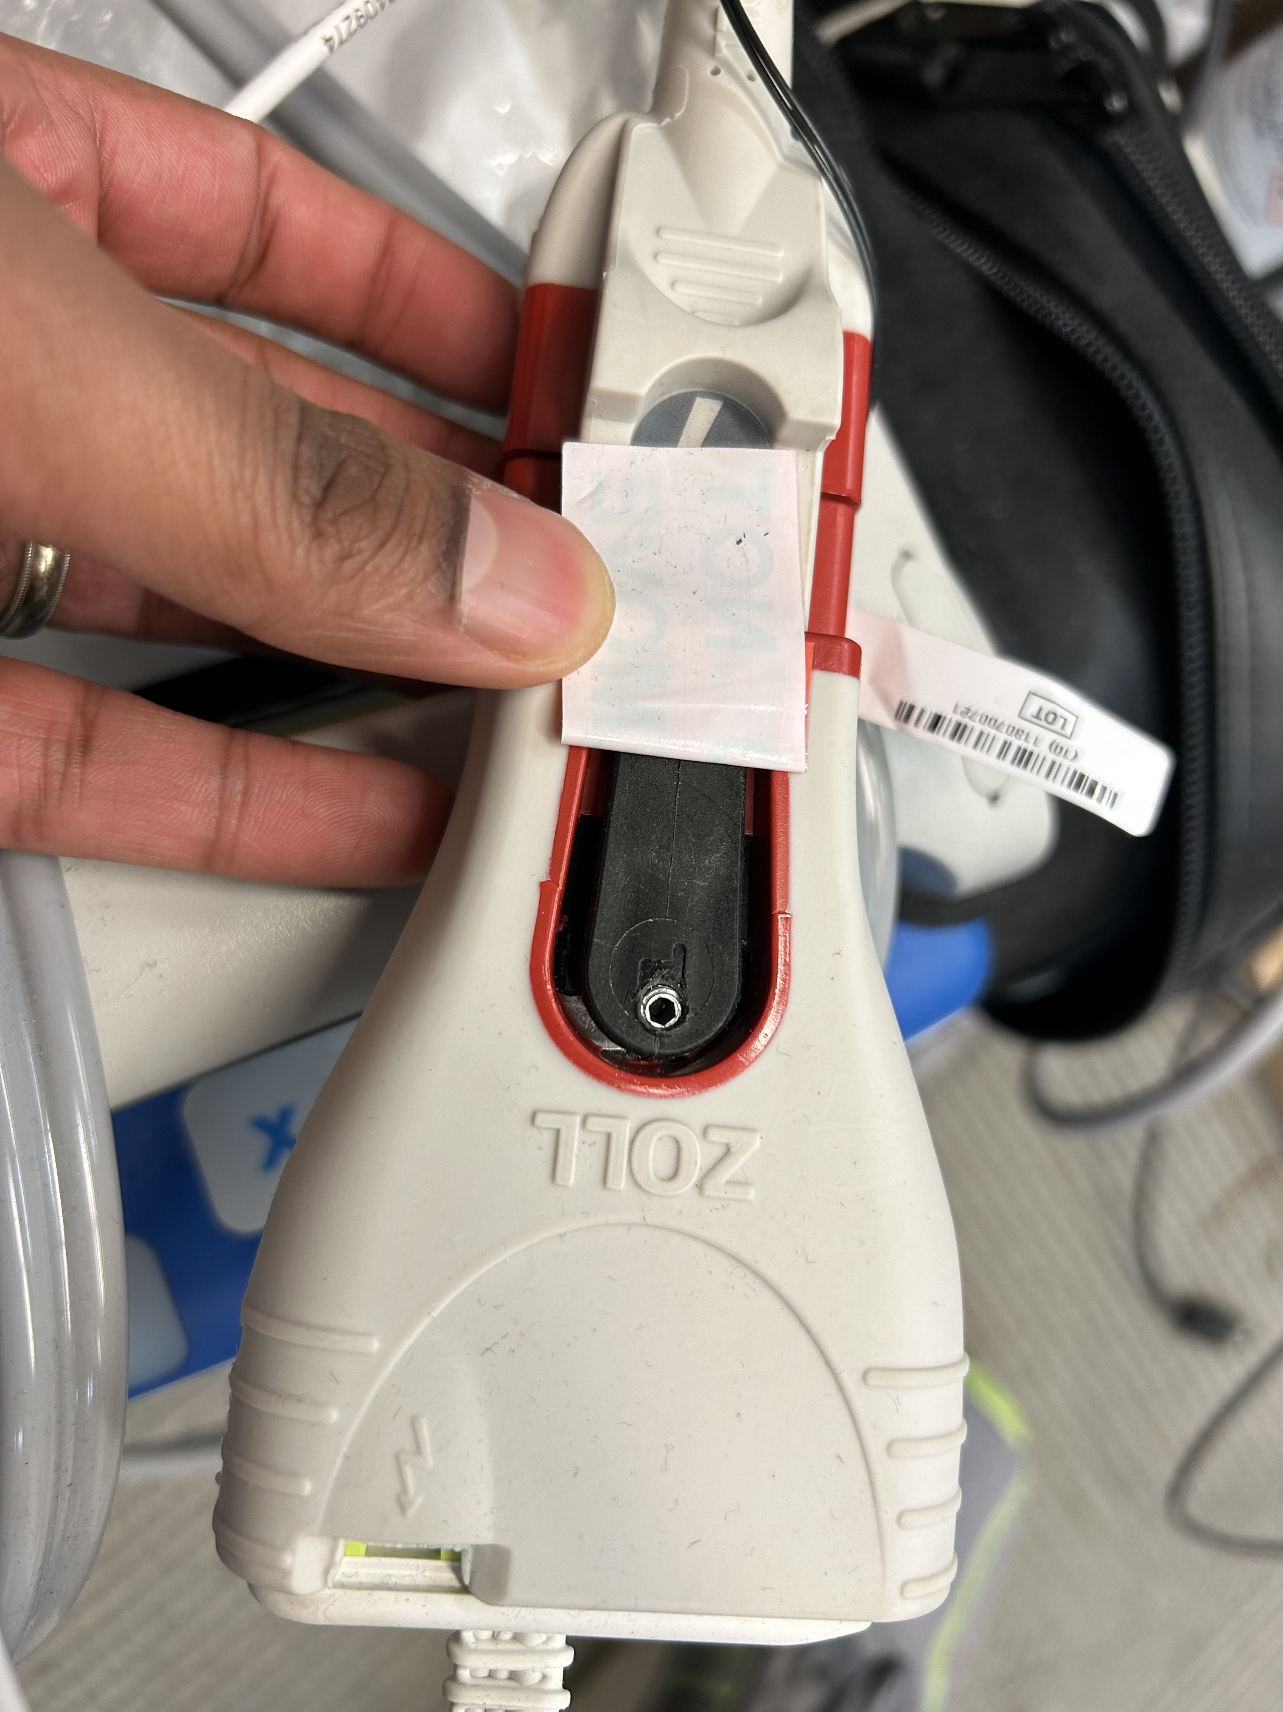

Figure 3: Final solution with set screw installed

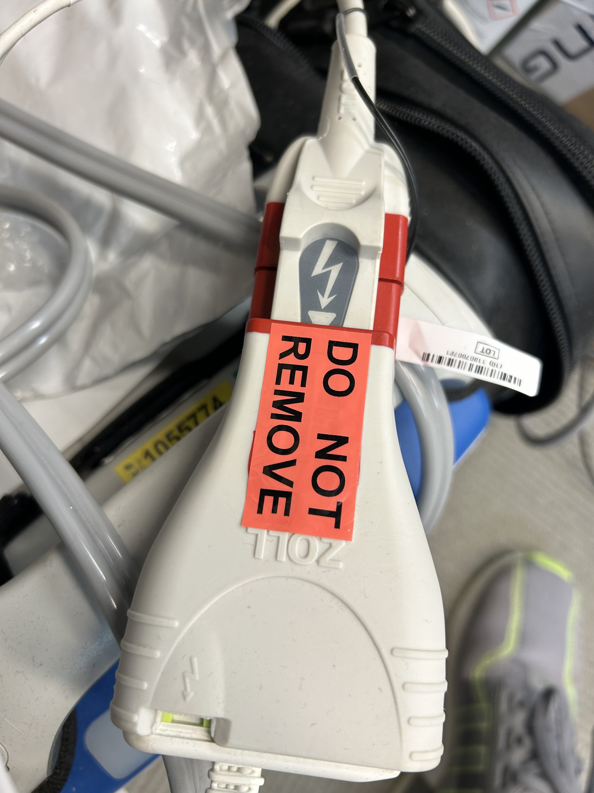

Figure 4: Final solution with visual label

CONCLUSION
Two problems arose from shortcomings of the intended design of the stock adapter: patient safety risk and high cost of replacement. After some trials a solution was found to address both problems. Securing the adapters and preventing them from being removed improves workflow for both clinical staff as well as biomed staff. This project also brings to light the potential of improving manufacturer design of any medical device design without compromising the functionality. Upon completion of this project, our team is better equipped at identifying similar opportunities with other devices. While manufacturer designs have their own unique advantages, there is always room for improvement to fit hospital specific clinical needs.

Conflict of Interest
The author declares that they have no conflict of interest.

