Best and Final Offer (BAFO) Procurement of Clinical Medical Equipment
A. Toomari¹, MHSc, P.Eng., M. Ramirez¹, P.Eng., MASc., CCE, FCMBES, S. Bruch¹, M.Eng., R. Yang¹, BASc, and Danny Bettencourt²
¹ Medical Engineering, The Hospital for Sick Children, Toronto, Canada
² Procurement, The Hospital for Sick Children, Toronto, Canada

Abstract- Public funded Ontario hospitals are required to be in compliance with the Broader Public Sector (BPS) procurement directive. As part of this directive, a total procurement value of goods, non-consulting services and construction above a threshold value of $121,200 (effective January 1, 2024) will require an open competitive process. This process often referred to as Request for Proposal (RFP) may have an additional step, called best and final offer (BAFO) incorporated. In the BAFO process, shortlisted vendors would go through an additional stage with new rated criteria and submission of best and final offer for pricing. An RFP process may span several months depending on the complexity of the product or services being procured. The addition of the BAFO step extends these timelines. This is in addition to the increased effort and resources required to draft and evaluate additional rated criteria and to evaluate the BAFO results. In this paper we aim to provide an overview of the steps involved in RFP and BAFO processes. We will also compare and analyze the results of two RFP and BAFO initiatives undertaken by The Hospital for Sick Children (SickKids) and review the benefits and challenges given the impact on project schedule, cost, and resources. We will also provide recommendations on important aspects to consider before initiating BAFO RFPs.
Keywords - Procurement, RFP, BAFO, BPS directive, medical equipment
- INTRODUCTION
Public funded Ontario hospitals are required to be in compliance with the Broader Public Sector (BPS) procurement directive. The BPS procurement directive describes procurement rules for the purchase of goods and services with public funds under Ontario’s Broader Public Sector Accountability Act, 2010 [1].
The purpose of this act is to
- to ensure that publicly funded goods and services, including construction, consulting services, and information technology are acquired by BPS organizations through a process that is open, fair, and transparent.
- to outline responsibilities of BPS organizations throughout each stage of the procurement process; and
- to ensure that procurement processes are managed consistently throughout the BPS [1] [2].
The directive is based on the following 5 key principles: accountability, transparency, value for money, quality service delivery, and process standardization [1] [2].
In the Canadian hospital setting, when a need is identified to procure new medical equipment or services, either one of the following sourcing methods is used: request for quotation (RFQ), request for tender, or request for proposal (RFP) [2].The procurement process that will be discussed and reviewed in this paper is Request for Proposal (RFP) and a multi-stage procurement process and RFP sub-step called Best and Final Offer (BAFO).
As per BPS directive, for purchases above $121,200 (previously over $100,000) an open competitive procurement process or RFP is required [2]. If the hospital or procuring entity determines that there are some criteria or requirements that need to be further discussed or questioned with the vendors and that the vendors would be able to further reduce the original price of the goods/services, a second process, called best and final offer is initiated [3]. The decision to complete a BAFO RFP needs to be made by the hospital prior to posting the initial RFP. This helps participating vendors in knowing that the RFP they are bidding on will have a BAFO stage.
The objectives of the Best and Final Offer (BAFO) are to:
- Increase understanding by vendors of the hospital’s requirements.
- Create competitive tension or enhance competition amongst highly motivated vendors, which means the procurement process can be concluded quicker as vendors may be more willing to accept a higher risk profile to win the contract.
- Encourage creative or innovative solutions and allow for different options for delivery to be considered.
- Expose potential risks such as technical shortfalls or depth of competencies.
- Develop contract management objectives and performance metrics to address inherent areas of risk.
- To allow vendors/proponents to adjust their bids/proposals for new market conditions and to update their submissions around the edges for new technologies and practices [3].
The BAFO process is not without its challenges as it has an impact on project timelines, costs, and resources. The BAFO process requires drafting and submission of a second set of rated requirements/criteria. The BAFO criteria may include certain features or functionalities that the clinical or technical stakeholders would like to learn more about or to obtain some clarification of the proposed product. Additional time and resources are required to draft, review, and finalize such criteria. Moreover, the procurement team has to reevaluate the scoring after BAFO submission for both rated requirements and pricing.
In the next sections, we will provide an overview of the full RFP process and BAFO process (as a sub-step of RFP process) and review and analyze an example of a recent RFP and BAFO that was completed at the SickKids hospital. We will also discuss the impact on timelines and resources versus the cost benefit.
- COMPETITIVE PROCUREMENT
- Request for Proposal
A Request for Proposal (RFP) is a document used to request suppliers to supply solutions for the delivery of complex products or services or to provide alternative options or solutions. It is a process that uses predefined evaluation criteria in which price is not the only factor [2].
The series of steps in an RFP process are as follows:
      - Gather requirements and create mandatory and rated criteria (general, functional, safety, & training)
      - Review and finalize requirements with users.
      - Finalize the grading/rating (contract, pricing, requirements, on-site evaluations)
      - Post the RFP.
      - Evaluate bids.
      - Finalize scoring based on RFP responses.
      - Select top bidders (typically 2 or 3)
      - Conduct clinical trials or on-site evaluations.
      - Final scoring and select the top bidder.
      - Initiate negotiations and award contract.
The typical timeline of an RFP process starting from step 1 to step 10 is between 4 to 8 months depending on the complexity of the technology and the RFP. An example timeline is shown in Fig. 1 below.

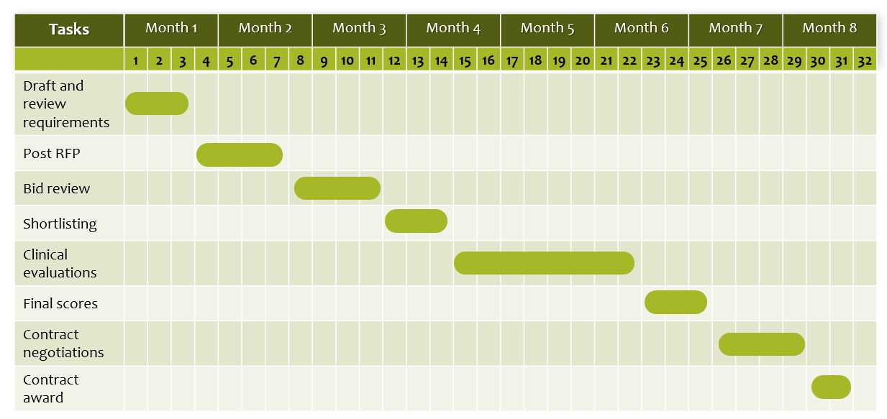
Fig. 1 RFP timeline
- Best and Final Offer (BAFO)
A BAFO is a multi-stage procurement strategy where it is believed that the procurement process would benefit from bidders/proponents having a final opportunity to improve their bids or proposals, by reducing prices, clarifying, or modifying their bid or proposal, or providing additional information [3].
The BAFO process can be considered as an additional step in the RFP process – after completion of the rated evaluations. As part of this step, shortlist bidders are invited to participate in an additional round of responses to more focused /rated requirements. The bidders are also invited to provide a revised financial submission which would be a better reduced pricing schedule than what was previously provided in the first RFP round. The additional steps are Create BAFO rated questions; Post BAFO; Evaluate BAFO responses; and Finalize BAFO scores.
Execution of BAFO from step 1 to 4, adds an extra duration to the RFP and project timelines. Fig. 2 shows an RFP timeline with the above-mentioned BAFO steps and impact on RFP and project schedule.
Fig. 3 is a flowchart depicting the RFP and BAFO processes.

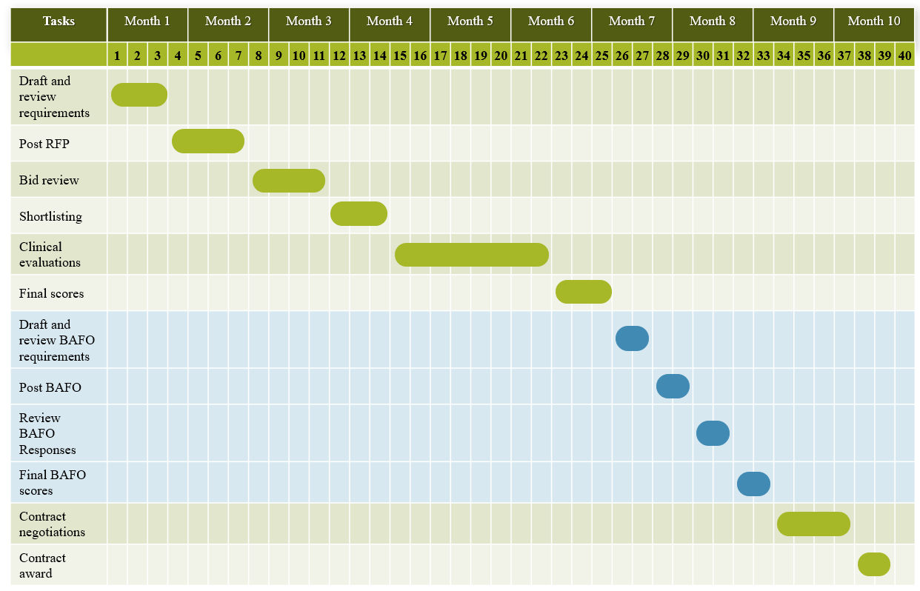
Fig. 2 BAFO impact on RFP timeline
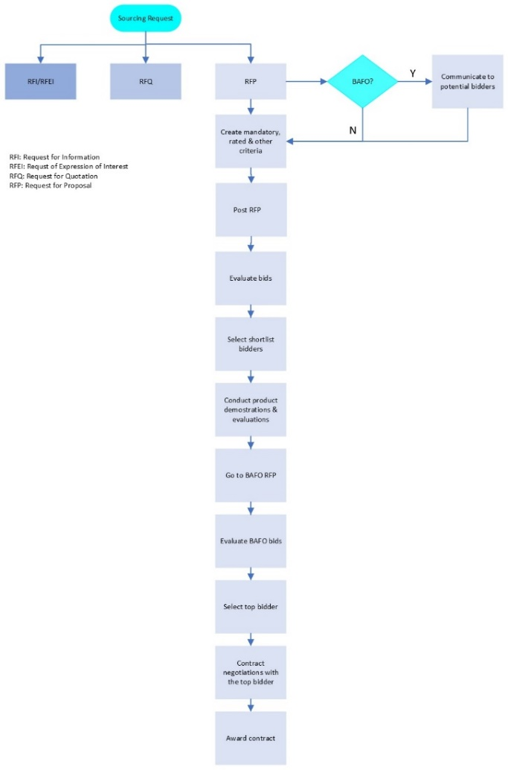
Fig. 3 Overview of RFP and BAFO processes
- COMPARISON AND ANALYSIS
One of the advantages of the BAFO process is the opportunity to ask additional questions that were missed during the first stage of the RFP and complete additional clinical evaluations. Another advantage stemming from this is that by the time of the BAFO, the procurement team is more familiar with the offered technologies and can ask more focused and direct questions to the vendors in the BAFO rated criteria step. Additionally, BAFO offers the potential for reduced pricing or value adds on capital equipment, implementation, training, accessories, or consumables and possibly reduced operational costs.
Initiating the BAFO process also has disadvantages such as extending the RFP or project timelines and as shown in Figure 2. This may or may not have an impact clinically or may put the hospital at a risk operationally if the existing technologies are obsolete and require immediate upgrades or replacements. Another disadvantage tied to the previous point is that there are multiple groups involved in the RFP and BAFO process and with the extension of project timelines, these groups would be impacted in terms of resources and time taken away from other projects/initiatives. Additionally, the BAFO process is not a guarantee that the vendors will offer reduced pricing or significant discounts and there is a chance that the pricing before and after the BAFO would remain unchanged.
In Fall/Winter 2020 The Hospital for Sick Children (SickKids) initiated an RFP process for two (2) different medical devices (equipment 1 and equipment 2) and related accessories, consumables, installation/ implementation, spare units, integration, and training (biomed and clinical). The decision to complete a BAFO was made before RFP initiation, and this was communicated with the vendors ahead of time. The purpose of the BAFO process was to further clarify requirements and seek reduced procurement and implementation costs. The impact of the BAFO on RFP pricing for both equipment is shown in Table 1.
Table 1 Original and BAFO pricing comparison
Equipment 1 | Vendor 1 | Vendor 2
RFP Price | Base RFP price | Base RFP price
BAFO Price | Base RFP price – 4% discount | Base RFP price + 0.33%
Value Adds (post BAFO) | Yes | Yes
Equipment 2 | Vendor 1 | Vendor 2
RFP Price | Base RFP price | Base RFP price
BAFO Price | Base RFP price – 5% discount | Base RFP price
Value Adds  (post BAFO) | Yes | Yes
As shown in Table 1, the BAFO process is deemed helpful in obtaining reduced pricing from 2 vendors. Vendor 1 for equipment 1 reduced their pricing by approximately 4% by offering value adds and additional discounts on unit pricing. For the same equipment, the BAFO price offered by vendor 2 was slightly increased than what was offered in the base RFP price. However, this increase was due to the hospital refining their requirements in BAFO and therefore modifying some of the features and capabilities of the equipment (not in scope pre-BAFO). Compared to what should have been originally included in the RFP base price, the BAFO pricing provided by vendor 2 was also discounted and included value adds.
Similarly for equipment 2, vendor 1 reduced their pricing by approximately 5% while vendor 2 did not offer any additional discounts. Through BAFO, the SickKids hospital was able to clarify their implementation and networking requirements and integration of both equipment 1 and 2 with existing hospital infrastructure and have a better understanding of which vendors would have a smoother implementation.
Analysis of the pre and post BAFO pricing for the two RFP projects discussed in this section, shows that:
- BAFO is beneficial in helping the hospital refine their requirements, project scope, and gain a better understanding of implementation requirements.
- BAFO may or may not lead to better or reduced capital pricing.
- BAFO may lead to reduced operational costs.
- BAFO requires additional time and effort from all parties involved in the procurement initiative.
Important factors to consider before initiating an RFP with BAFO are:
- Capital cost of equipment
- Procurement and implementation timelines and if extended BAFO timelines would be acceptable to the hospital and the project team.
- Clinical impact (if any) as a result of BAFO extended timelines.
- CONCLUSION
As per BPS directive and guidelines, hospitals need to initiate an open competitive procurement process or RFP for purchases above $121,200 (previously over $100,000) [2]. The regular RFP process may benefit from an additional step called Best and Final Offer (BAFO) if the hospital determines that there are some criteria or requirements that need to be further discussed or clarified with the vendors and that the vendors would be able to further reduce the original price of the goods/service [3].
The decision to complete a BAFO is made prior to RFP initiation. While BAFO is an additional step that does not guarantee a reduced capital cost, is resource intensive and extends project and RFP timelines, it has several advantages. BAFO enables the hospital to ask additional technical and focused questions that were initially missed and potentially receive a discounted price on equipment, service, implementation, and training.
SickKids's latest BAFO RFPs completed in 2020/2021 have shown that this process may lead to the desired outcomes, which are reduced pricing from the bidding vendors and understanding implementation and integration of the offered technologies with existing hospital infrastructure. However, the reduced pricing may not always be achieved in terms of a reduced final price offered by the vendors but rather it may include value add offers or an extension of a warranty or service at no charge. While these are not necessarily a reduction in price compared to what was originally offered in the first stage of the RFP by the vendor, they amount to operational cost reductions in the long term.
In conclusion, whether or not it is beneficial to the hospital to complete a RFP with a BAFO process, depends on complexity of the technologies being procured, the total value of the RFP, and the hospital’s implementation timelines. RFPs that are simple in nature with lesser capital and service costs may not benefit from a BAFO process as the savings may not amount to much compared to the total value of the RFP. Sometimes the hospital may also have tight implementation timelines due to failing equipment required for critical care or critical care equipment no longer being supported by the vendors. At these times, the project team needs to assess and determine if the benefit offered by BAFO’s reduction in pricing will outweigh the extended procurement and implemenation timelines.
It is recommended that a BAFO RFP be initiated based on the following considerations:
- Capital Budget Consideration – when the capital budget for the proposed equipment is of high value and potential cost savings from BAFO
- Clinical impact – the hospital should complete an assessment to determine if delivery of safe patient care would be impacted if the equipment procurement and installation is delayed
- RFP complexity where additional BAFO stage can enhance the competitiveness and clarity of proposals
CONFLICT OF INTEREST
The authors declare that they have no conflict of interest.
REFERENCES
- University of Guelph, "University of Guelph Financial Services," [Online]. Available: https://www.uoguelph.ca/finance/departments-services/procurement-and-payables/getting-started-procurement/broader-public-sector. [Accessed 16 11 2023].
- Ministry of Public and Business Service Delivery, "Broader Public Sector Procurement Directive," 1 July 2011. [Online]. Available: https://www.doingbusiness.mgs.gov.on.ca/mbs/psb/psb.nsf/Attachments/BPSProcDir-eng/$FILE/BPSProcDir-eng.html.
- The World Bank, "Procurement Guidance - Negotiations and Best and Final Offer (BAFO)," Washington, 2018.

