Predictive Capital Equipment Replacement Planning through Equipment Life Cycle Management

U. Ahmed1, MHSc., S. Bruch 1, M.Eng., and M. Ramirez1, P.Eng., MASc.

1 Medical Engineering Department, The Hospital for Sick Children, Toronto, Canada

Abstract—Every year Canadian hospitals spend millions on the procurement of capital equipment. Often the capital planning and procurement of equipment is a reactive and not proactive process. As a result, critical information required during the procurement process and accurate prioritization of equipment replacement is missed. This paper will highlight factors to consider when replacing medical equipment, and challenges with implementation of a predictive replacement life cycle management program. Additionally, this paper will review the steps involved in the creation of a predictive Medical Equipment Life Cycle Management program at The Hospital for Sick Children (SickKids). SickKids took a methodical approach when designing the program which included reviewing a medical equipment database, literature review, third party consultation (ECRI), and meetings with end users.

INTRODUCTION

Medical equipment life cycle management in most hospitals is not a data-driven process. Often the procurement of capital equipment is made on the departmental level, and a capital request is placed to purchase an item without considering key factors related to equipment purchasing, preventative maintenance, repairs, vendor notifications for out of support equipment, and decommissioning. This approach leads to inaccurate inventory and asset values, non-compliance with regulatory requirements, and increased unplanned capital purchases [1]. Increased unplanned capital purchases highlights the reactive nature of this approach.

In this paper we will review the establishment of a wholistic predictive medical equipment life cycle management program, including factors to consider during the planning process and challenges with implementation.

Medical equipment Life cycle management

Capital Equipment Planning

Prior to implementing a medical equipment life cycle management program, it is essential that senior leaders create a formal capital equipment approval process. This process should include an interdisciplinary team of stakeholders such as hospital executives, clinical managers, finance, Information Technology, and Medical Engineering. After key stakeholders are identified it is important to establish an equipment planning committee of primary stakeholders who continuously review past, present, and consider the future to determine the impact of the hospitals strategic directions on equipment needs and services [2].

Predictive Replacement Planning

In 2022, the SickKids’ Medical Engineering department started creating a medical equipment life cycle management program. A methodical approach was taken which involved reviewing the medical engineering equipment database, literature review, determining equipment scope outside of medical engineering, and an extensive formal review with a trusted third party - Emergency Care Research Institute (ECRI) - to ensure standards of practice were met. Fig.1 below illustrates the steps taken to establish the medical equipment life cycle management program.

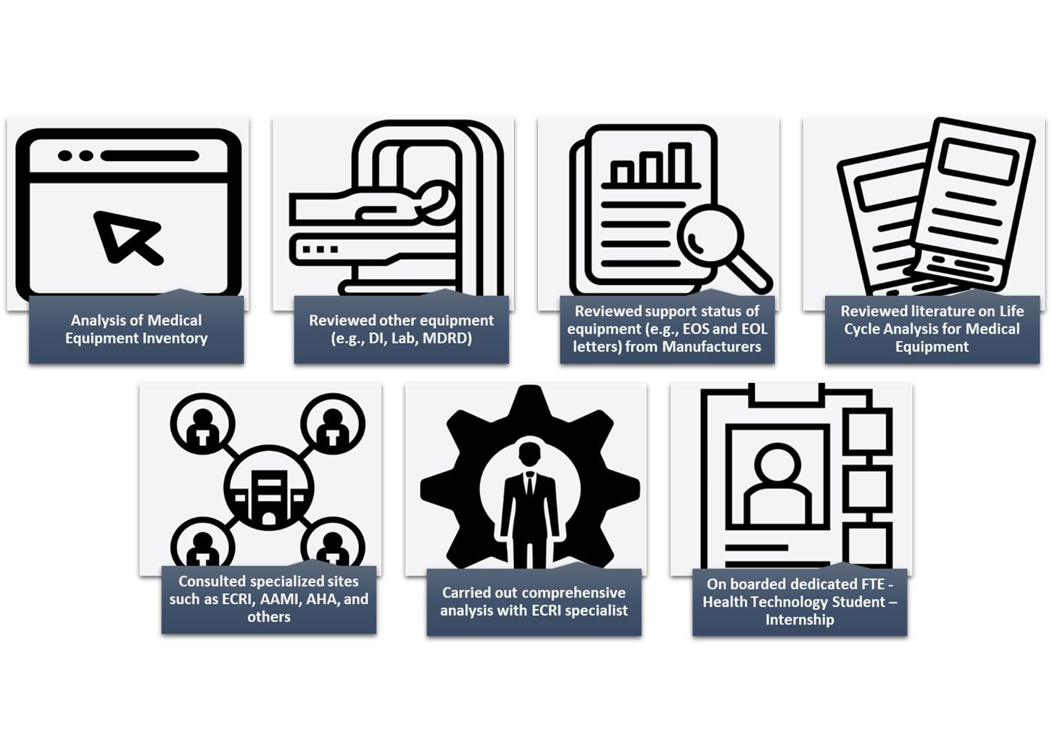Fig.1 Overview of the steps taken to establish the medical equipment life cycle management program at SickKids.

ECRI was contracted to verify and review a comprehensive Predictive Replacement Plan (PRP) completed by medical engineering for approximately 15,000 medical devices hospital-wide (Fig. 2). It is important to note an accurate biomedical inventory is essential when creating a robust predictive equipment life cycle management program. The equipment inventory was provided by the medical engineering department in collaboration with various clinical departments. This was necessary because not all equipment included in the analysis is maintained by medical engineering (e.g., Diagnostic Imaging, Laboratory, Pharmacy, Plant Operations). To provide expected life and replacement cost over the next 10 years, equipment included in the analysis was standardized to ECRI’s Universal Medical Device Nomenclature System (UMDNS). Devices excluded from the analysis comprised: test equipment, IT devices (computers, switches, access points, etc.), furniture, and infrastructure (elevators, HVAC, etc.). For the analysis all the pricing for existing equipment was provided by SickKids, and the replacement pricing was determined by UMDNS category and not a one-to-one model replacement price.



Fig.2 Quantity of equipment planned for replacement across 10 years for various programs at SickKids based on analysis from the Medical Equipment Life Cycle Management Plan

ECRI facilitated meetings with select department managers, clinicians, and clinical engineers. The purpose of the user meetings was to validate the data provided to ECRI as well as gain clinical end-user input. For example, replacement years for equipment was adjusted due to high or low utilization of equipment. Along with end-user input, additional criteria such as equipment age, OEM support and service, safety and risk, purchase cost, and equipment condition was used to evaluate equipment replacement across ten years (see Table 1).

Table 1 Predictive Replacement Planning Criteria [1]

|  |  |
| --- | --- |
| **Criteria** | **Description** |
| **Equipment Age (Life Span)** | The equipment may be susceptible to failure due to wear and tear with age. |
| **OEM Support and Service** | Original Equipment Manufacturers’ (OEM) ability to provide replacement parts as well as service and support. |
| **Safety and Risk** | The level of risk hospital staff or patients would take on if the device was not replaced. |
| **Purchase Cost** | Medical equipment with a higher cost should be identified earlier to allow for enough budgeting time. |
| **Equipment Condition** | Condition of the equipment based on how frequently it is used. Heavy use of equipment indicates the device may need to be replaced earlier than required by OEM. |

Upon completing the analysis, ECRI provided various cost reduction recommendations including standardization of all major devices to a single vendor, when possible, within a particular service line (e.g., Physiological Monitors, Ventilators, Endoscopes). Another suggestion was entering long term agreements with vendors to lock down pricing given the projection of equipment replacement was established for the next ten years. The long-term agreements would need to include technology leapfrog language to ensure future advancements in technology are covered. The last recommendation was to consider lease agreements for devices that are not technology mature and require frequent replacement (7 years or less), such as ultrasound machines and endoscopes.

Additional factors SickKids considered when implementing the equipment life cycle management program included:

1. Ongoing redevelopment projects
2. Equipment standardization
3. Infrastructure Requirements
4. Equipment Purchase Type
   1. Net new equipment purchase
   2. Replacing existing equipment
   3. Upgrading Equipment
   4. New and emerging technologies

limitations and reccomendations

The implementation of a medical equipment life cycle management program is essential to meet hospital priorities, reduce unnecessary capital expenses, and most importantly reduce patient risks and delay/denial of care. However, there are limitations to consider when implementing this program [3], mainly:

1. **Continuous upkeep and equipment documentation**

*Limitation:* The cyclical nature of equipment planning creates the need to constantly adjust the medical equipment life cycle management plan.

*Recommendation:* Use of a centralized computerized maintenance management system (CMMS) hospital-wide which includes a capital equipment planning module. In addition, if possible, integrate the hospital purchasing system with the equipment CMMS database to reduce errors and failures.

1. **Existing noncentralized approach – Data Gaps**

*Limitation:* Due to the various departments involved in the capital planning process, not all equipment inventory information is housed in the medical engineering CMMS database (e.g., IV poles, wheelchairs).

*Recommendation:* Clearly define the equipment scope for each department and use a centralized computerized maintenance management system database hospital wide.

1. **Clinical end-user priorities**

*Limitation:* Due to competing priorities and a focus on patient care, engaging clinical end users can be challenging.

*Recommendation:* Utilize existing standing meetings (daily rounds) to gather feedback and engage senior leadership for support. In addition, build rapport with staff, casual “hallway conversations” can sometimes be the best method to get information.

1. **Scope creep**

*Limitation:* Discussions could result in scope creep, which requires the creation of additional processes and procedures. For example, when implementing the program at SickKids, the need for tracking equipment outside of the medical engineering scope (e.g., medical dispensing cabinets, furniture) was determined.

*Recommendation:* Clearly define the equipment scope for each department and use a centralized computerized maintenance management system database hospital wide.

CONCLUSIONS

With lessening capital dollars available each year, the need for a medical device life cycle management program is essential in today’s hospital environments. Often institutions investigate replacing the high-tech showy items found in the surgical suites, cardiology, and imaging – and neglect thousands of items such as beds, IV Poles, and wheelchairs. Although items such as these are not glamorous, they add up to millions of dollars of equipment that must be planned for eventual replacement. A robust capital equipment life cycle management program can save institutions possibly millions over a long-term replacement cycle (5 to 10 years), by prioritizing capital purchases on objective data and grouping purchases into logical groups so that institutions may obtain the best value for dollar.

In conclusion, the establishment of a comprehensive medical equipment life cycle management program is crucial for addressing the challenges associated with reactive capital planning in Canadian hospitals. This paper presented a methodical approach taken by The Hospital for Sick Children, including the creation of a Predictive Replacement Plan (PRP) in collaboration with Emergency Care Research Institute (ECRI). The PRP, covering approximately 15,000 medical devices, emphasized the importance of considering factors such as equipment age, safety, and cost for strategic planning over a 10-year period. Despite identified limitations, such as continuous upkeep of data so it remains accurate on an on annual basis, the benefits of implementing a robust life cycle management program, including cost savings and improved patient care, are substantial. As institutions face budget constraints, a proactive approach to medical equipment replacement becomes increasingly essential for optimizing capital investments and ensuring long-term sustainability.

Conflict of Interest

The authors declare that there is no conflict of interest.

REFERENCES

1. Michaud, Sarah. "Bright Ideas: Hoag HTM Takes the Lead on Managing Equipment Life Cycles." Biomedical Instrumentation & Technology 54.3 (2020): 212-215.
2. Canadian Association of Radiologists. “Life Cycle Guidance for Medical Imaging Equipment in Canada,” 2013. [Online]. Available: <https://car.ca/wp-content/uploads/car-lifecycleguidance-summary.pdf>
3. Ayesr-Comegys, Morgan. Wang, Binseng. An Objective Capital Equipment Replacement Planning Method. April 2022, <https://accenet.org/publications/Downloads/2021-2022%20ACCE_education%20webinar%20session8_An%20Objective%20Capital%20Equipment%20Replacement%20Planning%20Method.pdf>. PowerPoint Presentation.