In vitro screening of inflammatory responses to polypropylene-based surgical mesh used in the treatment of pelvic organ prolapse
K.A. Fennell¹, K. Gee², L.A. Wells¹
¹Department of Chemical Engineering, Queen’s University, Kingston, Canada
²Department of Biomedical and Molecular Sciences, Queen’s University, Kingston, Canada

INTRODUCTION
Up to 25% of women face complications from the transvaginal insertion of polypropylene-based mesh used to treat pelvic organ prolapse (POP) and stress urinary incontinence (SUI) as it was repurposed for gynecological surgery without clinical or pre-clinical testing [1]. Foreign materials implanted in the body activate an immune response that can result in chronic inflammation often causing rejection of the material or pain [2]. Explants from women with mesh complications have shown increased presence of inflammatory macrophages (M1) and fibrosis [3], which is likely influenced by the properties of the mesh (surface chemistry, pore size, area density, etc.) [4]. In addition, hormonal modulation of the inflammatory response suggests that sexual dimorphism may exist in the immune response to foreign materials [5]. To date, the mechanism causing the failure of mesh is not understood, and there are no human-based in vitro methods to screen inflammatory responses to surgical mesh, leaving a gap in both knowledge and pre-clinical material development. We present a novel in vitro method to screen inflammatory responses to surgical mesh.

Methods
Polypropylene mesh used in the treatment of POP and SUI were characterized based on pore size, area density, stiffness, and peak load. A macrophage-like immortalized cell line (THP-1) was used in studies to evaluate the effect of female sex hormones (17β-estradiol and progesterone) and POP mesh on inflammatory responses of the macrophage phenotypes (M0, M1, M2). The presence of inflammatory markers (IL-6 and TNF-α) for all in vitro studies were detected using qPCR and ELISA assays.

Results & Discussion
In brief, characterization studies showed that, although, POP mesh has smaller area density and larger pore size than SUI mesh, both are within the suggested ranges of characteristics to minimize the foreign body response.
THP-1 studies showed that adding POP mesh during THP-1 polarization induces an increase in production of IL-6 but not TNF-α (Fig. 1) in M0 and M2 cells with no changes to cytokine production by M1 cells. Further, qPCR on CD80 (M1 cell marker) and CD206 (M2 cell marker) determined that adding POP mesh at polarization causes a shift in phenotype of M0 cells towards the inflammatory M1 phenotype up to two-fold relative to untreated M0 cells further suggesting the inflammatory nature of POP mesh (data not shown).
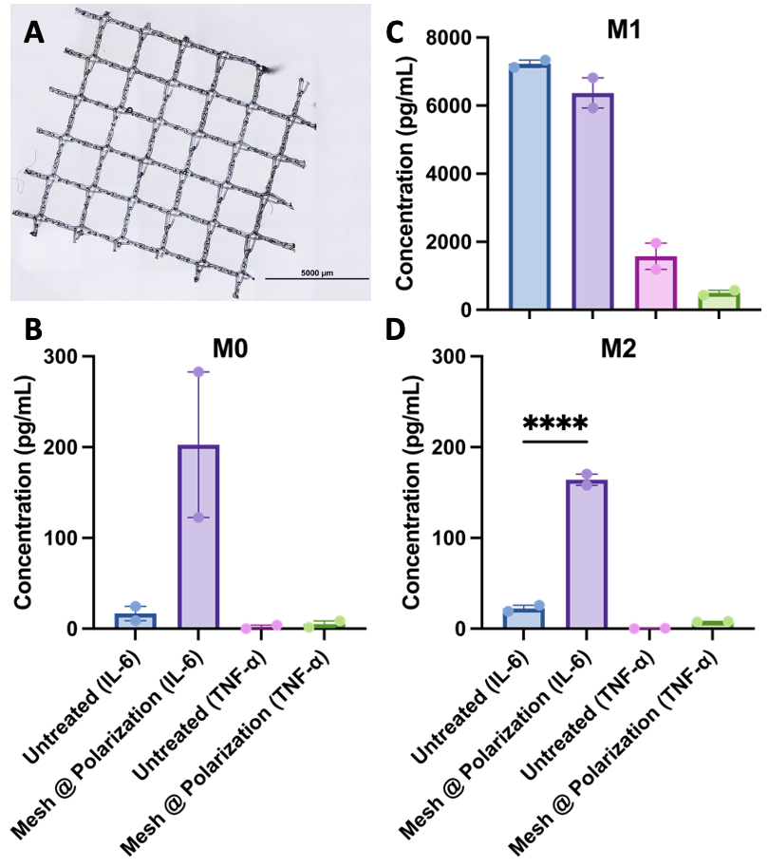
Fig. 1 (A) Brightfield image of polypropylene mesh used in the treatment of POP; production of IL-6 and TNF-α as measured by ELISA in untreated (control) and POP mesh added at polarization of (B) M0 (undifferentiated) THP-1 cells, (C) M1 (pro-inflammatory) THP-1 cells, and (D) M2 (anti-inflammatory) THP-1 cells. N = 2, **** represents p<0.0001.
Cell line experimental set-ups are being repeated with primary macrophages to further characterize the inflammatory effects of POP mesh.

Conclusion
It was discovered that mesh added to polarized macrophages caused increased expression of inflammatory proteins and genes. This highlights the importance of considering the inflammatory response from macrophages and other immune cells in the microenvironment of the implant to study how modulation of the innate immune response may influence inflammation resulting from mesh implantation. This will lead to the identification of material and immunological-based methods to improve mesh materials used in the treatment of prolapsed pelvic organs.

REFERENCES
[1] Cent European J Urol 67, pp. 296–301, 2014, doi: 10.5173/ceju.2014.03.art17.; [2] Front Bioeng Biotechnol 9, 2021, doi: 10.3389/fbioe.2021.622524.; [3] World J Urol 38, pp 73-80, 2020, doi: 10.1007/s00345-019-02679-w.; [4] World J Gastrointest Surg 7, pp. 226–236, 2015, doi: 10.4240/wjgs.v7.i10.226.; [5] Biomaterials 21, pp. 1947–1957, 2000, doi: 10.1016/S0142-9612(00)00078-8.

