Integrating Biomechanics and Probability: A Novel Framework for Helmet Impact Evaluation in Sports Injury
Reza Deabae1, Walter Herzog2, Amin Komeili1
¹ Department of Biomedical Engineering, University of Calgary, Calgary, AB, Canada
² Faculty of Kinesiology, University of Calgary, Calgary, AB, Canada

Abstract— This study introduces a framework for the evaluation of helmet protective performance in sports-related head injuries, including Traumatic Brain Injury (TBI) and concussion. The significance of this framework lies in its capacity to assess the performance of helmets in various impact conditions through simulations or experimental tests utilizing a range of evaluation metrics. Unlike existing testing protocols, this model is not confined to a set of pre-determined scenarios and metrics, and it incorporates the probability of each impact situation. An OR tree structure is employed to systematically represent a spectrum of impact configurations, such as impact locations, angles, and velocities, with an assigned probability value for each node. This facilitates a comprehensive analysis of potential impacts, generating a probabilistic evaluation for each configuration. The framework can employ multiple metrics, such as Head Injury Criteria (HIC), peak acceleration, and brain strain, to determine the helmet's overall protective efficacy, considering the likelihood of each impact scenario. Furthermore, this framework is designed to serve as an objective function for the optimization of helmet design. The present study also includes a case study to illustrate the practical application of the proposed method.
Keywords— Head injury, Helmet, Probability, Impact, Concussion.

INTRODUCTION
Sports incidents pose a significant risk of brain injuries, with three million mild Traumatic Brain Injuries (mTBI) occurring annually in North America [1, 2]. Sport-related concussions (SRC) may present a range of symptoms, including physical, behavioral, somatic, and cognitive symptoms [3, 4] that can last days, weeks, or even months as post-concussion syndrome [4]. Additionally, associations between concussion history and cognitive impairment or neurodegenerative disease development in later stages of life have been observed [4]. At the elite level, concussions can adversely affect athletes' performance and careers [5], making concussion prevention a key focus in sports policy and equipment innovation.
To mitigate head injuries, many sports have mandated the use of helmets, progressively integrating advanced technologies designed for energy absorption and force attenuation. Nevertheless, prevailing helmet testing protocols predominantly focus on safeguarding against high-velocity impacts, which are typical in concussions and severe injuries [6–8]. While this approach has been instrumental in diminishing the incidence of concussions and skull fractures [9, 10], it potentially overlooks the risks associated with lower velocity impacts.
In addition, several injury criteria such as the Head Injury Criterion (HIC) [11], Helmet Performance Score (HPS) [12], Diffuse Axonal Multi-Axis General Evaluation (DAMAGE) [13], and Head Acceleration Response Metric (HARM) [10] have been formulated. These criteria, alongside diverse testing methodologies, aim to characterize head impacts [7] and evaluate the risk of injuries [6]. However, the existing methods primarily evaluate helmets based on a predefined array of metrics and impact scenarios that may not necessarily represent the kinetics and kinematics of incident, highlighting a gap for a more comprehensive and versatile assessment approach.
The proposed research introduces an innovative framework for helmet performance evaluation, distinguished by its adaptability and comprehensive nature. Unlike existing methodologies confined to a predetermined set of metrics and impact scenarios, the proposed framework is inherently flexible and capable of integrating a wide array of evaluation metrics and a variety of impact scenarios. This versatility allows for customization according to the specific requirements of each study, ensuring a more tailored and accurate assessment of helmet safety and efficacy. Crucially, this method also serves as an objective function for optimizing helmet design and comparing various products and prototypes, thereby providing a robust tool for enhancing protective gear. The forthcoming sections will elaborate on the development of this framework and illustrate its application through a relevant case study.

A Framework for Helmet Performance Evaluation
The proposed framework is aimed at assessing helmet performance across diverse impact configurations (i.e., impact scenarios), utilizing a range of evaluation metrics while considering the probabilities of each impact. This is accomplished by the employment of an OR tree structure to model the various impact configurations (ICs). All possible ICs are systematically generated through a tree-based search algorithm, followed by the assessment of helmets according to multiple metrics within each IC. Subsequently, evaluation metrics from all ICs are aggregated to compute a comprehensive evaluation score, with the likelihood of each IC being taken into account. A detailed description of the workflow and its constituent steps is provided in the following sections.

Modeling of Impact Configurations
In this methodology, a generic OR tree is employed to represent various impact configurations, which include factors such as impact locations, angles, and velocities, as depicted in Figure 1. The root of the tree symbolizes the helmet being evaluated. The first branching level categorizes different impact locations or types (e.g., side, front, drop test, linear impact, etc.), followed by a level for impact velocities, and a third level to depict various impact angles (e.g., normal, oblique), where relevant. Consequently, the tree comprises three types of nodes: location nodes, velocity nodes, and angle nodes. Moreover, each sub-node within a branch is assigned a probability value ranging from 0 to 1, indicating the likelihood of that particular impact occurring at the specified location, velocity, or angle, ensuring that the total probability across all sub-nodes in each branch sums to 1. Figure 1 presents an exemplar OR tree, illustrating the location nodes, velocity nodes, angle nodes, OR relations, and the respective probability values assigned to each node.
L1
V3
V4
(P₃)
(P₄)
(P₆)
(P₅)
L2
V6
(P₇)
(P₈)

velocity node
probability
(n)
(P₉)
(P₁₀)
Helmet
OR relation
(P₁)
(P₂)
angle node
location node
V2
V1
V51
A1
A2

Fig. 1 A generic OR tree for modeling of impact configurations.

Generation of Impact Configurations
Tree-based search is utilized to generate distinct impact configurations from the generic OR tree. In this process, each impact configuration is examined, and the collected evaluation metrics from these configurations contribute to the overall evaluation score. Each configuration represents a potential impact scenario, defined by its specific impact location, angle, and velocity. The tree-based search for the creation of impact configurations from a generic OR tree is conducted by the following process:
- Initiate by creating an empty list intended to log an Impact Configuration and include the root node in this list.
- Verify that all nodes across every list have been examined. If so, proceed to Step (7). If not, continue to Step (3).
- Choose an unchecked node from the list and mark it as checked. If this node is a leaf node (i.e., the bottom node), revert to Step (2). If not, proceed to Step (4).
- Replicate the current list into n lists, inclusive of the current list, where n is the count of sub-nodes of the chosen node.
- Append each sub-node to a separate duplicated list.
- Return to Step (2).
- All the impact configurations are created.
Once all impact configurations are established, the probability of each configuration p_{i} (i=1,2,...,m), representing the chance of this impact scenario happening, is then calculated where m is the number of impact configurations. The probability p_{i} is determined by multiplying probabilities of all the nodes p_{ij} (j=1,2,...,$m_{i}$) within each impact configuration as shown in Equation (1):
$$\begin{aligned}p_{i}=\prod_{j=1}^{m_{i}}{p_{ij}}\#\left(1\right)\end{aligned}$$
where m_{i} represents the number of nodes in the i-th impact configuration. The impact configurations, along with their respective probabilities derived from the generic OR tree as presented in Figure 1, are shown in Table 1. This table serves as a comprehensive representation of the possible impact scenarios and their likelihood, facilitating a detailed analysis and understanding of each configuration's role in the overall evaluation of helmet safety.
Table 1 Impact configurations created from the generic OR tree.
Impact configuration | Probability
Helmet, L1, V1 | P1×P2
Helmet, L1, V2 | P1×P4
Helmet, L1, V3, A1 | P1×P5×P9
Helmet, L1, V3, A2 | P1×P5×P10
Helmet, L1, V4 | P1×P6
Helmet, L2, V5 | P2×P7
Helmet, L2, V6 | P2×P8

Evaluation
In the described methodology, the evaluation of a helmet's performance is conducted by comparing it to bare-head impact outcomes, thereby deriving an evaluation score. Initially, the ratio between the metrics is computed as illustrated in Equation (2). This comparative approach enables a quantifiable assessment of the helmet's protective efficacy by benchmarking it against the baseline scenario of an unprotected head.
$$\begin{aligned}∆y=\frac{y}{y_{0}}\#\left(2\right)\end{aligned}$$
where $∆y$ is the relative evaluation metric, y is the evaluation metric obtained for the helmet using simulation or laboratory test, and y₀ is the same evaluation metric for bare-head (i.e., without a helmet). Having calculated the relative evaluation metric ($∆y$) the evaluation score for the i-th impact configuration E_{i} can be calculated using Equation (3). This calculation provides a specific, quantified measure of the helmet's performance under each impact scenario, forming a component of the overall assessment framework.
$$\begin{aligned}E_{i}=\ln\left(1/{∆y}\right)\#\left(3\right)\end{aligned}$$
Should there be a necessity to incorporate multiple evaluation metrics, Equation (4) can be employed to calculate a comprehensive total evaluation score. This approach allows for an aggregated assessment, reflecting the helmet's performance across a broader spectrum of criteria and providing a more holistic view of its protective capabilities.
$$\begin{aligned}E_{i}=\sum_{k=1}^{q}{\left(W_{k}E_{ik}\right)}\#\left(4\right)\end{aligned}$$
where q denotes the total number of evaluation metrics to be used, W_{k} is the weighting factor for k-th evaluation metric, and E_{ik} is the evaluation score for k-th evaluation metric obtained from Equation (3). Ultimately, the evaluation scores from all impact configurations are aggregated to compute a comprehensive overall evaluation score for the helmet. This final score takes into account the probabilities of each impact configuration, ensuring a nuanced and probabilistic assessment of helmet performance, as detailed in Equation (5):
$$\begin{aligned}E=\sum_{i=1}^{m}{\left(p_{i}E_{i}\right)}\#\left(5\right)\end{aligned}$$
Where E is the overall evaluation score for the helmet, m is the total number of impact configurations, p_{i} is the probability of i-th impact configuration, and E_{i} is the evaluation score of i-th impact configuration. Collectively, this calculation methodically combines the individual impact configuration scores, weighted by their respective probabilities, to yield a singular, overarching metric that reflects the helmet’s protective efficacy under varied conditions.

A case study
To effectively demonstrate the practicality of the method introduced, this section details a case study aimed at evaluating and comparing the performance of four NFL helmets. Specifically, the models tested are Riddell, Schutt, Vicis, and Xenith, as depicted in Figure 2. These helmets were subjected to a series of tests encompassing three different impact scenarios (Figure 3): Linear Impactor (LI), Drop Test (DT), and Oblique Plate Impact (OP), each with varying angles and velocities with respected probabilities in the OR tree as illustrated in Figure 4. The probabilities for different impact scenarios were determined based on insights from prior research and established testing protocols [10, 12, 14, 15]. Consequently, a comprehensive set of impact configurations has been generated, adhering to the structure of the generic OR tree, and these configurations are systematically outlined in Table 2.
Table 2 Impact Configurations, their probabilities, and respective test results for the case study. HIC: Head Acceleration Criterion, PA: Peak Acceleration value.
Impact  configuration | Probability | Head |  |  | Schutt |  |  | Riddell |  |  | Xenith |  |  | Vicis
 |  | HIC | PA(g) |  | HIC | PA(g) |  | HIC | PA(g) |  | HIC | PA(g) |  | HIC | PA(g)
LI, 9.3, 0° | 0.144 | 758 | 208 |  | 550 | 131 |  | 406 | 110 |  | 387 | 89 |  | 349 | 91
LI, 9.3, 30° | 0.099 | 651 | 125 |  | 397 | 107 |  | 315 | 92 |  | 287 | 91 |  | 393 | 86
LI, 9.3, 60° | 0.057 | 246 | 70 |  | 152 | 56 |  | 151 | 85 |  | 105 | 43 |  | 116 | 60
DT, 5.5 | 0.0925 | 6780 | 567 |  | 1084 | 192 |  | 948 | 187 |  | 1946 | 306 |  | 1108 | 201
DT, 6.8 | 0.0925 | 13360 | 781 |  | 2831 | 339 |  | 2826 | 330 |  | 6209 | 532 |  | 3052 | 405
DT, 9.3 | 0.185 | 28990 | 4242 |  | 13150 | 743 |  | 12340 | 690 |  | 25839 | 1050 |  | 15963 | 819
OP, 30 | 0.099 | 70710 | 1643 |  | 4082 | 435 |  | 4766 | 460 |  | 4168 | 530 |  | 5028 | 445
OP, 45 | 0.132 | 13120 | 739 |  | 2816 | 324 |  | 1240 | 184 |  | 826 | 98 |  | 1823 | 251
OP, 60 | 0.099 | 3982 | 490 |  | 838 | 198 |  | 625 | 108 |  | 625 | 80 |  | 626 | 339

In this case study, two primary evaluation metrics are employed to gauge the helmets' performance: the Head Acceleration Criterion (HIC) and the Peak Acceleration (PA) value. As illustrated in Table 2, both the helmets and a bare-head model were simulated under each impact configuration, with the resulting data meticulously recorded. Notably, the results derived from these simulations exhibit a strong correlation with findings reported in the literature [16, 17].
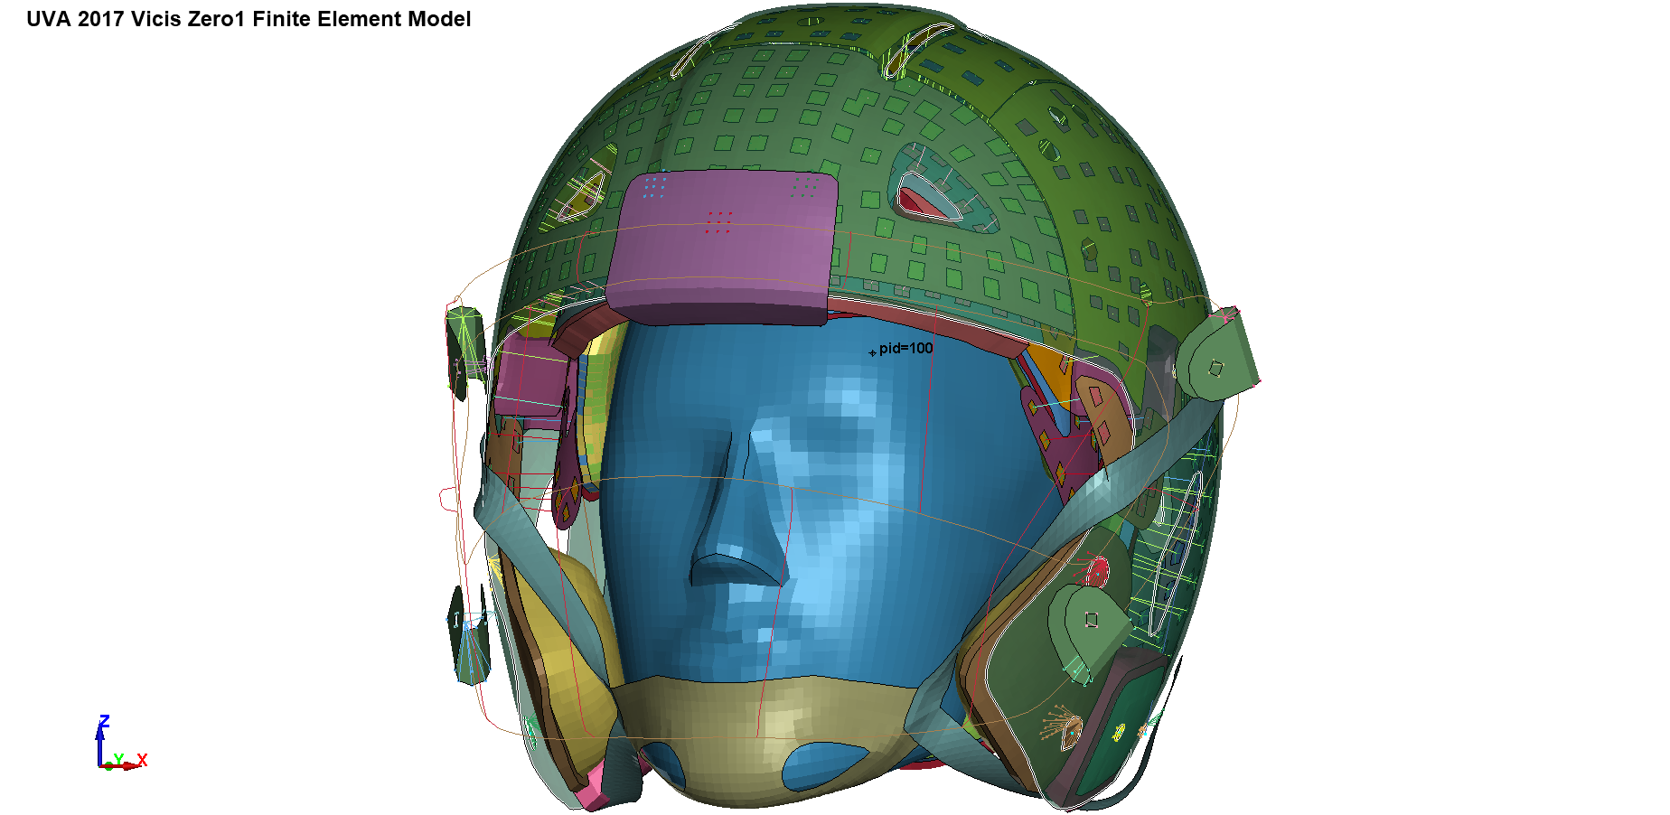
Riddell
Schutt
Vicis
Xenith
Fig. 2 Four helmet models investigated in the case study.
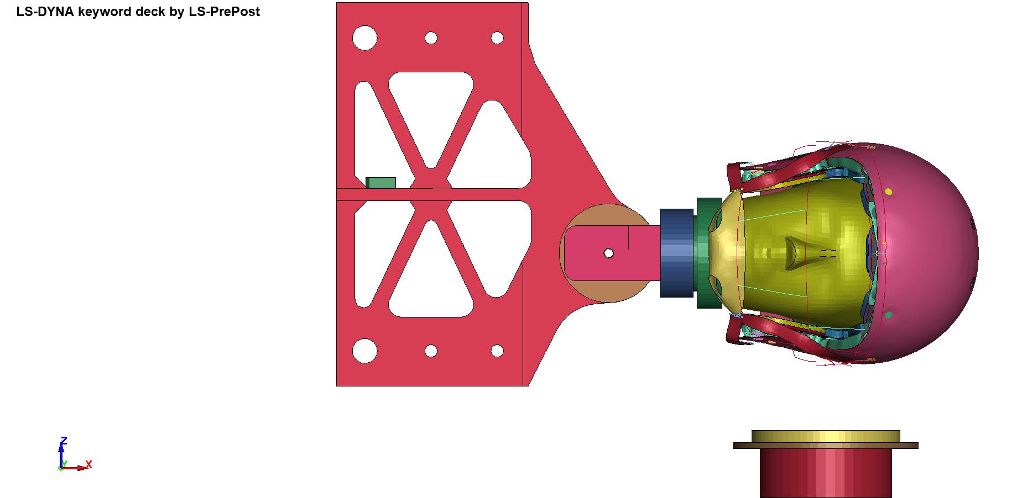
Linear
Impactor (LI)
Drop Test (DT)
Oblique
Plate test (OP)
Fig. 3 Three test setups used for evaluation of helmets in Figure 2.
As explained in section II, Equations (2-5) have been used in this case study to determine the overall evaluation score for each helmet based on simulation results and probabilities represented in Table 2 while the weighting factor for both the HIC and PA was considered to be equal to 1.
Table 3 presents the aggregated evaluation scores for each impact configuration (adjusted by probability) and the cumulative evaluation score for each helmet. As evidenced in Table 3, the Riddell helmet demonstrates superior performance in safeguarding the head across various impact scenarios, closely followed by the Xenith helmet. The lower HIC and PA values produced by these helmets, in conjunction with the probabilities of the impact configurations, contribute to their respective rankings.
Fig. 4 Generic OR tree for helmet test and evaluation.
LI
9.3
(0.19)
(1)
DT
9.3
(0.25)
(0.50)

velocity node
probability
(n)
(0.48)
(0.33)
Helmet
OR relation
(0.30)
(0.33)
angle node
location node
5.5
OP
(0.25)
6.8
0°
30°
60°
30°
45°
60°
(0.3)
(0.4)
(0.3)
(0.37)
Table 3 Combined evaluation scores for each helmet multiplied by probabilities of each impact configuration.
Impact  configuration | Schutt  (p_{i}E_{i}) | Riddell  (p_{i}E_{i}) | Xenith  (p_{i}E_{i}) | Vicis  (p_{i}E_{i})
LI, 9.3, 0 | 0.1128 | 0.1816 | 0.2190 | 0.2307
LI, 9.3, 30 | 0.0644 | 0.1022 | 0.1125 | 0.0870
LI, 9.3, 60 | 0.0402 | 0.0168 | 0.0763 | 0.0516
DT, 5.5 | 0.2697 | 0.2846 | 0.1725 | 0.2634
DT, 6.8 | 0.2207 | 0.2234 | 0.1064 | 0.1973
DT, 9.3 | 0.4685 | 0.4940 | 0.2796 | 0.4146
OP, 30 | 0.4139 | 0.3930 | 0.3923 | 0.3910
OP, 45 | 0.3120 | 0.4949 | 0.6317 | 0.4031
OP, 60 | 0.2440 | 0.3330 | 0.3628 | 0.2196
Overall Score  ∑(p_{i}E_{i}) | 2.1461 | 2.5235 | 2.3531 | 2.2585

Conclusion
This research introduces a novel framework designed to test and evaluate the protective performance of helmets by comparing them across multiple evaluation metrics and impact configurations against a bare-head reference. The method is versatile enough to function as a reward function for optimizing helmet design or for evaluating different helmets' efficacy in protecting against concussive and sub-concussive head impacts. The presented helmet assessment framework possesses the capability to evaluate helmets under a variety of impact scenarios with varying probabilities, surpassing the limitations of predefined cases. Moreover, it supports the simultaneous employment of multiple evaluation metrics such as Head Injury Criterion (HIC), peak acceleration, brain strain, and stress, enhancing the comprehensiveness and reliability of the helmet evaluation.

ACKNOWLEDGMENT
The authors acknowledge the financial support of the Natural Sciences and Engineering Research Council of Canada (DGECR-2020-00498).

Conflict of Interest
The authors declare that they have no conflict of interest.

REFERENCES
[1] Frieden et al., “Traumatic Brain Injury in the United States: Epidemiology and Rehabilitation,” 2015.
[2] Deabae et al., “Design and Simulation of a Pedestrian Protection Airbag Using Corpuscular Particle Method,” International Journal of Vehicle Design, vol. 86, no. 1–4, 2021,
[3] Manley et al., “A Systematic Review of Potential Long-Term Effects of Sport-Related Concussion,” Br J Sports Med, 2017,
[4] McCrory et al., “Consensus Statement on Concussion in Sport - The 5th International Conference on Concussion in Sport Held in Berlin, October 2016,” Br J Sports Med, vol. 51, pp. 838–847, 2017,
[5] Navarro et al., “Short-Term Outcomes Following Concussion in the NFL: A Study of Player Longevity, Performance, and Financial Loss,” Orthop J Sports Med, vol. 5, no. 11, Nov. 2017,
[6] Rowson et al., “Development of the STAR Evaluation System for Football Helmets: Integrating Player Head Impact Exposure and Risk of Concussion,” Ann Biomed Eng, vol. 39, no. 8, pp. 2130–2140, Aug. 2011,
[7] Bailey et al., “Development and Evaluation of a Test Method for Assessing the Performance of American Football Helmets,” Ann Biomed Eng, vol. 48, no. 11, pp. 2566–2579, Nov. 2020,
[8] NOCSAE, “Standard Performance Specification for Newly Manufactured Football Helmets NOCSAE DOC (ND)002-17m21,” 2021.
[9] Viano et al., “Change in Size and Impact Performance of Football Helmets From the 1970s to 2010,” Ann Biomed Eng, vol. 40, no. 1, pp. 175–184, Jan. 2012,
[10] Bailey et al., “Comparison of Laboratory and On-Field Performance of American Football Helmets,” Ann Biomed Eng, vol. 48, no. 11, pp. 2531–2541, Nov. 2020,
[11] Versace, “A Review of the Severity Index,” SAE Technical Papers, 1971,
[12] Biocore, “Helmet Test Protocol,” Charlottesville, VA, 2020.
[13] Gabler et al., “Development of a Second-Order System for Rapid Estimation of Maximum Brain Strain,” Ann Biomed Eng, vol. 47, no. 9, pp. 1971–1981, Sep. 2019,
[14] Kundra, “Concussion in Professional Football: Reconstruction of Game Impacts and Injuries,” Neurosurgery, vol. 55, no. 1, p. 260, Jul. 2004,
[15] Lessley et al., “Video Analysis of Reported Concussion Events in the National Football League During the 2015-2016 and 2016-2017 Seasons,” American Journal of Sports Medicine, vol. 46, no. 14, pp. 3502–3510, Dec. 2018,
[16] Gunnarsdóttir, “Evaluation of Test Methods for Football Helmets Using Finite Element Simulations,” 2019.
[17] Wikarna, “A Kinematic Rating System for Evaluating Helmet Performance,” 2019.

