Wearable microfluidic biosensor for real-time cortisol monitoring
F. Vajhadin1, K. Kuruvinashetti1, M. Hassani1, M. Khalghollah¹, B. Zarin¹, A. Komeili1,2, A. Sanati Nezhad1,2
¹ Department of Biomedical Engineering, University of Calgary, Calgary, Alberta, Canada
²Department of Mechanical Engineering, University of Calgary, Calgary, Alberta, Canada

Abstract
The impact of stress on physical and mental health is significant. The increased levels of cortisol observed during stress are reflected in its release from sweat glands, providing an external sweat biomarker for monitoring stress states. However, current approaches to utilize wearable sensors for monitoring sweat cortisol encounter challenges related to effective sweat management and the real-time and high-sensitivity detection of cortisol. Addressing this gap, we introduce a flexible and scalable capillary microfluidic device integrated with sensors.

Keywords: Wearable, Microfluidic, biosensor, cortisol

INTRODUCTION
Stress is an inherent element of our day-to-day experiences, and the exploration of its impact on health is becoming increasingly intriguing. Prompt response to stress is crucial to prevent prolonged or inappropriate stress responses and their negative impact on cognitive function, decision-making, social interactions, and various diseases, including neurodegenerative conditions and cancer.[1] Questionnaire-based approaches are not sufficient for stress evaluation since they are subjective. A promising approach for stress assessment is monitoring stress hormones released from the endocrine system. These hormones act as physiological cues that reflect the body's responses to internal and external stress stimuli [1, 2]. Therefore, the fabrication of point-of-care devices for assessing stress levels through rapid and accurate stress-related physiological markers in biofluids is of utmost importance.

Cortisol, a glucocorticoid hormone released by the adrenal cortex, plays a regulatory role in various physiological processes within the body. Moreover, it can be monitored in various biofluids, and its concentration correlates with the physical-stress related symptoms, including high blood pressure, fatigue, and pain, as well as behavioral changes such as irritability, depression, and lack of interest [3, 4].

Although blood test is the gold standard method for monitoring stress physiological markers, including the cortisol, its invasive nature, discomfort, and inconvenience during sample collection pose challenges when aiming to monitor stress monitoring. A non-invasive approach could involve measuring cortisol from other biofluids, such as saliva and sweat [1]. Sweat is a proper biofluid for stress monitoring as it offers the unique advantage of continuous collection from the skin through wearable devices, requiring minimal human intervention. Cortisol within sweat mainly exists in an unbound, free form, which is the biologically active form of cortisol, and when monitored, provides valuable insights into an individual's stress dynamics [5]. However, the technologies for reliable detecting stress biomarkers in sweat are still at an early stage of development.
The utilization of wearable microfluidic biosensors offers a promising tool for both the separation and measurement of cortisol from sweat [6, 7]. These devices can efficiently manipulate small volumes of sweat, ranging from nanoliters to microliters, via nano/micro channels. This capability allows for the collection of sweat without causing disruptions to daily routines. To provide quantitative data for stress monitoring, it is essential to integrate sensors into these devices.
The most current wearable microfluidic biosensors for stress monitoring are fabricated using PDMS [8, 9]. However, PDMS may adsorb and absorb hydrophobic molecules, such as cortisol, potentially impacting the accuracy of stress analysis. Integrating sensors into these devices is crucial for providing quantitative data for stress monitoring; without sensor integration, achieving quantitative analysis is not possible. Nevertheless, integrating electrochemical sensors into PDMS-wearable devices poses challenges, as ensuring their adherence and stability during fluidic operations can be difficult [10]. This potential instability might alter sweat flow dynamics, introducing resistance and impacting the sample collection process, leading to inaccurate or inconsistent results. Therefore, it is essential to advance stress monitoring through the development of innovative microfluidic devices that incorporate novel materials and approaches for sensing within microfluidics.
In this study, the aim is to develop a microfluidic device for collecting sweat from the skin surface and a sensor for measuring cortisol levels. The chip was fabricated by assembling polymer sheets to create walls with manipulated hydrophobicity and hydrophilicity. This design facilitates effective fluid management within the channels, enabling rapid transfer to the sensing area. The sensor within the chip was functionalized with cortisol antibodies to detect cortisol molecules from the complex mixture present in sweat. This microfluidic biosensor enables manipulation of sample volumes, controls separation processes, and enables rapid sensing. These microfluidic-based methods offer real-time cortisol collection, presenting a non-invasive and efficient approach to stress monitoring. This innovation addresses some of the limitations associated with traditional sweat analysis techniques.

Methods
To fabricate the microfluidic device, we utilized a laser cutter ( the Trotec Speedy 360 FLEXX, equipped with an 80 W CO2 laser and a 30 W Fiber laser). This laser cutter facilitated the exploration of diverse patterns for the microfluidic network across multiple fluidic layers. The wicking pads within the device were manipulated using cellulose papers. For the fabrication of walls, bottoms, and tops of the channels, we explored a combination of materials. The flexible Thermoplastic Elastomer transparent acrylate adhesives, and a waterproof adhesive layer (a double-sided medical pressure-sensitive adhesive) were investigated and employed in different layers. Graphene's unique electrochemical properties, characterized by fast electron mobility and an ultra-large surface area, render graphene-based screen-printed electrodes perfectly suited for sensor fabrication. Our customized screen-printed electrodes, functionalized with highly selective cortisol antibodies, were incorporated into a microfluidic device.
The chip was designed to collect sweat directly from the skin's surface and efficiently channel it across the electrode surface. Moreover, its relatively small dimensions, flexibility, and unsupervised application qualify it for potential use as a wearable device. To quantify cortisol levels, we employed various concentrations of cortisol spiked in PBS (Phosphate Buffered Saline) and artificial sweat. The sensing performance was assessed through electrochemical techniques for off-chip and on-chip.
In-vivo tests: In the in vivo study, sweat generation was induced through physical exercise as a stimulus. A group of 5 (4 male, 1 female) healthy participants performed a 30-minute running session on a treadmill at a low speed. During this activity, the wearable microfluidic chip, which incorporates the sensing electrode, was placed on the forehead to collect and analyze the generated sweat. It took about 10 to 25 minutes for the participants to generate enough sweat to fill the chip. This was due to different sweat generation rates and physical fitness of participants. The materials of the chip were optimized to enhance efficient sweat management through the channels and its rapid transfer to the sensing area. When sweat filled the sensing area, the chip was removed from the skin and connected to a potentiostat to assess its performance for cortisol sensing using the electrochemical impedance spectroscopy technique.

results and diScussioNS
A highly specific cortisol sensor capable of detecting cortisol in body fluids was developed through the interaction between cortisol and antibodies conjugated to the surface of graphene-based electrodes. Figure 1.A displays the image of our customized screen-printed strip with three electrodes, including working, counter, and reference electrodes, and Figure 1.B illustrates the SEM image of the working electrode, revealing embedded graphene layers within polymer structures. Figure 1.C illustrates the schematics of the working principle of the electrochemical sensing of the chortisol on the electrode surface.

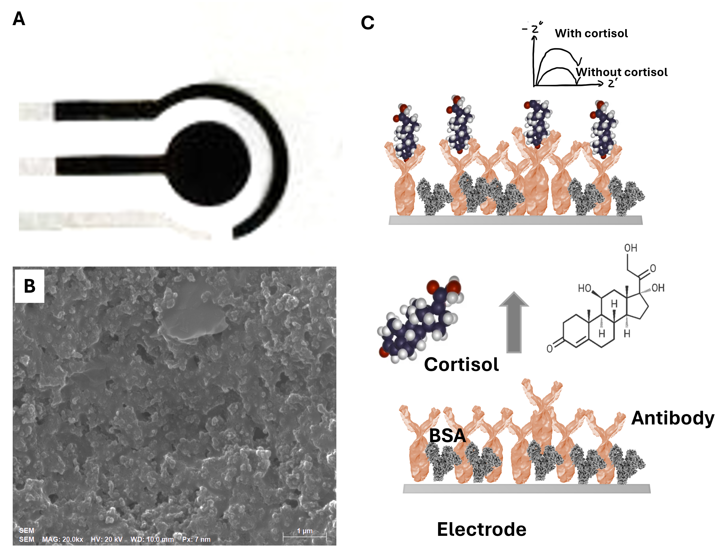

Figure 1. Optical image of the screen-printed electrode (A). SEM image of the working electrode (B). schematic image of the cortisol sensing principle (C).

As illustrated in Figuer 2.A, B, the chip demonstrates a linear correlation between Rct (charge transfer resistance) and cortisol concentration across the range of 0.1 to 35 ng/mL. We assessed the accuracy of cortisol sensing with our sensor in sweat by comparing its performance against standard methods like ELISA (Enzyme-Linked Immunosorbent Assay). This assessment enabled us to validate the reliability of our sensor's measurements. Notably, while ELISA required over 3 hours and laboratory instruments such as a well-plate reader and experienced operators, our wearable sensor allows for real-time cortisol sensing by individuals.

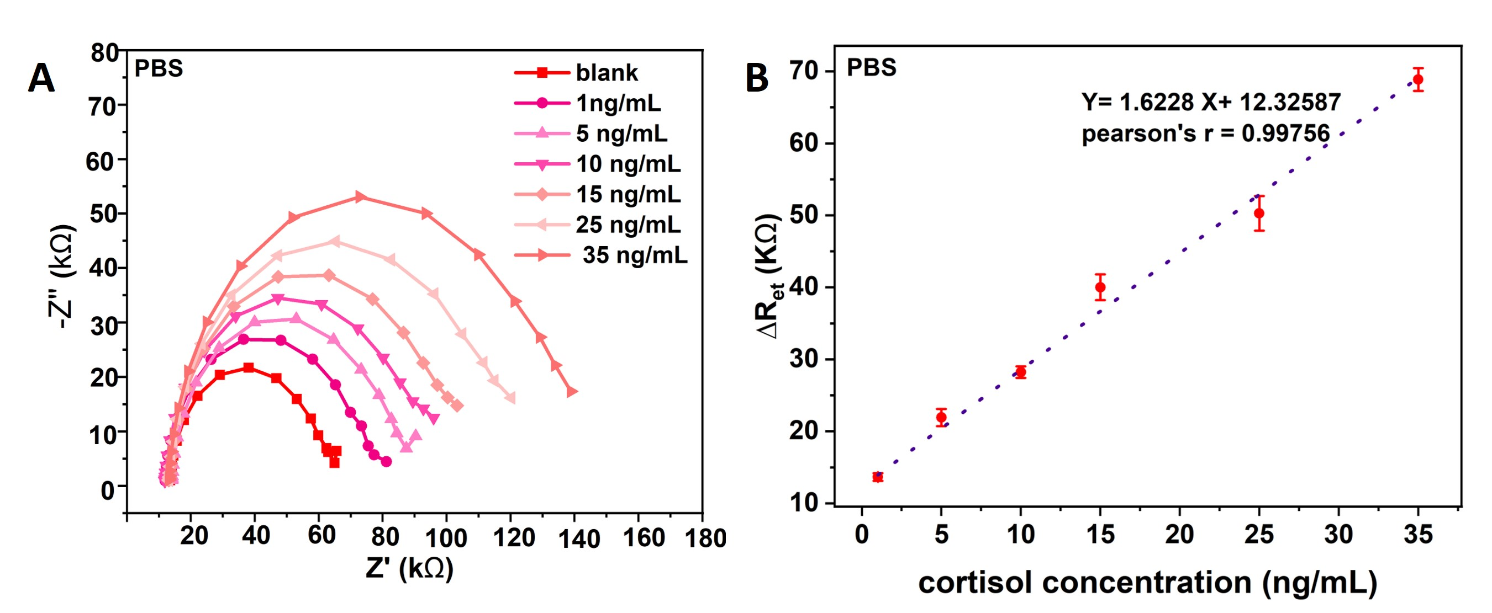

Figure 2. Nyquist plots (A) and (B) linearity curve for different cortisol concentrations in PBS.

The integration of sensor strips within the chip significantly improved its capability for individualized and personalized stress monitoring. By employing new polymer sheets, we've established a flexible framework for designing the microfluidic biosensor chip, enabling versatile application across diverse body locations. Thus, the wearable cortisol sensor not only facilitates an overview of sweat cortisol data but also helps to determine the longitudinal and daily variation of stress levels that might be the underlying cause of prolonged diseases. This capability contributes to tailored assessment of stress patterns, hilighting the potential of the wearable device in capturing detailed insights into the dynamics of stress response over time.

Conclusions
In summary, we designed a cost-effective, rapid, and point-of-care device capable of isolating cortisol and electrochemically detecting it in sweat with high sensitivity.

ACKNOWLEDGEMENTs
The authors acknowledge Natural Sciences and Engineering Research of Canada (NSERC), Canadian Institutes of Health Research (CIHR), and Alberta Innovates.

Corresponding Author: Fereshteh Vajhadin
Email: fereshteh.vajhadi1@ucalgary.ca
University of Calgary

REFERENCES
1. Shajari, S., et al., MicroSweat: A Wearable Microfluidic Patch for Noninvasive and Reliable Sweat Collection Enables Human Stress Monitoring. Adv Sci (Weinh), 2023. 10(7): p. e2204171.
2. Karachaliou, C.E., et al., Cortisol Immunosensors: A Literature Review. Biosensors (Basel), 2023. 13(2).
3. Khan, M.S., et al., Paper-Based Analytical Biosensor Chip Designed from Graphene-Nanoplatelet-Amphiphilic-diblock-co-Polymer Composite for Cortisol Detection in Human Saliva. Anal Chem, 2017. 89(3): p. 2107-2115.
4. O'Connor, D.B., J.F. Thayer, and K. Vedhara, Stress and Health: A Review of Psychobiological Processes. Annu Rev Psychol, 2021. 72: p. 663-688.
5. Khumngern, S. and I. Jeerapan, Advances in wearable electrochemical antibody-based sensors for cortisol sensing. Anal Bioanal Chem, 2023. 415(18): p. 3863-3877.
6. Fiore, L., et al., Microfluidic paper-based wearable electrochemical biosensor for reliable cortisol detection in sweat. Sensors and Actuators B: Chemical, 2023. 379.
7. Ok, J., et al., Wearable and Implantable Cortisol Sensing Electronics for Stress Monitoring. Adv Mater, 2023: p. e2211595.
8. Auner, A.W., et al., Chemical-PDMS binding kinetics and implications for bioavailability in microfluidic devices. Lab on a Chip, 2019. 19(5): p. 864-874.
9. Liu, Q., et al., Preparation of nanostructured PDMS film as flexible immunosensor for cortisol analysis in human sweat. Anal Chim Acta, 2021. 1184: p. 339010.
10. Ghaffari, R., J.A. Rogers, and T.R. Ray, Recent progress, challenges, and opportunities for wearable biochemical sensors for sweat analysis. Sens Actuators B Chem, 2021. 332.

