Title: Studying Schwann cells adhesion on
PVA-hydrogels copolymerized with Gelatin.

Pr. Laura Poole Warren
Graduate School of Biomedical Engineering
Biomaterials and Tissue Engineering
UNSW Sydney
NSW 2052 AUSTRALIA
l.poolewarren@unsw.edu.au
Dr. Ulises Aregueta Robles
Graduate School of Biomedical Engineering
Biomaterials and Tissue Engineering
UNSW Sydney
NSW 2052 AUSTRALIA u.areguetarobles@unsw.edu.au
Larissa Marlène Yakam Djomatchoua
Graduate School of Biomedical Engineering
Biomaterials and Tissue Engineering
UNSW Sydney
NSW 2052 AUSTRALIA
z5505566@ad.unsw.edu.au

Introduction
Nerve damage is not an isolated incident; it represents a global health challenge. Nearly a billion people worldwide are affected by neurological damage and disorders, making it a major public health problem.[1] These disorders can lead to a permanent loss of sensation, movement, or control of vital functions, having a profound impact on the quality of life of the individuals concerned.[2] The peripheral nervous system, which is essential for communication between the brain and the rest of the body, relies on essential glial cells such Schwann cells. These cells play a crucial role in nerve regeneration and the formation of the Myelin sheath, which facilitates the rapid transmission of nerve impulses. Schwann cells also provide neurons with essential factors of their growth and function and play an active role in nerve repair after injury. [3] Despite research efforts into various treatments, such as drugs, growth factors, gene therapy, activity-based therapies, and methods of enhancing neuron growth, their effectiveness in achieving accurate reinnervation and functional recovery remains generally limited. [4]

Objective
The aim of this study is to investigate the impact of varying the gelatin concentration in PVA- hydrogel copolymer matrices on Schwann cell adhesion and subsequent regeneration. By examining different concentrations of PVA and reducing the gelatin content to specifically optimize cell adhesion. The purpose is to determine which of these concentrations is optimum to Schwann cell regeneration.

Methodology
Schwann cells were cultured in T-25 flasks at 37ºC in incubator with 5%CO2. Cells were passaged at 90% confluency. Day 1 Gels were produced using different concentrations of PVA-MA and Gelatin-MA and PBS. Polymer solutions were prepared by mixing these components together followed by heating, mold preparation, UV light exposure for photopolymerization, and rising with Mili-Q water. On Day 2, gels were Sterilized, transferred to 24- well plates, and seeded with Schwann cells at a density of 30000 cells per cm2, followed by a 48-hour incubation period for cell proliferation. On Day 4, cell viability was assessed using a live/ dead cell assay with calcein-AM and propidium iodide. Cells were covered with dye solution, incubated, washed, and analyzed under a confocal microscope to distinguish live (green fluorescence) from dead (red fluorescence) cells. For statistical analysis, ImageJ, were used for qualified living and dead cell surface areas providing data on cell distribution on the gels. Cell viability percentages were averaged for each concentration using Excel, Facilitating analysis of cell behavior and consequently, cell regeneration.
Choice of Polymer
The choice of PVA-MA copolymerized with methacrylate gelatin (GEL-MA) was based on its similarity to the mechanical properties of neural tissue, favouring the development of Schwann cells and the survival of neurons. [5] Plates coated with Gel-MA allowed faster cell growth and less size heterogeneity compared with plates coated with collagen, fibronectin, and laminin indicating the superior performance of gelatin in improving cell culture results compared with the collagen, fibronectin and laminin used by other researchers. [6]
Expectect Results
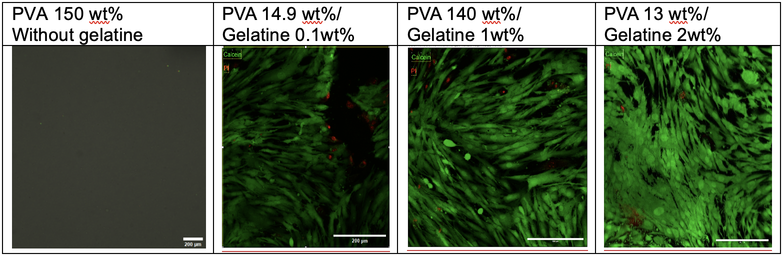
The preliminary finding indicates that the gel with gelatin concentration of 2wt% has a wider distribution of cells, suggesting a favorable environment for cell adhesion and proliferation compared with the other gels. However, the absence of gelatin in the gels compromises cell proliferation leading to unstable results.
Conclusion
In summary, this study reveals a key result: the concentration of gelatin significantly influences the behavior of Schwann cells. Seeding on gelatin with 13wt% PVA with 2wt% Gelatin demonstrates optimal performance, offering important prospect for nerve regeneration. Variations in concentration are aimed at identifying the optimal formulation, highlighting the significant impact of substrate composition on cell response. These discoveries open translational opportunities in the field of regenerative medicine.
Key words: Peripheral nerve damage, Schwann cells, Biomaterials, hydrogels, Nerve regeneration, Extracellular matrices, Neurites, 3D microchannel.
Resources
- ﻿﻿Aregueta-Robles, U. A., Martens, P, J., Poole-Warren, L. A., & Green, R. A. (2019). Tissue engineered hydrogels supporting 3D neural networks. Acta Biomaterialia, 95, 269-284.

- Ma, T., et al. (2022). Sequential oxygen supply system promotes peripheral nerve regeneration by enhancing Shawn cells survival and angiogenesis. Biomaterials, 289, 121755.

- Balakrishnan, A., Belfiore, L., Chu, T. -H., Fleming, T., Midha, R., Biernaskie, J., & Schuurmans, C. (2020). Insights Into the Role and Potential of Schwann Cells for Peripheral Nerve Repair from Studies of Development and Injury. Frontier in Molecular Neuroscience, 13, 608442

- Ghosh, M., & Pearse, D. D. (2023). Schwann Cell-Derived Exosomal Vesicles: A Promising Therapy for the Injured Spinal Cord. International Journal of Molecular Sciences, 24(24), 17317

- Jiang, S., Liu, S., & Feng, W. (2011). PVA hydrogel properties for biomedical application. Journal of the Mechanical Behavior of Biomedical Materials, 4(7), 1228-1233.

6 Mogha, P., Lyer, S., & Majumder, a.(2023). Extracellular Matrix Protein Gelatin Provides Higher Expansion, Reduces Size Heterogeneity, and Maintains Cell Stiffness in a Long-term Culture of Mesenchymal Stem cells, tissues and cell, 80,101969

