Gold Nanoparticles Loaded with Cannabinoids for Targeted Cancer Therapy
Anshuman Jakhmola¹, Farshad Moradi Kashkooli¹, Krishnan Sathiyamoorthy¹, Kevin Rod³, Michael C. Kolios^{1,2}, Jahangir (Jahan) Tavakkoli^{1,2, *}
¹ Department of Physics, Toronto Metropolitan University, Toronto, Ontario, Canada
² Institute for Biomedical Engineering, Science and Technology (iBEST), Keenan Research Centre for Biomedical Science, St. Michael's Hospital, Toronto, Ontario, Canada
³Toronto Poly Clinic Inc., Toronto, Canada
*Corresponding Author, Email: jtavakkoli@torontomu.ca
Abstract
In recent years, numerous scientific studies have highlighted the advantages of natural anti-cancer agents. Many research groups have found that cannabinoids can inhibit tumor progression by impeding the proliferation of cancer cells, promoting apoptosis, and inducing cell cycle arrest, among other effects. However, the bioavailability of cannabinoids is very low due to their hydrophobic nature, gastric instability, and rapid metabolism. To improve its bioavailability, nanotechnological innovations can serve as crucial tools for developing new therapeutic strategies. In this respect we have designed a green protocol to simultaneously synthesize and load spherical GNPs with cannabidiol (CBD) by using a cocktail of two reducing agents viz. trisodium citrate and l-tyrosine. l-tyrosine, a hydrophobic α‑amino acid, binds strongly to the surface of GNPs through its amine group, thus creating hydrophobic pockets on the surface layer that serve as attachment site for cannabinoids via non-covalent interactions. The cannabinoid loaded colloidal gold solution was bright red in color and displayed a sharp plasmon band at around ~530 nm. We conducted cell viability tests on different cancer cell lines using the colorimetric MTT assay. In all cases, cannabinoid loaded onto GNPs were significantly more effective in killing cancer cells than their simple aqueous solution. Cells were seeded in a 96-well cell culture plate at a density of 10⁴ cells/well and treated with increasing concentrations of cannabinoids (i.e., free and attached cannabinoids on GNPs). As an example, for SK-BR-3 (a human breast cell line), IC₅₀ of free CBD was approximately 13 µM, whereas that of CBD loaded on GNPs was approximately 9 µM. Subsequently, 3D in vitro cell culture experiments were conducted on MDA-MB-231 spheroids, where cannabinoids loaded on GNPs outperformed the pure compounds. These results suggest that GNPs served as efficient nanocarriers for delivering cannabinoids into cancerous cells, highlighting the potential of cannabinoid-loaded GNPs as future of cancer therapy.

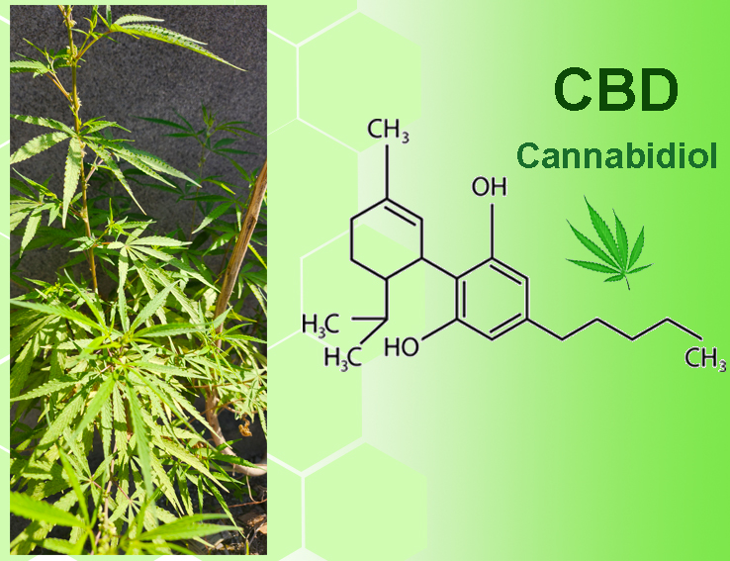
Figure 1: High resolution TEM image of a gold nanoparticle loaded with cannabinoids extracted from the leaves of plant Cannabis Sativa.

