Gold Nanoparticles Loaded with Cannabinoids for Targeted Cancer Therapy
Anshuman Jakhmola¹, Farshad Moradi Kashkooli¹, Krishnan Sathiyamoorthy¹, Kevin Rod³, Michael C. Kolios^{1,2}, Jahangir (Jahan) Tavakkoli^{1,2, *}
REVIEW COMMENTS
This submission of this abstract by authors examines the effect of Gold Nano Particles (GNPs) loaded with cannabinoids at varying concentrations on selected cancer cells. The overall study experiment(s) is well established with impactful objectives that could provide new insights into cancer therapy. However, the abstract organization is somewhat lacking which limits proper understanding of the studies/results presented.
Specific Comments
The submission lacks references. Adding citations to this work can make it more cogent. Authors need to add references in the revised version.
When introducing their work, authors needed to briefly define all key terms to the audience clearly. For instance, the term ‘Gold Nano Particles (GNPs) was not defined clearly, which is necessary to capture a great understanding and context for this abstract. Additionally, it would be helpful if authors briefly defined, cited, or provided a rationale for the type of cannabinoids used here.
There was a lack of details on specific methods used such as imaging modalities for visualizing the color of cannabinoid-loaded colloidal gold solution. It was not clear if the color was simply observed or viewed with microscopy.
The authors lacked coherence while presenting their methods and results. They kept mixing the two sections which is confusing to the reader.
Finally, the presentation of results was a bit lacking and less detailed which made interpretation difficult.
OVERALL EVALUATION
Investigators/authors possess the necessary expertise to complete the study using the necessary resources.
I strongly believe that the efforts put together by the authors of this abstract will contribute immensely towards cancer therapy and strategies.
Therefore, I recommend it for selection at the 46th conference of the Canadian Medical and Biological Engineering Society 2024, with major corrections.
Response to comments: Thank you for your insightful feedback. We have implemented all the suggested changes accordingly.
Gold Nanoparticles Loaded with Cannabinoids for Targeted Cancer Therapy
Anshuman Jakhmola¹, Farshad Moradi Kashkooli¹, Krishnan Sathiyamoorthy¹, Kevin Rod³, Michael C. Kolios^{1,2}, Jahangir (Jahan) Tavakkoli^{1,2, *}
¹ Department of Physics, Toronto Metropolitan University, Toronto, Ontario, Canada
² Institute for Biomedical Engineering, Science and Technology (iBEST), Keenan Research Centre for Biomedical Science, St. Michael's Hospital, Toronto, Ontario, Canada
³Toronto Poly Clinic Inc., Toronto, Canada
*Corresponding Author, Email: jtavakkoli@torontomu.ca
Abstract
In recent years, numerous scientific studies have highlighted the advantages of natural anti-cancer agents [1]. Many research groups have found that cannabinoids such as cannabidiol (CBD) and Δ⁹-tetrahydrocannabinol (THC), which are naturally found in plant Cannabis sativa can inhibit tumor progression by impeding the proliferation of cancer cells, promoting apoptosis, and inducing cell cycle arrest [2]. However, the bioavailability of cannabinoids is very low due to their hydrophobic nature, gastric instability, and rapid metabolism [3]. To improve its bioavailability, nanotechnological innovations can serve as crucial tools for developing new therapeutic strategies. On the other hand, gold nanoparticles (GNPs) are well known for their high area to volume ratio and high biocompatibility, rendering them an excellent choice for cancer detection and therapy [4]. It is feasible to effectively load a plant-derived highly hydrophobic cannabinoid, CBD, onto the surface of GNPs to enhance their bioavailability [5]. In this study, we have designed a green protocol to simultaneously synthesize and load spherical GNPs with CBD by using a cocktail of two reducing agents viz. trisodium citrate and l-tyrosine. l-tyrosine, a hydrophobic α‑amino acid, binds strongly to the surface of GNPs through its amine group [6]. Therefore, they can create hydrophobic pockets on the surface layer, acting as attachment sites for cannabinoids via non-covalent interactions. The cannabinoid loaded colloidal gold solution was visually bright red in color and displayed a sharp plasmon band at around ~530 nm in the UV-vis spectra, indicative of GNPs with spherical geometry. We further conducted in vitro two-dimensional (2D) cell viability tests on three different breast cancer cell lines using the colorimetric MTT assay and optical microscopy. For 2D cell viability tests, 10⁴ cells/well were seeded in a 96-well cell culture plate and subjected to increasing concentrations of CBD (i.e., free and attached cannabinoids on GNPs). In all the cases, CBD loaded onto GNPs were significantly more effective in killing cancer cells than their simple aqueous solution. As an example, for SK-BR-3 (a human breast cell line), IC₅₀ of free CBD was approximately 13 µM, whereas that of CBD loaded on GNPs was approximately 9 µM. Subsequently, 3D in vitro cell culture experiments were conducted on MDA-MB-231 spheroids, which represents a more accurate model of tumors in living organisms. Interestingly, CBD loaded on GNPs exhibited more effectiveness in disrupting spheroids as compared to pure compounds. These results suggest that GNPs served as efficient nanocarriers for delivering CBD into cancerous cells, highlighting the potential of cannabinoid-loaded GNPs as a prospective therapy for cancer.

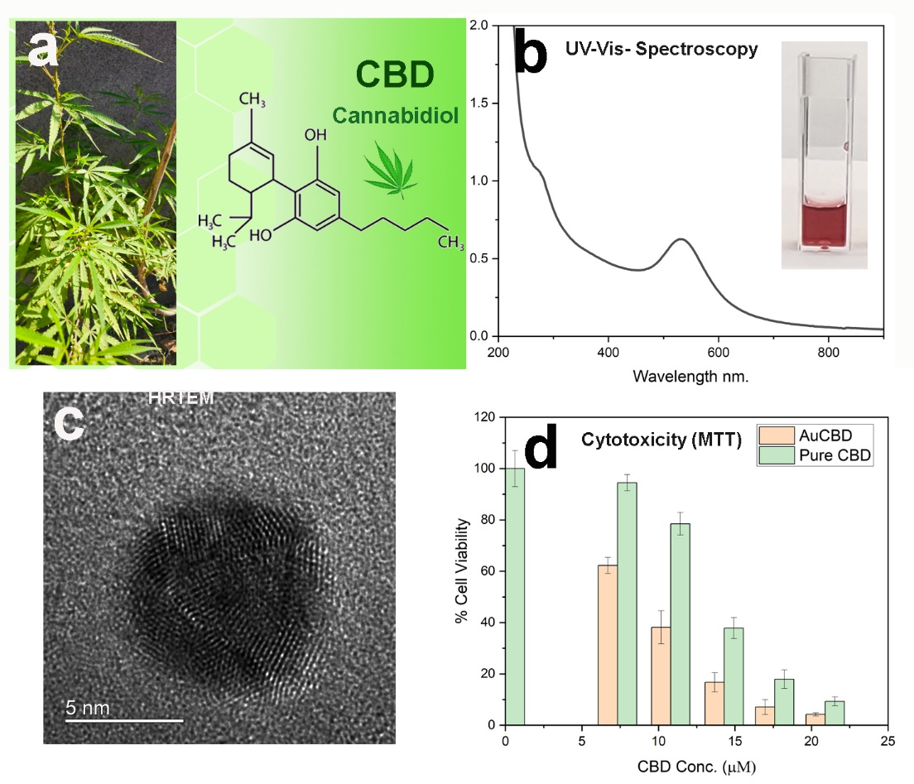
Figure 1: (a) Cannabis Sativa plant and CBD structure (b) UV-vis spectra and color of colloidal gold loaded with CBD (c) High resolution transmission electron microscopy (HRTEM) image of a GNP loaded with CBD (d) MTT cytotoxicity assay for CBD loaded on GNP and pure CBD in water.

Reference
[1] A. Naeem, P. Hu, M. Yang, J. Zhang, Y. Liu, W. Zhu, Q. Zheng, Natural Products as Anticancer Agents: Current Status and Future Perspectives, Molecules 27 (2022) 8367. https://doi.org/10.3390/molecules27238367.
[2] B. Dariš, M. Tancer Verboten, Ž. Knez, P. Ferk, Cannabinoids in cancer treatment: Therapeutic potential and legislation, Bosn J Basic Med Sci 19 (2019) 14–23. https://doi.org/10.17305/bjbms.2018.3532.
[3] M. Palrasu, L. Wright, M. Patel, L. Leech, S. Branch, S. Harrelson, S. Khan, Perspectives on Challenges in Cannabis Drug Delivery Systems: Where Are We?, Med Cannabis Cannabinoids 5 (2022) 102–119. https://doi.org/10.1159/000525629.
[4] F.-Y. Kong, J.-W. Zhang, R.-F. Li, Z.-X. Wang, W.-J. Wang, W. Wang, Unique Roles of Gold Nanoparticles in Drug Delivery, Targeting and Imaging Applications, Molecules 22 (2017) 1445. https://doi.org/10.3390/molecules22091445.
[5] A. Jakhmola, T.K. Hornsby, F.M. Kashkooli, M.C. Kolios, K. Rod, J. Tavakkoli, Green synthesis of anti-cancer drug-loaded gold nanoparticles for low-intensity pulsed ultrasound targeted drug release, Drug Deliv Transl Res (2024). https://doi.org/10.1007/s13346-024-01516-x.
[6] A. Jakhmola, R. Vecchione, F. Gentile, M. Profeta, A.C. Manikas, E. Battista, M. Celentano, V. Onesto, P.A. Netti, Experimental and theoretical study of biodirected green synthesis of gold nanoflowers, Mater Today Chem 14 (2019) 100203. https://doi.org/10.1016/j.mtchem.2019.100203.

