An experimental investigation on the effect of airflow on the sound generated in a simplified tube with a constriction representing trachea for obstructive sleep apnea diagnosis during wakefulness
Walid Ashraf¹, and Zahra Moussavi¹

¹ University of Manitoba, Biomedical Engineering Graduate Program, Winnipeg, Canada

Abstract— Obstructive sleep apnea (OSA) diagnosis using tracheal breathing sound analysis during wakefulness has already shown great potential with an accuracy of 84.5% compared to the gold-standard polysomnography (PSG). The inclusion of geometrical parameters in the acoustic diagnosis of OSA during wakefulness may not only increase the accuracy but also provide insight into OSA pathology. In this study, we aimed to develop an upper airway model for a flow-sound relationship in the presence of a constriction (e.g. increased airway stiffness and/or collapsibility). The geometrical change selected for this study is a circular constriction representing tracheal narrowing. An experimental measurement was conducted on a 3D-printed model of a tube with a constriction while recording the airflow-generated sound at three locations. Several constriction sizes were tested at different airflow rates. The results show a higher frequency shift for the resonating frequencies for the smaller constrictions. In addition, larger slopes of the logarithmic relationship between airflow and the generated sound power were observed for the larger constrictions. These findings are encouraging for future studies to evaluate the mathematical relationship between the tracheal breathing sounds in the presence of different constriction sizes for a realistic upper airway geometry.
Keywords—Obstructive sleep apnea, Tracheal Breathing Sounds, Upper airway modelling.

INTRODUCTION
Obstructive sleep apnea (OSA) is a prevalent sleeping disorder associated with several clinical conditions such as cardiovascular disease, depression, diabetes and daytime hypersomnolence[1]. It is characterized by either a complete (apnea) or partial (hypopnea) collapse of the upper airway during sleep that lasts >10 sec and is also associated with a >3% drop in blood oxygen saturation. Polysomnography (PSG) is considered the gold standard for OSA diagnosis. Given that PSG is an expensive and time-consuming test requiring highly skilled labor and has a long wait, OSA is still massively underdiagnosed [2]. PSG’s economic burden on the healthcare system accounts for billions of dollars annually [3]. In addition, PSG is not a suitable option to diagnose OSA prior to a surgery for patients requiring full anesthesia due to lack of time for a sleep study. Thus, fast screening questionnaires (Ex: STOP-Bang, Berlin) are usually employed using parameters such as age, gender, weight, smoking history, etc. Although these questionnaires have high sensitivity, their specificity is very low (~36%) [4]. In the last decade, several studies have been conducted on OSA diagnosis using tracheal breathing sounds (TBS) [5], [6]and voice analysis [7], [8]during wakefulness. The underlying rationale of these studies is based on imaging studies that provided evidence for the existence of anatomical and morphological differences between OSA and non-OSA individuals during wakefulness [9], [10], where an increased pharyngeal length, higher dilator muscle activity and longer/thicker, soft palate were observed in OSA individuals [10]. These characteristics can potentially be detected by breathing sounds generated due to airflow turbulence in an upper airway with these deformities. The study in [6] reported an accuracy of 83.92% using sound features only and 84.53% using sound features and anthropometric features such as BMI, age, and gender. The study employed spectral and bi-spectral features of the tracheal sound signal generated due to breathing; however, anatomical and morphological features were not included.
The combination of the anatomical features of the upper airway structure and the spectral features may then benefit OSA classification by understanding the effect of the upper airway geometry on TBS. Extensive research has been previously conducted regarding TBS modelling and the sound generation mechanism. The study in [11] developed a dynamic acoustic model of the respiratory tract including the sound sources generated due to turbulent flow with a focus on the glottal aperture variation. The respiratory tract consisted of short sections with each section represented by a lumped acoustic circuit element. The sound pressure and velocity were considered analogous to voltage and electrical current respectively. The model predicted an increase in the sound power with the increase of respiration flow rate (0.5 to 2 L/s) with the greatest increase observed between 0.5 and 1 L/s. In addition, the sound power was greater during the expiration phase than during the inspiration phase, based on measurements performed on 4 participants, due to the smaller glottal opening size during expiration [11]. However, no specific parameter has been reported to evaluate the effect of the opening size on the rate of increase in the sound power. The study in [12] employed the power law relationship between the respiratory flow and the sound power as in Eq. 1:
$\begin{aligned}P=K ×Q^{α} \#\left(1\right)\end{aligned}$
where P is the sound power and Q is the respiratory flow rate. K and $α$ are model constants that vary based on several factors in the sound generation mechanism in the upper airway. Furthermore, the study in [13] employed Eq. 1 to study the variation in the respiratory flow-sound relationship between OSA and non-OSA during wakefulness and sleep, while assessing the effect of different levels of airway obstruction. The study was performed on experimental patients’ recordings of TBS rather than upper airway modelling. It was found that the power factor ($α$) varied significantly from wakefulness to sleep for OSA patients only, which depicts the dependency of the power factor on the airway collapsibility while the tracheal length was found to be a significant factor affecting the parameter K [13].
The above results show a great interest in a study that evaluates the effect of the upper airway narrowing size and location on the flow-sound relationship parameters quantitatively. The findings could be helpful for the classification of OSA and non-OSA individuals. Therefore, the purpose of this study is to experimentally study the effect of a constriction size in a simplified tube, representing trachea, on the sound generated due to airflow. In addition, the effect of the airflow rate is investigated.

Methodology
Fig. 1 shows a schematic of the experimental test setup. A compressor was used as the flow source which was attached to a rotameter serving as the flow control meter. The outlet of the rotameter was connected to the simplified tube model. The trachea was simplified as a circular tube with a constant diameter of 20 mm and a total length of 280 mm. An inlet tube with a diameter of 4 mm was added to facilitate the attachment to the flow control meter. The tube was constricted at a distance of 100 mm from the inlet. The CAD model of the simplified tube is shown in Fig. 2. The simplified tube model was 3D printed using PLA material. The complete setup, excluding the flow source and flowmeter, was placed in a small anechoic chamber to reduce the acoustic reflections. The sound was recorded for 5 seconds of continuous flow using Sony ECM-77B microphones with a sensitivity of -52 ± 2 dB at three microphone locations. Microphones 1 and 2 were placed on the tube surface with direct contact with the flow and located 175 mm and 225 mm from the inlet, respectively. Microphone 3 was placed at the tube centerline located 50 mm from the outlet. The voltage signals were amplified, filtered with a 3 kHz low pass filter, 0.05 kHz high pass filter and sampled at 10 kHz using Biopac DA 100C. The raw voltage-time domain signals were then converted to pressure signals which were then segmented with a Hamming window of size 250 ms and 50% overlap. The frequency components were calculated utilizing fast Fourier transformation. The sound pressure level (SPL) was calculated for each microphone using Eq. 2.
$$\begin{aligned}SPL=20log\frac{P}{P_{ref}} \#\left(2\right)\end{aligned}$$where; $P$ is the measured acoustic pressure in Pascal and $P_{ref}$ is the reference acoustic pressure (threshold of hearing) and is equal to 2 x 10⁻⁵ Pascal. The test was conducted for three constriction diameters (5 mm opening/ 75% constriction, 10 mm opening/ 50% constriction and 15 mm/ 75% constriction) and at 7 flow rates (8 L/min to 20 L/min with a step of 2 L/min). Finally, the logarithmic relationship between the airflow rate and the acoustic power is investigated.
It was expected to observe a strong effect from the jet noise generated at the inlet vicinity due to the large area change at this location. To reduce this non-physiological effect, the test was repeated using a longer tube (340 mm) containing cell foam at the inlet to dampen out the noise generated at the inlet. The new microphones’ locations were 235 mm and 285 mm from the inlet and 50 mm from the outlet for microphones 1, 2 and 3, respectively.

Fig. 1 Schematic of the testing setup
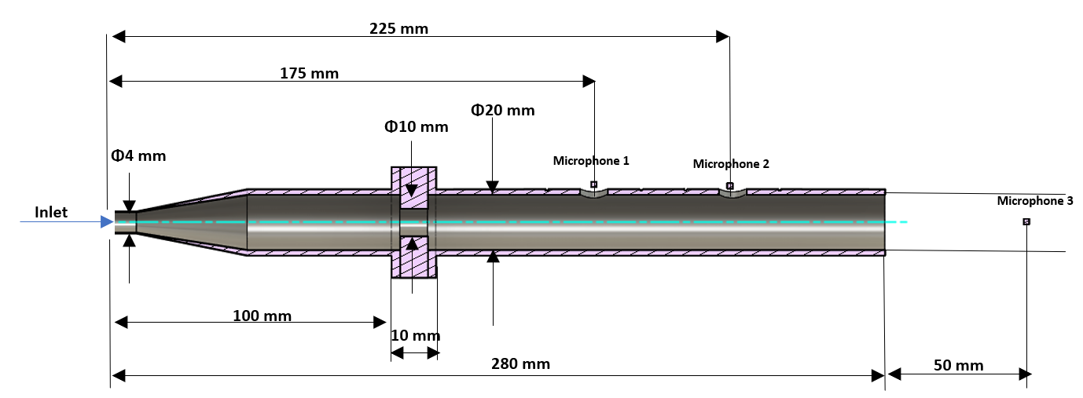
Fig. 2 Simplified Tube CAD model with the location of the three microphones

Results
Fig. 3 shows the sound pressure level measured at three different constriction sizes (25%, 50% and 75%) using the 280 mm long tube model without the cell foam. There was no change in the 1st resonating frequency between the three constrictions since the tube length did not change. However, there was a frequency shift at the 2nd and 3rd resonating frequencies implying a relationship between the constriction size and these frequencies. Moreover, higher amplitudes were observed at the larger constriction openings, especially at higher frequencies. This can be explained by the greater effect of the jet noise occurring at the inlet vicinity as previously mentioned. Larger areas allow for larger pressure amplitudes to be captured by the microphones downstream of the flow. Therefore, to magnify the physiological significance of the constriction in the tube model, the longer tube of 340 mm in length with added cell foam at the inlet was tested. Fig. 4 shows the results of this new setup. For this experiment, two additional constriction sizes (7 mm opening diameter/65% constriction and 8 mm opening diameter/60% constriction) were added to the test to amplify the inference. Several observations are depicted in this plot. First, the sound pressure measured at the two microphones placed on the tube surface was able to classify between the five constrictions, especially in the low-frequency region (below 500 Hz). Larger amplitudes are expected at the higher constrictions due to the larger area change generating higher flow turbulence, as shown in Fig. 4.

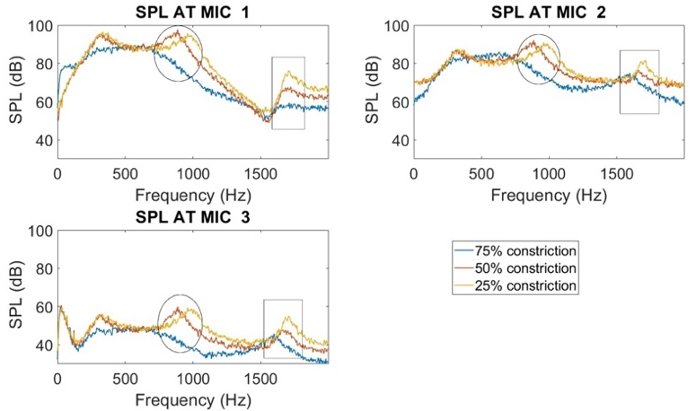
Fig. 3 Experimental sound pressure level (SPL) of three constriction sizes measured at the three microphones (tube length = 280 mm without cell foam)
Furthermore, the logarithmic root mean square (RMS) pressure is plotted against the inlet flow rate. As shown in Fig. 5, steeper slopes were observed at higher constrictions, depicting an increase in the growth rate of the sound power for smaller opening sizes when the flow rate was elevated.

Discussion
OSA classification during wakefulness using the spectral features of tracheal breathing sounds along with anthropometric features has already been proven. However, the inclusion of geometrical features and breathing airflow has not been analyzed. This study aimed to experimentally measure the sound pressure level generated due to airflow inside a tube with a constriction to study the effect of the constriction size and the flow rate on the generated sound. Two tests were performed for this objective. The first test involved direct measurement of the sound generated in the tube without eliminating the effect of jet noise while the second test included the use of cell foam before the constriction opening to study the effect of the constriction solely. The results of this study have shown a resonance frequency shift towards higher frequencies when reducing the constriction (larger opening diameter). Moreover, higher sound power was observed at increased flow rates with an increased logarithmic slope for larger constrictions. This finding came in line with those in [13] that reported an increase in the logarithmic slope of the flow-sound power relationship from wakefulness to sleep with a significant change for OSA individuals. In addition, the study in [14] investigated the sensitivity of TBS to degrees of respiratory airflow obstruction by measuring the airflow of acromegaly and healthy participants with the aid of orifice plates of different sizes. Higher sound power was found for smaller orifice diameters for both groups. In addition, acromegaly patients showed increased sound power compared to the healthy participants [14]. These findings show a great potential for quantifying the relationship between the breathing flow rate and the constriction size; thus, providing more rationale for the classification of OSA during wakefulness and assessing the constriction size of an OSA patient using tracheal breathing sounds only.
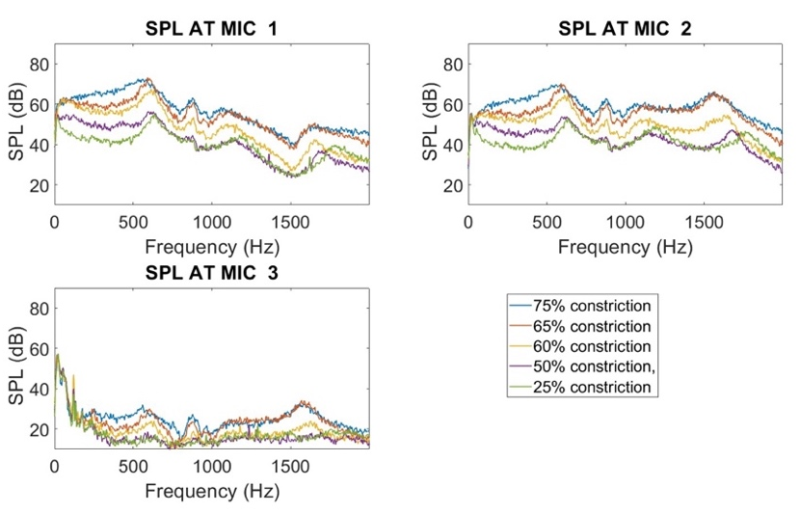
Fig 4: Experimental sound pressure level (SPL) at 5 constriction sizes measured at the three microphones (tube length =340 mm with cell foam)
This study encounters two primary limitations. Firstly, there is a geometric oversimplification of the trachea, as the experiment employs a tube with a sharp constriction, disregarding the various shapes of tracheal narrowing seen in OSA patients, such as tube, hourglass, and bottle shapes as demonstrated in [9]. A future study should explore the impact of these diverse shapes on TBS. Secondly, the rigid material used in the 3D printed model fails to accurately represent the high damping for sound amplitudes caused by human skin. This constraint could be mitigated in a future study by incorporating a more pliable 3D printing material with acoustic properties resembling human skin and by creating a realistic 3D model of the upper airway through CT scans.

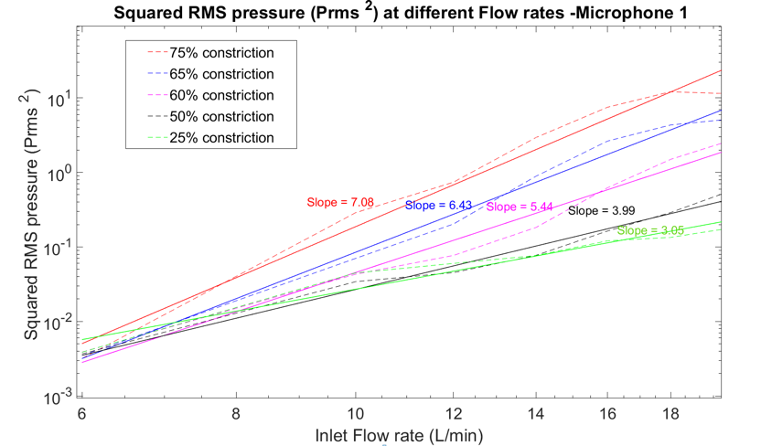
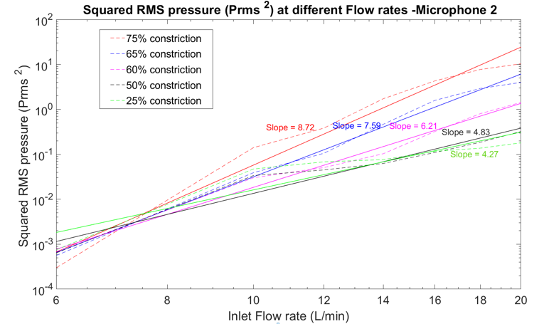
Fig 5 Experimental logarithmic RMS pressure squared vs the inlet flow rate measured at the three microphones for the five constriction sizes for microphone 1 (upper figure) and microphone 2 (lower figure), (Measured ----Dash line, Fitted line Solid line)

Summary
This study reports the results of an experimental upper airway modeling implemented on a simplified tube with a constriction representing trachea. Despite the oversimplification of the model, many important findings have been drawn and validated. There is a strong relationship between the frequency shift and the constriction size, representing tracheal narrowing. In addition, the evaluation of the slope of the logarithmic relationship between the airflow rate and the sound power could serve as a factor in OSA classification during wakefulness. These results indicate great potential for further studies assessing the geometrical features of the upper airway and their effect on TBS to help in the diagnosis of OSA during wakefulness.

Conflict of Interest
The authors declare that they have no conflict of interest.

REFERENCES
[1] J. A. Dempsey, S. C. Veasey, B. J. Morgan, and C. P. O’Donnell, “Pathophysiology of Sleep Apnea,” Physiol Rev, vol. 90, no. 1, pp. 47–112, Jan. 2010, doi: 10.1152/physrev.00043.2008.
[2] M. Kato, T. Adachi, Y. Koshino, and V. K. Somers, “Obstructive sleep apnea and cardiovascular disease,” Circulation Journal, vol. 73, no. 8, pp. 1363–1370, 2009, doi: 10.1253/circj.CJ-09-0364.
[3] N. Alghanim, V. R. Comondore, J. Fleetham, C. A. Marra, and N. T. Ayas, “The economic impact of obstructive sleep apnea,” Lung, vol. 186, no. 1. pp. 7–12, Feb. 2008. doi: 10.1007/s00408-007-9055-5.
[4] M. Nagappa et al., “Validation of the STOP-Bang Questionnaire as a Screening Tool for Obstructive Sleep Apnea among Different Populations: A Systematic Review and Meta-Analysis,” PLoS One, vol. 10, no. 12, p. e0143697, Dec. 2015, doi: 10.1371/journal.pone.0143697.
[5] A. Elwali and Z. Moussavi, “Obstructive Sleep Apnea Screening and Airway Structure Characterization During Wakefulness Using Tracheal Breathing Sounds,” Ann Biomed Eng, vol. 45, no. 3, pp. 839–850, Mar. 2017, doi: 10.1007/s10439-016-1720-5.
[6] A. Elwali and Z. Moussavi, “A Novel Decision-Making Procedure during Wakefulness for Screening Obstructive Sleep Apnea using Anthropometric Information and Tracheal Breathing Sounds,” Sci Rep, vol. 9, no. 1, Dec. 2019, doi: 10.1038/s41598-019-47998-5.
[7] J. Solé-Casals et al., “Detection of severe obstructive sleep apnea through voice analysis,” Applied Soft Computing Journal, vol. 23, no. October 2014, pp. 346–354, 2014, doi: 10.1016/j.asoc.2014.06.017.
[8] F. Espinoza-Cuadros, R. Fernández-Pozo, D. T. Toledano, J. D. Alcázar-Ramírez, E. López-Gonzalo, and L. A. Hernández-Gómez, “Speech Signal and Facial Image Processing for Obstructive Sleep Apnea Assessment,” Comput Math Methods Med, vol. 2015, 2015, doi: 10.1155/2015/489761.
[9] Y. Finkelstein et al., “Velopharyngeal anatomy in patients with obstructive sleep apnea versus normal subjects,” Journal of Oral and Maxillofacial Surgery, vol. 72, no. 7, pp. 1350–1372, 2014, doi: 10.1016/j.joms.2013.12.006.
[10] Z. Lan, A. Itoi, M. Takashima, M. Oda, and K. Tomoda, “Difference of pharyngeal morphology and mechanical property between OSAHS patients and normal subjects,” Auris Nasus Larynx, vol. 33, no. 4, pp. 433–439, Dec. 2006, doi: 10.1016/j.anl.2006.03.009.
[11] V. P. Harper, H. Pasterkamp, H. Kiyokawa, and G. R. Wodicka, “Modeling and measurement of flow effects on tracheal sounds,” IEEE Trans Biomed Eng, vol. 50, no. 1, pp. 1–10, 2003, doi: 10.1109/TBME.2002.807327.
[12] N. Gavriely and D. W. Cugell, “Airflow effects on amplitude and spectral content of normal breath sounds,” J Appl Physiol, vol. 80, no. 1, pp. 5–13, 1996, doi: 10.1152/jappl.1996.80.1.5.
[13] A. Yadollahi, A. Montazeri, A. Azarbarzin, and Z. Moussavi, “Respiratory flow-sound relationship during both wakefulness and sleep and its variation in relation to sleep apnea,” Ann Biomed Eng, vol. 41, no. 3, pp. 537–546, 2013, doi: 10.1007/s10439-012-0692-3.
[14] N. A. Lima Junior, N. V. Oliveira, A. B. W. Tavares, A. J. Lopes, and P. L. Melo, “Determining airflow obstruction from tracheal sound analysis: simulated tests and evaluations in patients with acromegaly,” Med Biol Eng Comput, vol. 60, no. 7, pp. 2001–2014, 2022, doi: 10.1007/s11517-022-02584-2.

