Smart Bili-wrapper: A Low-cost Phototherapy device for Low Resource Setting
B.K. Williams1, O.E. Ajibola², C. Okey-Ihedi2, E. Arowesan2 and A. Eniola²
¹Institute for Global Health Technologies, Rice University, Houston, USA
²UNILAG Design Studio, University of Lagos, Lagos, Nigeria

INTRODUCTION
Phototherapy is the use of visible light to treat hyperbilirubinemia skin condition also called jaundice in newborns [1]. It does this by lowering the bilirubin levels in a neonate's blood through a process called photo-oxidation. Six out of ten term babies and eight out of ten preterm babies are affected by neonatal jaundice according to the World Health Organization [2]. In Nigeria, the neonatal mortality rate is about 40 deaths per 1,000 live births. More than 60% of all newborns suffer neonatal jaundice with the majority of the affected infants from developing countries where there is limited access to adequate phototherapy treatment [3]. This work sought to develop a portable smart low-cost device to administer phototherapy care to infants suffering from jaundice in low-resource settings where access to standard healthcare services is challenging.

Materials and method
The novel Billi-wrapper in this work uses the concept of embedding a source of blue light in a neonate’s covering cloth (called “wrapper”). The design incorporates a temperature monitoring system that shuts down the light source when a set threshold temperature level is exceeded. Ultimately, the entire design comprises three parts: a 450nm blue light-source providing irradiance of 10 µW/cm²/nm, a microcontroller-based temperature control unit, and a detachable body wrapper. The LED strip arranged over a 25cm x 12cm sized-wrapper acts as the source that provides the light directed at the neonate's body through a transparent layer of the wrapper.

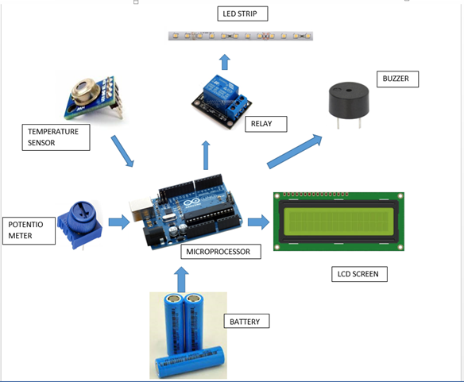
Fig. 1 Components of Temperature monitoring & control unit
The control unit uses an Arduino microcontroller board connected to a buzzer and a temperature sensor. The detachable wrapper has a transparent and opaque layer that helps with easy installation of the light source. The transparent part ensures free passage of the light rays to the body while the opaque layer prevents the light rays from getting to the newborn’s eyes and the environment.

Results & Discussions
The device continually read and displayed the temperature of the neonate on an LCD unit. The measured irradiance was 9.6 µW/cm²/nm. The gross weight of the device was found to be 1.2kg (battery pack and wrapper inclusive). Above a preset threshold temperature of 37.5 °C, the device switched off the LED and alerted a caregiver with a buzzer sound. The testing and evaluation of the device (Fig. 2) confirm that the device is promising and has the potential to impact many lives, especially in sub-Saharan Africa where neonatal mortality is predominant.

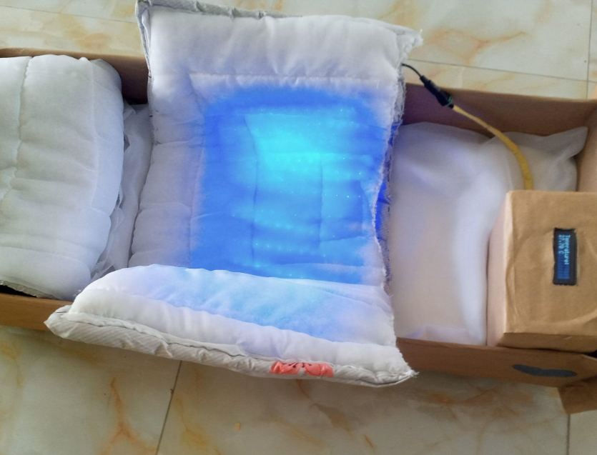
Fig. 2 The Billi-wrapper in a demo baby cot

ACKNOWLEDGEMENTs
We are indebted to Rice University and the University of Lagos Design Studio for granting us the platform and needed resources to carry out this work. We also thank The Lagos State University (LUTH) where we engaged with healthcare professionals to identify problems and needs for this work.

REFERENCES
[1] L. Stokowski, “Fundamentals of Phototherapy for Neonatal Jaundice,” Adv. Neonatal Care, vol. 6, pp. 303–312, Jan. 2007, doi: 10.1016/j.adnc.2006.08.004.
[2] A. Suleiman, A. s.krishnapillai, N. Hasani, and A. Ridha, “Use of home phototheraphy for neonatal jaudice,” Malaysian J. Public Heal. Med., vol. 7, pp. 49–52, Jan. 2007.
[3] M. Ihekaike, M. Shehu, A. Jimoh, U. Onyenuche, A. Uhunmwangho-Courage, and A. Yakubu, “Causes of Neonatal Morbidity and Mortality in Bingham University Teaching Hospital, Jos, Plateau State, Nigeria,” Asian J. Pediatr. Res., vol. 13, pp. 82–88, Aug. 2023, doi: 10.9734/ajpr/2023/v13i2267.

